Women Members’ Annual Conference – Friday 29 November 2024

Guest Speaker:

Flora Renz, Centre for Sexuality, Race and Gender Justice
University of Kent
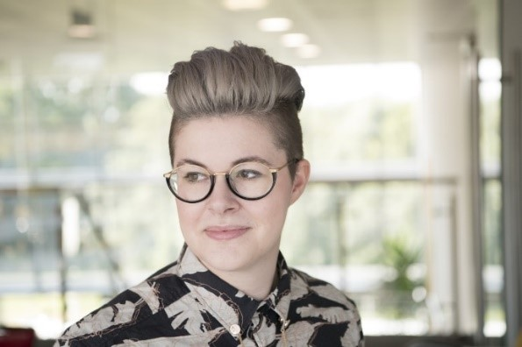
Flora Renz is a Senior Lecturer in Law at Kent Law School and an early career researcher working in the area of gender, disability, feminism and the legal regulation of identities. Flora is currently a Co-Investigator on the ESRC funded project the Future of Legal Gender and is working on how decertification would impact single-sex spaces.

Dr Jenny Douglas, Black Women’s health and Wellbeing Research Network
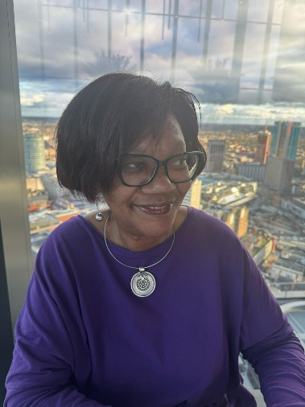
Dr Jenny Douglas is passionate about the health and wellbeing of Black women as evidenced through her research and public engagement. Dr Jenny Douglas is a Senior Lecturer in Health Promotion in the Faculty of Wellbeing, Education and Language Studies at the Open University. Jenny is chair of K310: Public Health – Health Promotion and Health Security. The focus of her research and activism, is intersectionality – exploring how ‘race’, class and gender affect particular aspects of African - Caribbean women’s health. She established and chairs the Black Women’s Health and Wellbeing Research Network (www.open.ac.uk/black-womens-health-and-wellbeing). She is a medical sociologist with a PhD in Women’s Studies from the University of York. She was a Visiting Scholar at George Washington University, Washington D.C., USA,

during the tenure of a National Centre for Research Methods Fellowship on intersectionality informed research methods. She is a Plumer Visiting Research Fellow at St. Anne’s College, University of Oxford. Jenny is a member of Welcome Social Sciences Discover Advisory Group. She is an honorary member of the Faculty of Public

Health, a director of the UK Public Health Register and a Trustee of the Foundation for the Sociology of Health and Illness. Jenny is the

Open University Co-Sponsor of the WHEN 100 Black Women Professors Now programme.

Dr Amelia Baldwin, UWE Bristol

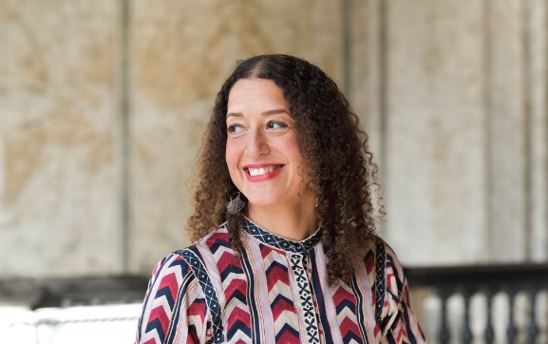
Dr Amelia Baldwin is a Chartered Counselling Psychologist. She is currently a senior lecturer in counselling psychology at the University of West Of England and a practitioner psychologist in private practice. Amelia is an Associate Fellow with the British Psychological Society and is a member of the Division of Counselling Psychology.

Over the past two decades, Amelia has gained experience as a therapist, advocate, researcher, leader, and supervisor in various settings, including the voluntary sector, NHS services, and academia. She is an intersectional feminist who leads on varied aspects of anti-racist, decolonial, systemic thinking, and feminist approaches to therapy, research, and supervision.

