Migrant Members’ Annual Conference – Thursday 28 November 2024

Guest Speakers

Kamran Khan, University of Birmingham
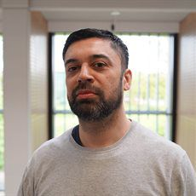
Kamran Khan is the director of the Mosaic research group on multilingualism at the University of Birmingham. He is the author of ‘Becoming a Citizen: Linguistic Trials and Negotiations’ (Bloomsbury, 2019). He was previously a Marie Sklodowska-Curie Fellow at the University of Copenhagen on the role of the ‘ghetto’ policy in Denmark. His work is focuses on the role of security and race in relation to language and he is a specialist on the social impact of citizenship testing.

Dr Paul John Alegado, University of Worcester

Dr Paul John Alegado holds a PhD in Comparative Education and is a senior lecturer at the School of Nursing and Midwifery, University of Worcester. Dr Alegado was also a former fellow of NHS England and the Florence Nightingale Foundation INMA Program and is currently the executive secretary of the Filipino Nurses Association UK and a regional director for West Midlands. He is an award-winning nurse educator, researcher, speaker and mentor. He won the Nursing

Times Award as Overseas Nurse of the Year and Practice Educator Finalist in 2023. He is also a published author with various publications locally and
internationally, including the British Journal of Nursing, the Nursing Standard and Educational Philosophy and Theory.
Before joining the UK workforce, he worked as a research fellow at the International Network on Gender, Social Justice and Praxis at the University of

Newcastle, Australia, a lecturer at the Beijing University of Technology, and a teaching fellow at a PhD program at Beijing Normal University.

Currently, he is the Year 2 Module Deputy Lead for Assessment and Planning. He is also involved in research work which explores the impact on health of anti-homosexual laws in Ugandan refugees, queer vulnerabilities in climate change and international student nurses support in Higher Education Institutions in the UK.
For more information, visit the following:
- University Web:
https://www.worcester.ac.uk/about/profiles/dr-paul-john-alegado
- Research:https://eprints.worc.ac.uk/view/author/Alegado=3APaul-John=3A=3A.html
Twitter: @pauljohnale

Mrs Kemi Obayelu, Goshen Solicitors

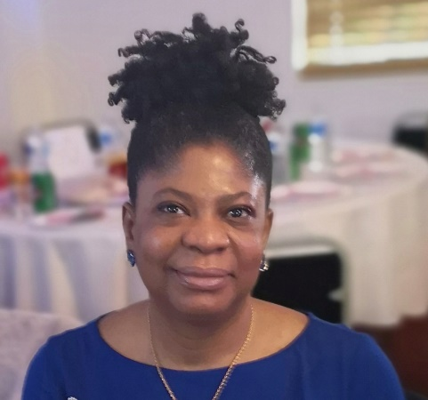
Kemi Obayelu is the managing director of Goshen Solicitors Limited. A Lexcel Accredited law firm with two Offices in Birmingham.
She has been practising in the UK for over 15 years and holds a Master of law degree (LLM) in International Human Rights from Birmingham City University.

She has multi and cross-functional practice experience covering immigration and asylum and family law. She has appeared at all levels of the Asylum and Immigration Tribunal and handled Judicial review proceedings in the Administrative Court and Upper Tribunal of the Immigration and Asylum Chamber.

She is accredited by the Law Society Immigration and Asylum Accreditation Scheme as a Supervising Senior Caseworker.
​

She was also called to the Nigerian Bar as a qualified solicitor and barrister, with robust practice experience in criminal proceedings.
​
She was appointed a visiting lecturer in law at Birmingham City University in 2018 and Birmingham Newman University in 2021.

