LGBT+ Members’ Annual Conference – Saturday 30 November 2024

Guest Speakers:

Harun Tulunay, Training & Volunteering Programme Manager at Positively UK and Activist in Sexual Health & HIV
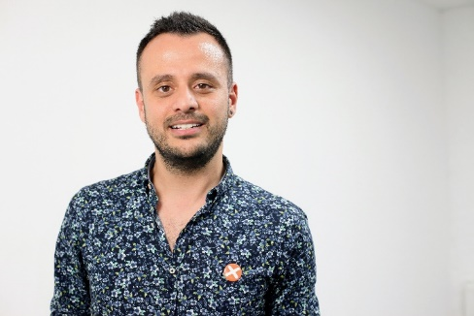
Born in Turkey, Harun worked as an events manager for over 10 years. He moved to the UK in 2015 to escape anti-LGBT+ hostility and discrimination.
When Harun was diagnosed with HIV in 2016, he chose to use the experience to become an ambassador for good sexual and mental health, volunteering for several London-based charities. In 2020 he decided to devote himself fully to HIV support work and left events and digital marketing. He joined Positively UK, where he currently works as Training and Volunteer Coordinator.
In June 2022 he contracted Monkeypox and was hospitalised for 10 days, becoming one of the most severe cases in the UK. He shared his experience publicly to raise awareness of the condition and to challenge the stigma around it. His story has been shared with the world by WHO and UN to raise awareness.
Harun is committed to speaking publicly and sharing his life experiences to tackle stigma and raise awareness of HIV, Monkeypox and mental health, as well as the stigma he faced as a gay man in Turkey. He also works as a peer mentor to support others living with HIV and shares up to date information on sexual health both in Turkish and English through his social media.

Muwonge Gerald, Team Leader at Foaster Foundation for Healthcare, Uganda Breathing Underwater

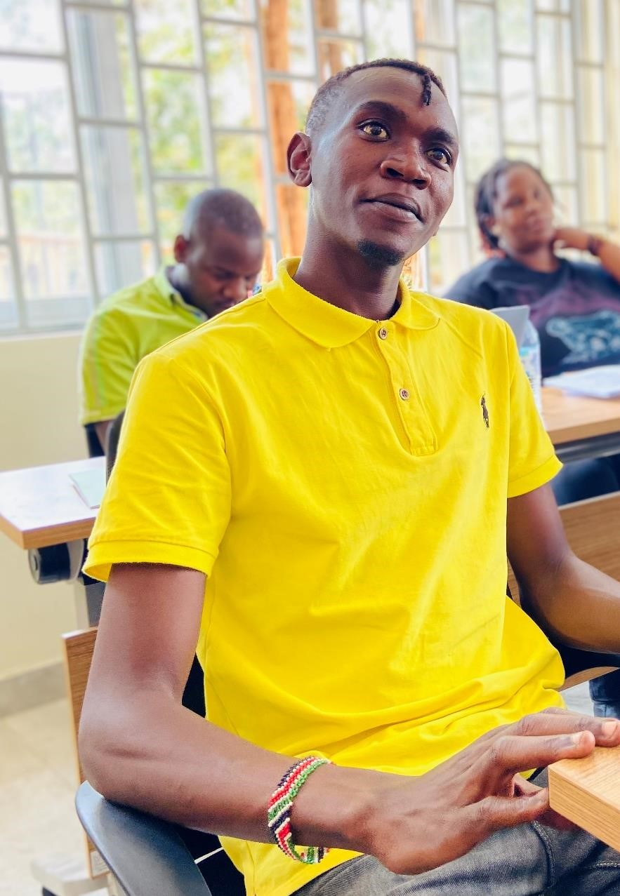
Muwonge is the current Executive Director of Foaster Foundation For Healthcare Uganda. Muwonge Gerald is an infinite queer human rights advocate aged 27yrs and an HIV positive open living queer activist, he is the Team Leader of Foaster Foundation for Healthcare Uganda, and the founder of Extend a Life Initiative Uganda. Both the organizations work with LGBTQ+ people and women at risk, living and effected with HIV in Uganda. In 2016, November, Muwonge found out that he is HIV positive, and he was so down to the extent that he wanted/tried to kill himself but through guide and counselling, He managed to set himself free and came out publicly through his personal social media accounts such as Facebook under the names of Muwonge Rock Gerald as a queer free person living and
affected with HIV. Muwonge has been on the front page of advocating and fighting for equality and gender balance in Uganda and has worked with several queer-led orgs. https://www.facebook.com/100009887765967/posts/1563820337290877 /

Lexi Breen, Senior Lecturer at University of Lincoln
Contemporary intersex and transgender issues in education

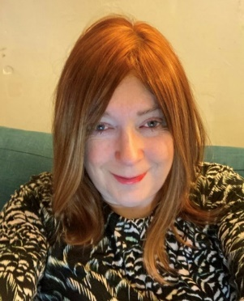
Lexi is a Senior Lecturer / Programme Lead in the College of Health and Care Science at the University of Lincoln. A registered Nurse and Paramedic. Before joining the university in 2019, Lexi was employed as an Advanced Clinical Practitioner and has worked in healthcare for over 30 years, predominantly in Urgent, Emergency Care and education.
Initially became a professional member of the Klinefelter's Syndrome Association in 2015 when at the age of 50 found out she was intersex and is now the Vice-Chair. She is also a trustee on Interconnected UK (an Intersex charity).
She is the only representative with XXY Chromosomes for the European Reference network for rare endocrine conditions (Endo-ERN) and takes an active part attending meetings and medical conferences across Europe to increase the awareness of intersex variations to fellow healthcare professionals. She is a professional member of the Society for Endocrinology, an affiliate member of British Association of Gender Identity Specialists (BAGIS), is a regular guest on a local radio station discussing intersex issues and is working with a number of Universities on research projects on Intersex variations and Transgender care. As well as doing her own PhD research om gender incongruence in intersex people.

