**Disabled Members’ Annual Conference**

**Thursday 28 November 2024**

Report to Disabled Members’ Conference from the Chair on behalf of the Disabled Members’ Standing Committee

Welcome to the annual Disabled Members’ Conference 2024.

I would like to thank the current members of the Disabled Members Standing Committee (DMSC), Bijan Parsia (University of Manchester), Kevin Daws (City of Bristol College), Jennifer Dods (Leeds Beckett University), Cecily Blyther (Petroc), Cecilia Wee (Royal College of Art), Christina Paine (London Metropolitan University), Alison Gaughan (Kirklees College), Dan Green (Heriot-Watt University), Jacqui Lovell (Liverpool John Moores University), Sophia Lycouris (University of Edinburgh) and Claire Graf (University of Edinburgh, for their work and contribution to progressing disability equality.

As chair, I would like to speak directly to our FE members from all sectors, especially Adult Education and Prisons, who are underrepresented in this committee and across the equalities strands. We serve to make a difference. As chair of the committee, I work closely with your HE representative, Bijan Parsia, Kevin Daws, vice chair (FE), our Equality Support Official, Sharon Russell, and our Equality unit administrator, Swati Patel. Each member of the committee is fully committed to working on your behalf. All your input at this conference will ensure that we can put your priorities first and lay the roadmap for the work plan for next year.

The theme for this year is ‘Challenges, Rights and Opportunities’ and aims to discuss how we can collectively and individually challenge the inequality we face as Disabled workers by using the rights we earned to progress equality and to look at the opportunities that await us.

After 14 years of a conservative government that saw attack after attack on Disabled people, from benefit cuts to the disproportionate deaths of disabled people during the Coronavirus pandemic, we urge the new Labour government to address and ‘do the right thing’ concerning disability equality and rights.

We will continue to campaign to close the disability pay gap, which the TUC state currently stands at 17%. While not included in the Employment Rights Bill, we notice that the government has outlined its plans in its ‘Next Steps document’ under the Equality (Race and Disability) Bill to implement mandatory disability pay gap reporting and action plans for employers with more than 250 staff and extend equal pay rights to workers experiencing discrimination based on race or disability. We also have raised awareness of the TUC Disability Pay Gap Day held on November 7 #DisabilityPayGap.

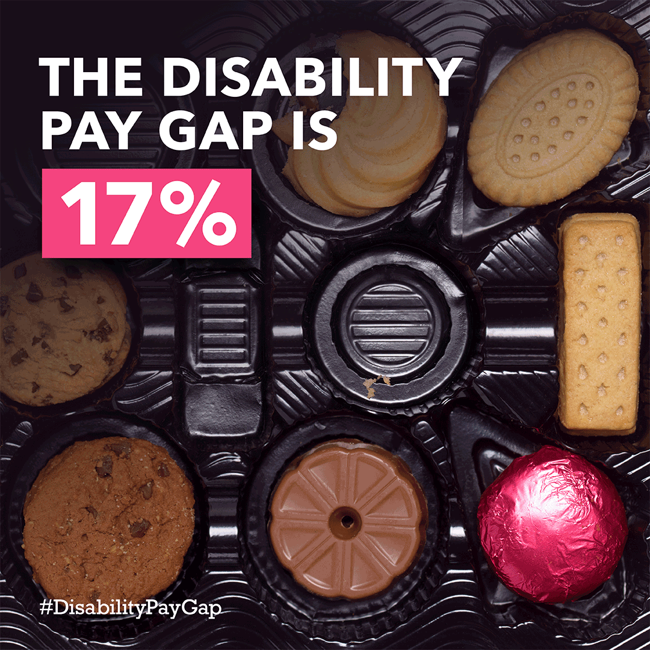 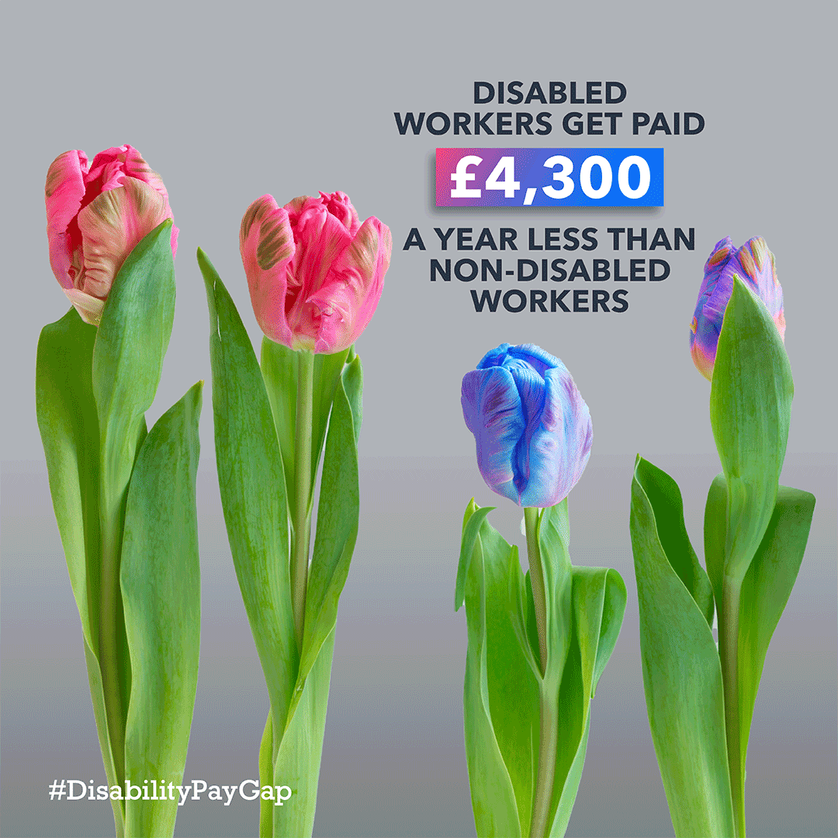 

As the Employment Rights Bill is debated, we welcome the call for the long-awaited levelling up to ensure equality reps have statutory rights on a par with Health and safety reps. We will continue to campaign as a union with the TUC, the trade union movement, and Deaf and Disabled People’s Organisations (DDPOs) on issues affecting Disabled workers at work and broader society.

The DMSC's work has been based on your input at the last conference 2023, where we discussed the United Nations Rights of Disabled People (UNCRDP) and its importance for advancing disability justice at work and in society.

The committee produced a webinar on this subject during the year. This webinar is readily available on the UCU site, and I urge you to view it if you have not yet done so. This webinar will be followed up with an ‘Accessibility as Standard’ checklist. The committee checklist aims to improve workplace accessibility, including buildings and virtual learning environments. In addition, we have worked closely with UCU officials, advising via the National Executive Committee, to ensure that all conferences, including the National Congress, are accessible to all members.

I was delighted to be elected last year as your NEC representative for disabled members and to be re-elected to represent you on the National TUC Disabled Workers Committee, working with other unions to ensure equality and fairness for disabled people and spoke alongside committee members at the TUC Annual Disabled Workers Conference, promoting inclusive education as a right.

This work continues and is added to our commitment to the Disabled People’s Manifesto and a constant fight on the ‘War on disabled people’, which has existed for so long. We believe it is time for change. All the above fits with the key responsibilities of the committee. These are, but not limited to, planning this annual conference, attending the National TUC Disabled Workers Conference, where policy for the trade unions is made, organising the Annual Day of Action for Disability Equality in Education, promoting the use of UCU’s Reasonable Adjustment Passport and Policy, Encouraging Branches to sign up for the Disability Charter, improving access through the ‘Accessibility as Standard’ checklist, raising Neurodiversity as a workplace issue.

This conference will enable you to use the tools and resources that will support you when facing obstacles and challenges in your workplace and beyond. On behalf of the Disabled Members’ Standing Committee, thank you for being here to help us find solutions to our challenges, exercise our rights, and look forward to opportunities that await us.

Nothing about us without us!

**Pat Roche, NEC (FE) rep and Chair of the Disabled Members’ Standing Committee, Blackpool and The Fylde College**

**Disabled Members’ Standing Committee 2023 – 2024**

|  |  |
| --- | --- |
| Pat Roche, NEC (FE) Disabled Rep and Chair of the Disabled Members’ Standing Committee | Bijan Parsia, NEC (HE) Disabled rep, University of Manchester |
| Cecily Blyther, PETROC (FE) | Kevin Daws, Vice Chair, DMSC, City of Bristol College (FE) |
| Jennifer Dods, Leeds Beckett University (HE) | Alison Gaughan, Kirklees College (FE) |
| Claire Graf, University of Edinburgh (HE) | Dan Green, Heriot-Watt University (HE) |
| Jacqui Lovell, Liverpool John Moores University (HE) | Sophia Lycouris, University of Edinburgh (HE) |
| Christina Paine, London Metropolitan University (HE) | Cecilia Wee, Royal College of Arts (HE) |