**Equality Groups Conference, Joint Plenary Session**

**Friday 29 November 2024**

**Guest Speakers:**

**Dr Jo Grady UCU General Secretary**

Dr Jo Grady was elected General Secretary of the University and College Union in 2019 and re-elected in 2024. Previously she had spent ten years as a UCU departmental rep and branch officer at the universities of Leicester and then Sheffield, where she was a Senior Lecturer in Employment Relations.

**Maxine Looby, UCU President**

Maxine Looby is UCU President of the University and College Union (UCU), She currently works as an FE Lecturer at Oldham College, Greater Manchester, where she was previously the branch secretary, caseworker, health and safety rep, and negotiator. She has also been the North West Region Committee chair and Black members representative. She also sits on the North West TUC Black members group and works alongside union reps and activists across various unions to develop and support Black members in the trade union movement. Maxine has been a committed trade unionist and activist throughout her career and continues to advocate and fight for members around the issues of racism, intersectionality, bullying, stress, and work overload in FE - including Adult Community Education and Prison and HE. She is passionate about developing, mentoring, and supporting members from marginalised and   underrepresented groups to become more active, take up leadership positions and claim their voice.

**Taj Ali, Freelance journalist**

Taj Ali is a journalist and historian specialising in coverage of trade unions and workers' rights. He is the former editor of Tribune Magazine and is currently writing a book on the history of British South Asian political activism.

**Saima Razzaq Khan LGBT+ activist**

Saima became the first Queer Muslim woman to lead a pride parade in the UK, in 2019. During this time, Saima was also appointed chair of SEEDS, an equalities group, set-up as a direct response to anti-LGBT+ protests outside schools in Birmingham. This appointment saw Saima become a mediator between teachers, protesting parents and the city's LGBT+ community. Saima holds a diverse leadership portfolio, gained from working in marketing communications for over a decade, across TV, Financial Services and the Arts. Saima now works as the Director of Change and Communications at Birmingham Pride.

**Dr Leona Vaughn,** **Derby Fellow for Slavery and Unfree Labour Research**

Dr Leona Vaughn is a sociologist with three decades of award-winning experience in research and advocacy for racial and social justice in higher education, central government and civil society. She has held numerous positions including global research lead for populations vulnerable to modern slavery at United Nations University; Chief Executive of anti-race hate crime charity Anthony Walker Foundation and national equality and human rights policy advisor for Crown Prosecution Service, where she worked on the first ever public policy on racial and religious hate crime and devised an award-winning national positive action programme to increase representation of Black prosecutors.

Leona is currently a Research Fellow at University of Liverpool researching coloniality and risk in social policy, specifically racialisation and risk in safeguarding children from radicalisation and coloniality in studies of slavery and unfree labour, and co-founder of Barriers to Black Academia [[www.blackacademia.co.uk](https://url.uk.m.mimecastprotect.com/s/NWXCCxGvQU1okAYf8f4FymQsz?domain=blackacademia.co.uk)] which aims to remove structural barriers to Black representation in education

**Dr Joe Mulhall, HOPE not hate**

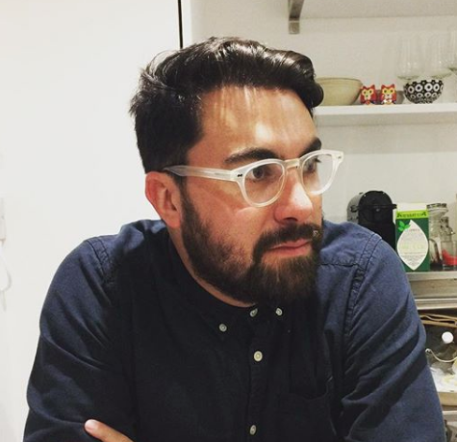 Dr Joe Mulhall is one of the UK’s leading experts on far-right extremism. Director of Research at the UK’s largest anti-fascism organisation, HOPE not hate, his books include Drums in the Distance: Journeys in the Global Far Right, British Fascism After the Holocaust and The International Alternative Right (Co-Author). He has written for the Guardian, Independent and New Statesman and appears regularly on broadcast media including the BBC News at Ten, Radio 4’s Today programme, The Moral Maze and Channel 4 News, among others.

**Sundos Hammad, Right to Education Campaign**

Sundos Hammad is the coordinator of the Right to Education Campaign at Birzeit University in Occupied Palestine, a role she has held for over twelve years. A dedicated human rights advocate, she holds a master’s degree in international studies and is deeply committed to social justice and academic freedom, particularly within the context of Israeli colonialism.