DFDFD

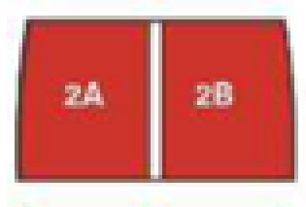

**Hall 2B Congress, HE Sector Conference**

**Hall 2A Welcome Reception, Catering and Exhibition**

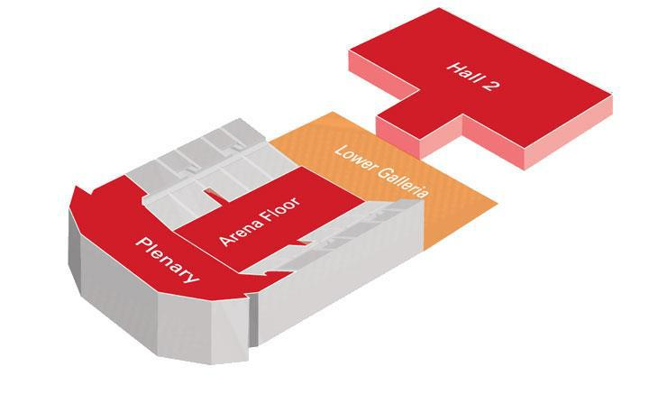



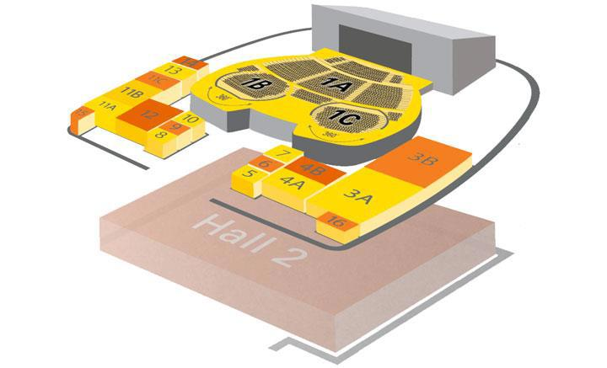

**Room 3 (3A/3B combined) FE Sector Conference**

**Room 4 (4A/4B Combined Fringe Meetings**

**Hall 11B Fringe Meetings**

**Hall 11C Fringe Meetings**

**Room 13 Retired Members Meeting**