JOINT AGREEMENT ON GUIDANCE ON GRIEVANCE PROCEDURES IN FURTHER EDUCATION COLLEGES

BETWEEN

THE ASSOCIATION OF COLLEGES (AoC)

AND

ASSOCIATION FOR COLLEGE MANAGEMENT (ACM)

ASSOCIATION OF TEACHERS & LECTURERS (ATL)

GMB
UNIVERSITY AND COLLEGE UNION (UCU)
UNISON
UNITE THE UNION

December 2009

Joint agreement on guidance on grievance procedures

- Scope and purpose

1.1 This procedure shall apply to all employees, other than “holders of senior posts” as defined in the College’s Articles of Government and the Clerk to the Corporation, to whom the College’s grievance procedure for senior postholders will apply.

1.2 The procedures will be applied in accordance with the Articles of Government of the Corporation and in accordance with the Advisory, Conciliation and Arbitration Services (ACAS) Code of Practice, ‘Disciplinary and Grievance Procedures’, dated April 2009.

1.3 The procedure aims to help to resolve individual grievances in a manner which is as fair and expeditious as possible. It is the College’s policy to find a solution to individual grievances as early in the procedure as possible.

2 General principles

2.1 An employee has the right to be accompanied at formal grievance meetings by a representative of a trade union or fellow worker of their choice, subject to a reasonable request being made. (Please refer to the Notes Section for guidance on the role of the companion).

2.2 Managers are required to familiarise themselves with the grievance procedure.

2.3 Every effort will be made to resolve the grievance at the informal stage.

2.4 In the interest of ensuring that grievances are resolved as speedily as possible, time limits are given for appropriate stages in this procedure. These are for guidance. If it is not practicable to adhere to these time limits, they may be amended, ideally by mutual agreement. Due regard will be given to the personal circumstances of all parties involved in the procedure.

2.5 If the grievance is against the immediate line manager, then the person to whom the grievance should be sent should be senior to the line manager. If the grievance is against the Principal or another senior post holder, it should be sent to the Clerk to the Corporation, and will be heard by a member or a committee of the Corporation.

3 Stage 1 - Informal Procedure

3.1 If an employee has a grievance relating to his/her employment, the matter should be raised initially with the employee’s manager. The grievance should be raised orally in the first instance. In the event that the grievance relates to the manager who would normally deal with a grievance at this stage, the grievance should be referred to the [immediate supervisor’s own manager] [Head of Department’s immediate manager].

3.2 The manager will take appropriate steps to resolve the grievance as quickly as possible on an informal basis. He/she shall enquire into the grievance and will discuss it with the employee. A written record of the discussion and the outcome will be provided within [ten] working days after the complaint is received. It is anticipated that most grievances will be resolved at this stage.

3.3 If the matter is very serious or in other circumstances where the employee does not wish to raise the matter informally, the employee may proceed straight to the formal stage of the procedure.

4 Stage 2 – Formal Procedure

4.1 If the employee feels that the matter has not been resolved through informal discussion, or in the event that paragraph 3.3 applies, the grievance should be put in writing.

4.2 The grievance should provide full details of the complaint and should be addressed to the employee’s manager.

4.3 The College will, as soon as possible [ideally within five working days, but no longer than ten, of receipt of the written grievance] arrange a grievance meeting.

4.4 The employee may be accompanied at the meeting by a trade union representative or work colleague (Please refer to the Notes Section for guidance on the role of the companion). The College should remind the employee of the right to be accompanied prior to a grievance meeting. Before the meeting, the employee should tell the College who he / she has chosen to be a companion.

4.5 If the grievance involves another employee, the College may require the attendance of that employee or any other employees who may be able to provide relevant information. If the employee wishes to call relevant witnesses to the meeting, he / she should advise the College of this in advance of the meeting. The employee will be informed prior to the meeting if the College intends to call relevant witnesses.

4.6 At the meeting the employee or his/her companion will be given the opportunity to explain the nature of the grievance, submit verbal/written evidence and call appropriate witnesses.

4.7 The manager hearing the grievance will consider all of the matters raised at the meeting and undertake all reasonable investigations into the grievance.

4.8 The manager’s decision will be communicated in writing to the employee as soon as reasonably practicable following the meeting; ideally within five working days, and normally within ten, of the meeting. The letter to the employee will outline, where appropriate, what action the College intends to take to resolve the grievance, and will also inform him / her of the right to appeal. Where the decision is to not uphold the grievance, the manager will explain the reasons for this in the letter. Any other parties involved in the grievance will also be appropriately informed of the outcome.

5 Stage 3 - Appeal

5.1 If the grievance is not resolved to the satisfaction of the employee at Stage 2, he or she may appeal. Any such appeal must be submitted in writing, setting out the full grounds for the appeal, and sent to the [Personnel Department] within [ten] working days of receipt of the decision reached at Stage 2.

5.2 The College will, as soon as possible [and in any event, within ten working days of receipt of the written appeal], invite the employee to an appeal meeting, which will be chaired by an appropriate senior manager, who has not been involved in the grievance process in question so far and who is senior to manager who heard the original grievance. The employee will be entitled to be accompanied at the appeal meeting by a trade union representative or work colleague (Please refer to the Notes Section for guidance on the role of the companion).

5.3 The senior manager will consider the appeal and may be supplied with all of the documentation submitted in relation to the earlier stages of the procedure. If the grievance involves another employee, the senior manager may require the attendance of that employee at the appeal meeting, or any other employees who may be able to provide relevant information.

5.4 The appeal decision will be provided in writing within [ten] working days of the appeal meeting. Any other parties involved in the grievance will also be appropriately informed of the appeal decision. Such decision will be final.
Notes relating to the model grievance procedure

Section 3
Employees have the statutory right to be accompanied by a fellow worker or trade union representative, where they are invited by the employer to attend a grievance meeting and when they make a reasonable request to be so accompanied.

The trade union representative can be an officer employed by a trade union, or a lay
trade union officer, so long as (in the latter case) they have been reasonably certified in writing by their union as having experience of, or as having received training in, acting as an employee’s companion at grievance meetings.

An employee may ask an official from any trade union to accompany them at a grievance meeting, regardless of whether or not he or she is a member or the union is recognised by the College.

A fellow worker or trade union representative who is to accompany the employee at the grievance meeting should be permitted to take a reasonable amount of paid time off to fulfil this. This should cover the grievance meeting and it is also good practice to allow time for the companion to familiarise themselves with the case and confer with the employee before and after the meeting.

To exercise the statutory right to be accompanied, an employee must make a reasonable request. What is reasonable will depend on the circumstances of each individual case. However, it would not normally be reasonable for an employee to insist on being accompanied by a companion whose presence would prejudice the meeting nor would it be reasonable for an employee to ask to be accompanied by a companion from a remote geographical location if someone suitable and willing was available on site.

The companion should be allowed to address the meeting to put and sum up the employee’s case, respond on behalf of the employee to any views expressed at the meeting and confer with the employee during the meeting. The companion does not, however, have the right to answer questions on the employee’s behalf, address the meting if the employee does not wish it or prevent the employer from explaining their case.

JOINT AGREEMENT ON GUIDANCE FOR GRIEVANCE PROCEDURES IN FURTHER EDUCATION COLLEGES

SIGNATURES OF THE PARTIES TO THIS AGREEMENT

 AoC

ACM 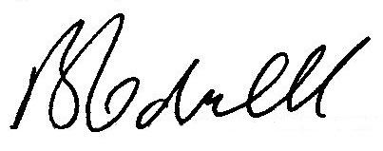
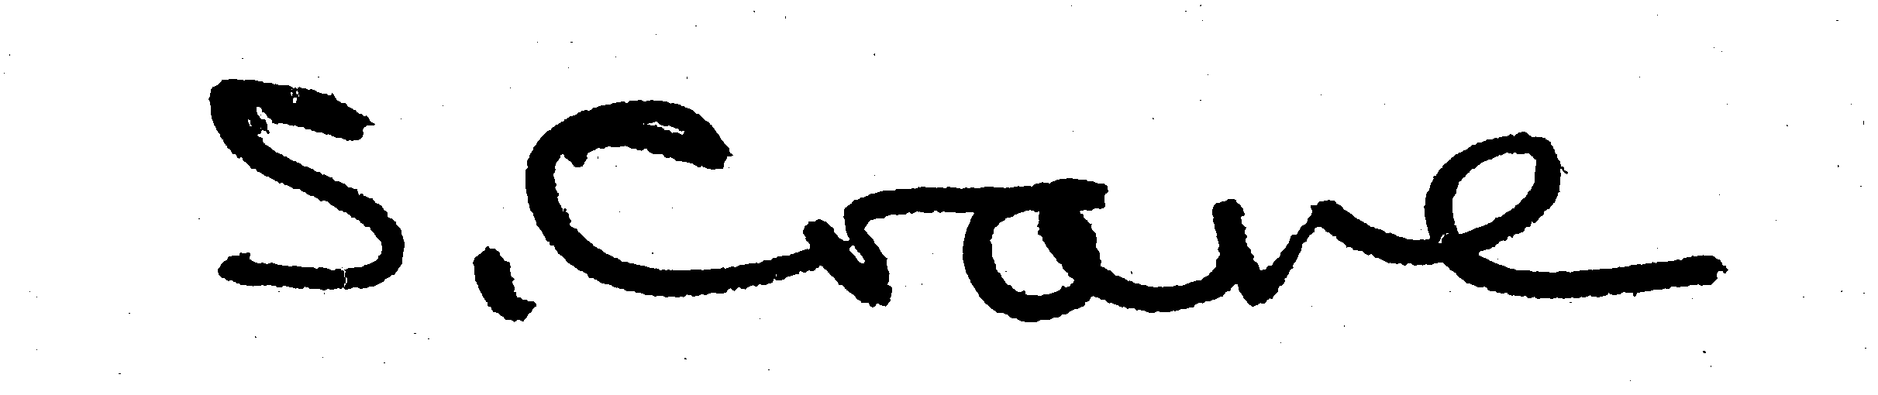

ATL
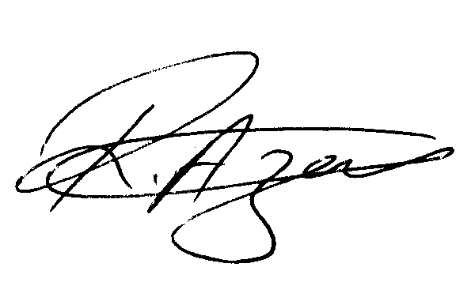

GMB
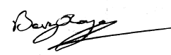

UCU

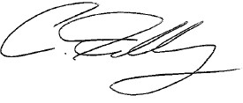
UNISON

UNITE 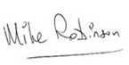

Date of Commencement of this Agreement:

December 2009

