JOINT AGREEMENT ON LOCAL RECOGNITION AND PROCEDURAL AGREEMENTS IN FURTHER EDUCATION COLLEGES

BETWEEN
THE ASSOCIATION OF COLLEGES (AoC)

AND

ASSOCIATION FOR COLLEGE MANAGEMENT (ACM/AMiE)

ASSOCIATION OF TEACHERS & LECTURERS (ATL)

GMB

UNIVERSITY AND COLLEGE UNION (UCU)

UNITE – THE UNION

UNISON

1 PURPOSE
The purpose of this Agreement is to establish arrangements for consultation and negotiation between (name of College) and the recognised Trade Union(s) and represent minimum standards which can be implemented and improved on locally

2 GENERAL PRINCIPLES
2.1 The spirit and intention of this Agreement is to promote harmonious relations between the College and its employees through the development of effective joint consultative and negotiating machinery.

2.2 It is a common objective of the parties that the College should function efficiently and effectively to the benefit of both the institution and its staff.

2.3 The Agreement is not intended to detract from an individual employee's right of access to management or the Corporation's right to communicate directly with its employees or the union's right to communicate with its members.

3 RECOGNITION
3.1 (Name of College) recognises the following unions: (ATL and UCU) for lecturers and senior lecturers; (ACM and UCU) for management spine staff; and (GMB, UNISON and UNITE) for support staff for the purposes of collective bargaining, communication and consultation as appropriate.

The Union(s) recognise that it is the right and responsibility of the College to manage the institution.

4 PROCEDURES
4.1 There will be a common interest group, which will consist of all the recognised trades unions. This joint committee is expected to meet at least once per term or as often as necessary to maintain good employee relations. In addition and where appropriate there will be special interest groups representing issues that are specific to each employment group only e.g. lecturers and senior lecturers; management spine and support staff. The union(s) recognised in respect of each employment group will attend the special interest groups if convened.

4.2 The joint committee will consider matters relating to conditions of employment and other matters of common concern for the purpose of achieving understanding and agreement. It will be a forum for negotiation, consultation and communication as appropriate. Matters within its remit shall include all relevant employment matters in accordance with Section 178 of the Trade Union and Labour Relations (Consolidation) Act 1992 and good industrial relations practice as defined by ACAS.

4.3 Requests for meetings may be initiated by either Side and will be by mutual agreement. There should be the minimum of delay in arranging meetings.

4.4 The representatives on the joint committee will be as follows: Management Side: () representatives of the College Trade Union Side: () representatives of (ACM); () representatives of (ATL); () representatives of (GMB); () representatives of (UCU); () representatives of (UNISON); () representatives of (UNITE).

4.5 A full-time Union official may be present at a meeting of the committee in an advisory capacity subject to the agreement of all parties.

4.6 College management will provide administrative support for the work of the joint committee, including the preparation of an agreed agenda based upon items submitted by either side and the keeping of minutes.

4.7 Attendance and participation in the work of the joint committee shall be an approved duty with appropriate facility time being available as agreed by the College.

5 PROCEDURE FOR DEALING WITH UNRESOLVED ISSUES
5.1 It is agreed by all parties to the Agreement that every attempt will be made to use the procedures above to avoid dispute including having additional meetings and involving paid regional and national officials where appropriate.

5.2 Where there is a failure to reach an agreement within local procedures, and both parties agree that the issue warrants it, the matter may be referred to the Advisory Conciliation and Arbitration Service (ACAS) in order to seek a resolution.

5.3 Where the disagreement concerns the interpretation of a national agreement approved by the College, the Joint Secretaries of the appropriate national body may, if both parties agree, be requested to advise on resolving the matter.

6 FACILITIES
6.1 The College recognises that representative Trade Unions are an effective means of achieving constructive industrial relations and will therefore make new employees aware of the recognised Trade Unions within the induction process. The College should provide, within the staff induction programme, an opportunity for the recognised union representatives to explain the role of a Trade Union to new employees.
6.2 Each recognised Trade Union will elect representatives in accordance with its rules. The elected representative must work at the College within the employment group for which the union is recognised.

6.3 For the purposes of this agreement, the term “trade union representatives” includes workplace representatives, regional and national committee members, health and safety representatives and learning representatives.

6.4 Management will offer facilities within normal working hours for the election of representatives. Names of elected representatives will be given to (the Principal) as soon as possible after the election.

6.5
6.5.1 Representatives will be given reasonable time off in accordance with the provisions of The Trade Union and Labour Relations (Consolidation) Act 1992 (TULCRA) SECTIONS 168-170, The Health and Safety at Work Act 1974 (HASAW), Employment Relations Act 1999 Employment Act 2002 and the ACAS Code of Practice entitled ‘Time off for Trade Union Duties and Activities.’ Time off with pay will be dependent on whether the activities engaged in are Trade Union Duties or Activities.

6.5.2 Union representatives who have teaching responsibilities should normally be allocated proportionate time off both teaching and non-teaching duties reflecting the pattern of working in their contract of employment.

6.5.3 An agreed allowance of time off available for trade union duties should be negotiated and agreed with the recognised trade unions concerned. College Management will give reasonable consideration to union requests for time off in excess of the agreed allowance where circumstances require.

6.5.4 In the event of a representative being elected to a national or regional position within their union, arrangements for reasonable time off to fulfill their functions and responsibilities will be subject to agreement between the individual and the College.

6.5.5 Similar arrangements to 6.5.4 should apply in the event of a representative being elected as a national conference delegate at an appropriate national union conference.

6.5.6 The College will normally agree that a reasonable number of union meetings may be convened during normal working hours with arrangements enabling the attendance of all trade union members.

6.6 Reasonable paid time off from normal duties will be granted for representative training. Prior permission must be obtained before any commitments are made which involve absence from College.

6.7 In accordance with the recommendation of the ACAS Code, Trade Union representatives will be provided with dedicated office accommodation for their use which is adequate for consultation and small meetings and which affords secure accommodation for files and administrative work. They will be able to make reasonable use of photocopiers, stationery, external telephone calls, e-mail/internet access and similar items. Use of electronic resources must be in accordance with the college’s Email and Internet Policy.

7 DISCLOSURE OF INFORMATION
The College recognises that employee representatives are entitled to be provided with relevant information concerning the College in accordance with Section 181 of the Trade Union and Labour Relations (Consolidation) Act in order to carry out their collective bargaining activities.

8 VARIATION AND TERMINATION OF THIS AGREEMENT
8.1 Variations can be made by agreement between the College and the recognised Trade Union(s).

8.2 The College or Trade Union(s) can terminate the Agreement by giving six months' notice in writing.

JOINT AGREEMENT ON LOCAL RECOGNITION AND PROCEDURAL AGREEMENTS IN FURTHER EDUCATION COLLEGES
SIGNATURES OF THE PARTIES TO THIS AGREEMENT

 AoC

ACM 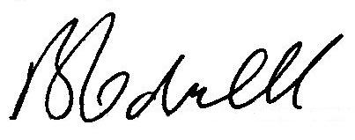

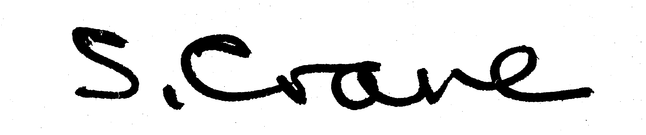
ATL

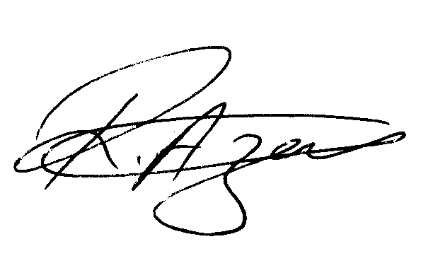
GMB
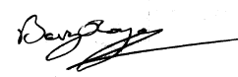

UCU
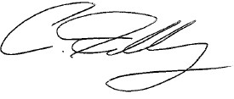

UNISON

UNITE 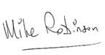

Date of Commencement of this Agreement: December 2009

