NATIONAL RECOGNITION AND PROCEDURE AGREEMENT

BETWEEN

THE ASSOCIATION OF COLLEGES (AoC)

AND

ASSOCIATION FOR COLLEGE MANAGEMENT (ACM)

ASSOCIATION OF TEACHERS & LECTURERS (ATL)

GMB

UNIVERSITY AND COLLEGE UNION (UCU)

UNISON

UNITE – THE UNION

May 2010

1. INTRODUCTION

  - The Further and Higher Education Act 1992 established Further Education Corporations in England and Wales. Each Further Education Corporation is an independent employer responsible for the employment of all staff.
  - The Association of Colleges (AoC) negotiates through the National Joint Forum (NJF) for the purpose of providing recommendations to AoC member Colleges.
  - The signatories to this agreement recognise that employment issues in the sector require a context of stability, which will be best enhanced by negotiation and consultation with the recognised trade unions at a national level.
  - The AoC and the signatory Unions recognise the importance of developing confidence in the machinery established in this Recognition and Procedure Agreement.

2. PURPOSE
The purpose of this Agreement is to establish a National Joint Forum (NJF).

This Agreement is between the AoC and the signatory Unions for the all College employees, excluding designated senior postholders.

The outcome of national negotiations and consultations are recommendations to local Colleges. The signatories to this agreement recognise that The Further and Higher Education Act 1992 gives Corporations the right to determine their own terms and conditions of employment, therefore the national recommendations are advisory only. The signatories to this agreement will, however, promote the national recommendations to their constituent members.

3. GENERAL PRINCIPLES

  - Objectives
a) The AoC and the signatory Unions anticipate that the recommendations produced by the NJF will assist Colleges to function efficiently and effectively to the benefit of both the institution and its staff.

b) The AoC and the signatory Unions accept that nothing in this Agreement is intended to replace, detract from or weaken the direct and positive relationships that exist between individual employees and their employers.

3.2 Recognition
a) The AoC recognises the following Unions for the NJF. The Unions will send representatives to the NJF as per the numbers set out in 4.3 below.

- The Association of College Management (ACM)
- The Association of Teachers and Lecturers (ATL)
- The General Municipal Boilermakers and Allied Trades Unions (GMB)
- University and Colleges Union (UCU)
- UNISON
- Unite – The Union

- The parties acknowledge that the majority of Colleges recognise trade unions.

4. THE NATIONAL JOINT FORUM

  - The existence of this procedure in no way detracts from an employee’s right of access to the Corporation’s management or the Corporation’s right to communicate directly with its employees or the signatory Unions’ right to communicate with their respective memberships.
  - Purpose of the National Joint Forum
The NJF will undertake the following activities:

- negotiate on pay recommendations to individual Colleges in the Further Education sector in England.

- negotiate on employment matters and develop, as appropriate, good practice guidance in relation to employment matters relevant to Colleges across England (and including Wales and Northern Ireland where appropriate).

- undertake work to review the implementation of recommendations to the sector and promote the implementation of such agreements in member Colleges. Similarly the Unions will seek to ensure that any agreements reached are accepted by their members at local level.
4.3 Membership of the National Joint Forum is as follows:
ACM Officers and up to 2 representatives
AoC Officers and up to 8 representatives
ATL Officers and up to 2 representatives
GMB }
UNITE }Officers and up to 8 representatives
UNISON }
UCU Officers and up to 8 representatives

4.4 Mechanics of the National Joint Forum
a) For Pay Negotiations:

The AoC and the Unions will seek to negotiate recommendations that can be made to individual corporations. This will be undertaken in the National Joint Forum. The aim is to secure agreement with as many of the Unions as is possible.
b) For Good Practice Guidance in relation to employment matters;
The NJF will determine areas in which to develop good practice guidance, which will be agreed between the AoC and the relevant Unions. Working parties may be established as appropriate to develop guidance in specific issues and to report back to the NJF. Membership of the working parties will be determined at the time of their convening, and may include agreed external specialists. Such a working group would only be formed to deal with the specific issue in question, with the agreement of the NJF.

4.5 Procedures of the NJF
The joint trade unions will elect a person/s to undertake the role of trade union side Secretary. AoC’s Employment Team will provide the secretariat support for the employers’ side.

A meeting of the NJF can be called by any one of its constituent members through the secretariat. In any event it is expected that the Forum will meet on at least two occasions in any one calendar year.
Meetings will be planned to ensure that all members are able to attend wherever possible. The NJF will not be quorate unless a representative from the AoC and each of the signatory Unions is either present or has agreed that another constituent member will sit on their behalf, or has had the opportunity to make their views known in writing.
Decisions of the NJF will be made on the basis of agreement between the AoC and the majority of the signatory Unions provided that all members have had the opportunity to participate in the decision making process.
4.6 Costs of the NJF
The costs of operating the NJF shall be shared equally by all parties
  - Procedure for Dealing with Unresolved Issues
a) It is agreed that the aim of the NJF is to recommend good practice and to avoid disputes until all stages of the procedures have been exhausted.
b) In the event of the NJF failing to resolve an issue within its defined remit, representatives of the Unions and the AoC shall consider the matter jointly and may, if mutually agreed to do so, refer it to conciliation, arbitration or any other form of assistance.
c) In the event of a disagreement at a Corporation on the interpretation of any national recommendation, the good offices of the AoC and the appropriate Union will be available to assist in resolving that disagreement should both parties locally agree to refer the matter to them.
5. VARIATION AND TERMINATION OF THIS AGREEMENT
5.1 Variations or changes to this Agreement will be by agreement between the AoC and
the Unions.
5.2 Either the AoC or the Unions (collectively) may terminate this Agreement by giving six months’ notice in writing to the other party. Any Union may withdraw individually from this agreement by giving six months’ notice in writing to the AoC.

5.3 Joint agreements on guidance negotiated through the NJF will from time to time become out of date. The NJF is responsible for ensuring that all joint agreements on guidance made under it are kept up to date, in line with changes in legislation and case law.
5.4 This Agreement will operate from the date of all parties signing the Agreement.

NATIONAL RECOGNITION AND PROCEDURE AGREEMENT

SIGNATURES OF THE PARTIES TO THIS AGREEMENT

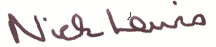

AoC
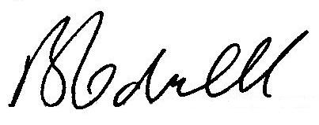

ACM

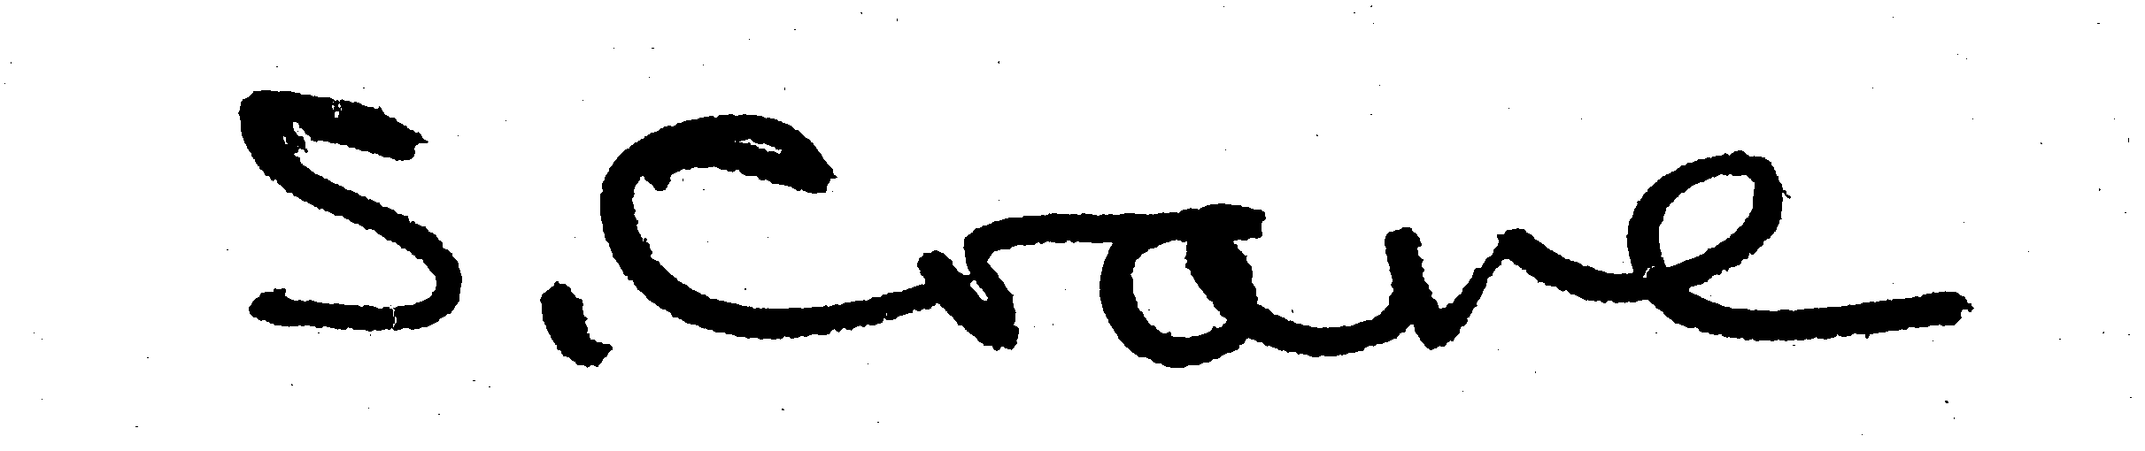

ATL
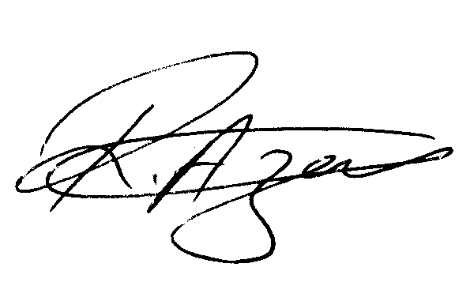

GMB

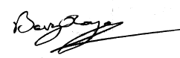

UCU

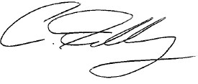

UNISON

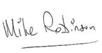
UNITE

Date of Commencement of this Agreement

May 2010

