Joint Agreement on Guidelines for the Development and use of Career Families and Career Pathways in Further Education Colleges

Between

The Association of Colleges (AoC)

and

Association for College Management (ACM)

Association of Teachers & Lecturers (ATL)

GMB

National Association of Teachers in Further and Higher Education (NATFHE)

Transport & General Workers’ Union (T&G)

UNISON

July 2004

Joint Agreement on Guidelines for the development and use of Career Families and Career Pathways in Further Education Colleges

1.1 This agreement on guidelines (hereafter known as “the agreement”) is intended to assist FE colleges involved in the development, implementation and application of career families and career pathways. It has been jointly agreed between the trade unions and the AoC in the National Negotiating Joint Forum. Both sides recommend the agreement to their constituent memberships.

1.2 This guidance should be viewed alongside the National Joint Forum Modernising Pay Arrangements recommendation for 2003/2004, which states:

“A joint agreement on guidelines for career families and career pathways be agreed by 1 April 2004 through the Modernising Pay Arrangements working group, to facilitate the implementation of the career family structure, ensuring equality of pay particularly for part time staff.”
1.3 The pay modernisation framework enables colleges to make a start on tackling staff recruitment and retention issues and develop tools for succession planning. It includes pay harmonisation, performance management, job evaluation and career families and career pathways for example:
- Teaching and Training
- Advanced Teaching and Training
- Leadership and Management
1.4 A series of example role outlines have been distilled from the FENTO occupational standards. Further work is being undertaken by FENTO to develop Business & Learning Support Standards. These will be distilled to produce example role outlines. Both sides recommend them to colleges to facilitate the implementation of the career family structure.

1.5 Learning Support standards are being developed by FENTO and further role outlines will be recommended by the NJF when this work is completed. Further discussions are to be held in the NJF to develop guidance on Business Support role outlines.

1.6 These role outlines are not intended to be prescriptive and may be modified to suit local circumstances. They give a guide to occupational competencies that may be expected within individual career families.

1.7 These guidelines provide a framework for the introduction of career families and career pathways which should be developed locally with staff and within the existing consultation/negotiation arrangements with trade unions at the college.

1.8 The role outlines are also recommended as a tool to assist in the development and operation of performance review schemes by colleges. They complement the NJF National Agreement on Guidelines for Performance Management in FE Colleges, which recommends a developmental model of performance management.

1.9 The career families and pathways scheme should be capable of delivering long-term cultural change which will afford employees the opportunity for acquiring greater opportunities for their own career development and objective setting within the framework of the college’s need to achieve its Success for All targets.

1.10 At the same time a scheme should afford colleges the opportunity to identify and develop longer-term skills requirements, succession planning strategy and career pathways for employees to aid capacity building, recruitment and retention of staff.

1.11 The role profiles can be used to identify the activities required for the jobs employees have or may want to apply for in the future. They may then help to plot career pathways with development activities via performance management; and increase the qualifications, skills, knowledge and experience of staff in line with Success for All targets set by colleges.

1.12 There is no expectation that employees shall have automatic entitlement to posts at a similar level or promoted posts upon the attainment of competencies by reference to the Occupational Standards. Consideration for promoted posts or posts at similar level would, therefore, be by way of the colleges’ locally determined recruitment and selection policy and procedure.

2 Implementation

2.1 This agreement is recommended to Corporations.

2.2 Both sides recognise the guidelines of this Agreement fulfil the requirements of the Employment Relations Act 1999 in respect of consultation with recognised trade unions.

2.3 The principles of this Agreement in respect of access to performance management shall be commended to employment agencies and third party providers engaged by the colleges.

2.4 Colleges may seek access to professional support where requested to assist in the development and introduction of a performance management system.

3 Interpretation, monitoring and review

3.1 The interpretation of any aspect of this Agreement may be referred to the Joint Secretaries of the National Joint Forum for comment and advice.

3.2 This Agreement will be subject to regular monitoring and review and any amendment will be, by agreement, within the National Joint Forum.

Joint Agreement on Guidelines for the Development and use of Career Families and Career Pathways in Further Education Colleges

Signatures of the parties to this agreement


AoC

ACM

ATL

GMB
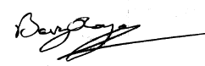
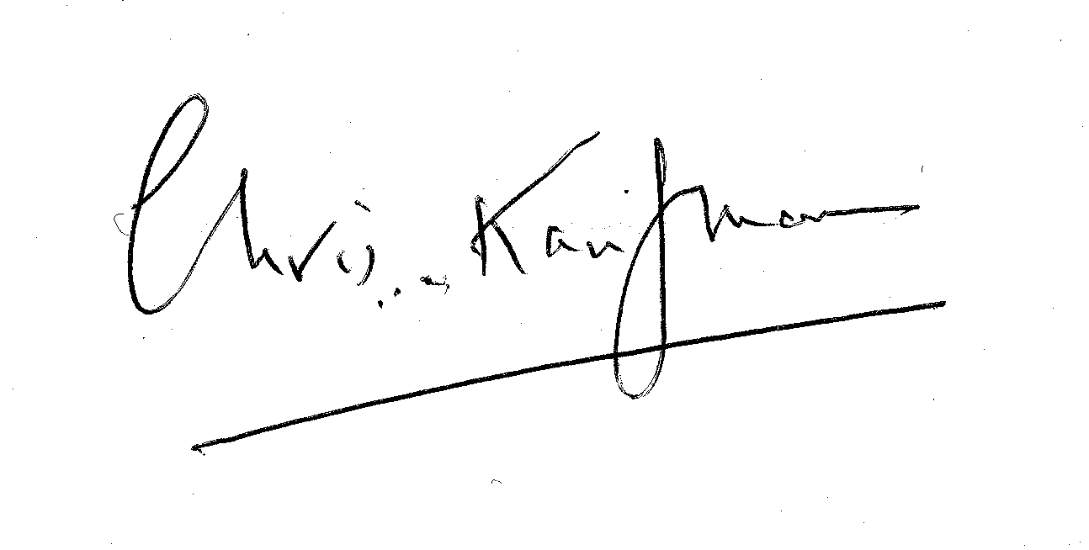
NATFHE

T & G
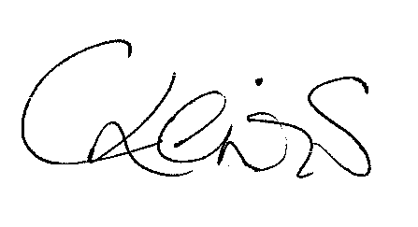
UNISON

Date of Commencement of this Agreement
July 2004

Joint Agreement on Guidelines for the Development and use of Career Families and Career Pathways in Further Education Colleges

Chair of Trade Union side Chair of Employers side
Signed: Signed: Signed:

PRINT: Peter Pendle PRINT: Nick Lewis

Date: July 2004 Date: July 2004

