Joint Agreement on guidelines for the development and implementation of a Job Evaluation Scheme in Further Education Colleges

Between

The Association of Colleges (AoC)

and

Association for College Management (ACM)

Association of Teachers & Lecturers (ATL)

GMB

National Association of Teachers in Further and Higher Education (NATFHE)

Transport & General Workers’ Union (T&G)

UNISON

July 2004

Joint Agreement on guidelines for the development and implementation of a Job Evaluation Scheme in Further Education Colleges

1 Introduction

1.1 This agreement on guidelines (hereafter known as the agreement) is intended to assist FE colleges involved in the development, implementation and application of Job Evaluation. It has been jointly agreed between the trade unions and the AoC in the National Negotiating Joint Forum. The agreement is recommended by both sides to their constituent memberships.

1.2 It provides guidance on the structures required to support effective implementation, appropriate training, and the importance of trade union involvement in the process.

1.3 This guidance should be viewed alongside the National Joint Forum Modernising Pay Arrangements recommendation for 2003/2004 which states:

“A joint agreement on guidelines for Job Evaluation be agreed by 1 April 2004 through the Modernising Pay Arrangements working group. To facilitate the implementation of the career family structure, ensuring equality of pay particularly for part time staff.”

1.4 Where colleges have already adopted and implemented their own Job Evaluation Scheme or alternative approaches to equal pay such as those described in the EOC Equal Pay Review toolkit, we recommend that these colleges ensure that the scheme in use meets the requirements below.

1.5 Both sides recommend the Further Education Job Evaluation (FEJE) Scheme to colleges as it meets the Equal Opportunities Commission’s (EoC’s) requirements of Job Evaluation schemes as set out in Section 2 below.

1.6 The FEJE Scheme has been specifically developed for the FE sector in conjunction with college representatives and the trade unions of the National Joint Forum. It is the only scheme explicitly designed to cover the full range of jobs within further education colleges. This is achieved through:

- The unique FE factor plan
- The method of scoring and weighting of factors
- The questions and logic trees built into the “Gauge” JE software

1.7 This agreement provides a framework for colleges to implement a Job Evaluation scheme.

1.8 This agreement has been jointly agreed between the trade unions and the AoC in the National Negotiating Joint Forum. It constitutes an agreement for the operation of Job Evaluation to all employees in colleges and is recommended by both sides to their constituent memberships.

2 Equal Opportunities Commission (EOC) Guidance on Job Evaluation

2.1 In its Good Practice Guide on Job Evaluation Schemes Free of Sex Bias (EOC) states that:

Non-discriminatory Job Evaluation should lead to a payment system which is transparent and within which work of equal value receives equal pay regardless of sex.
Equal pay legislation requires the Job Evaluation study to have been done by an analytical method, i.e. the study should have been undertaken with a view to evaluating ‘in terms of the demands made on a worker under various headings (for instance, effort, skill, decision)’.

In the leading case Bromley v Quick (1988) the Court of Appeal ruled that a Job Evaluation system can provide a defence against an equal pay claim only if it is analytical in nature. The Employer must demonstrate the absence of sex bias in the Job Evaluation scheme, and jobs will be held to be covered by a Job Evaluation scheme only if they have been fully evaluated using the scheme’s factors.

Employers must also comply with the General Statutory Duty placed by The Race Relations (Amendment Act) 2000 to promote race equality in all relevant functions as explained in the draft Statutory Code of Practice on the Duty to Promote Race Equality produced by the Commission for Racial Equality, and with the requirements of disability discrimination legislation as explained by the Disabilities Rights Commission. The equality of treatment between different ethnic groups and those with and without disabilities required by this legislation includes the need to provide equal pay for work of equal value.

These provisions also extend to cover discrimination on grounds of sexual orientation or religion or belief, family responsibility, marital status, colour, ethnicity, nationality, gender, trade union activity and unrelated criminal convictions and they will be further extended in 2006 to cover age.

2.2 Meeting the need

To meet the need an analytical scheme is necessary which, as defined by the EOC, is one ‘where jobs are broken down into components (known as factors) and scores for each factor are awarded with a final total giving an overall rank order’. In this definition, the EOC is referring to what is commonly known as a point-factor scheme.

2.3 Aims of Job Evaluation

The aims of Job Evaluation are to:

- establish the relative value or size of jobs, i.e. internal relativities
- produce the information required to design and maintain equitable grade and pay structures
- provide as objective as possible a basis for placing jobs within a grade structure
- enable consistent decisions to be made about grading jobs
- ensure that the organisation meets legal and ethical equal pay for work of equal value requirements and the legal and ethical requirements not to discriminate on grounds of disability, family responsibility, marital status, race, colour, ethnicity, nationality, religion belief, gender, sexual orientation, trade union activity and unrelated criminal conviction and further extended to cover age in 2006.

2.4 Features of Job Evaluation Processes

The main features of a Job Evaluation process is that it:

- attempts as far as possible to enable objective judgments to be made about relative job size and gradings
- enhances objectivity by providing factual evidence (job analysis) on which informed judgments can be based rather than relying on opinion or pre-conceptions
- provides a framework of defined yardsticks which will help to channel judgments - to achieve as high a degree of objectivity and consistency as possible, these are based on an analysis of job demands under different headings
- evaluates the job not the person – evaluations take no account of the personal characteristics or performance of individuals, although it has to be recognised that where there is some flexibility, the content of the job can be influenced by the job holder
- does not directly take into account the volume of work

is solely concerned with internal relativities – account is not taken of market rates.

3 Staff and Trade Union Involvement

3.1 Job evaluation gains maximum acceptance in the workplace when it is “owned” by both the employer and the employee. A partnership approach will enhance the quality of the process and promote commitment to its objectives. It is vital that staff have confidence in the process and their recognised Trade Union representatives are both well informed and able to advise, support and accompany them at the request of the employee, throughout each stage of the job evaluation process.

3.2 It is essential that the recognised trade unions be fully informed of the intention to use a Job Evaluation scheme at the earliest opportunity through the established local consultation/negotiation procedure.

3.4 Institutions and recognised local trade unions should consult on the amount of facility time, including cover for duties, that would be reasonable for local trade union representatives to have in order to fully participate in the job evaluation process.
3.5 The facility time should ensure that staff and recognized trade unions:

- Are able to be fully involved in joint discussions about the implementation of the scheme
- Are able to receive sufficient and appropriate training to enable them to work to support the implementation of the scheme. Such training should include training by their trade union (s) and joint training in some aspects of the scheme.

4 Consultation/Negotiation Arrangements

4.1 It is recommended that the responsibility for the implementation of job evaluation should be considered via the existing consultation/negotiation arrangements at the college.

4.2 Reporting to the Principal or other senior manager, such discussions should give consideration to the following:

- An implementation programme including associated documentation.
- Any training requirement in addition to that provided when the Scheme is purchased
- The basis on which jobs are to be selected for evaluation and how the evaluation process will be carried out.
- The arrangements for monitoring and reviewing the evaluation outcomes, including the appointment of a Review Panel
- A communication strategy including regular updates on progress.

4.3 Disputes or grievances that cannot be resolved will be referred to the relevant locally agreed consultation/negotiation procedure.

5 Training

5.1 Full and effective training should be provided to anyone directly concerned with the evaluation including staff and trade union representatives.

5.3 Training should cover, for example:

- The principles of job evaluation
- How the scheme has been developed and the intentions behind it
- The factors and how to interpret them
- Techniques in job analysis/interviewing
- Conducting job evaluations
- Reviewing and Auditing the evaluation outcomes
- Equal value considerations
- Administration of the evaluation programme
- Use of Job Evaluation software
- Mechanisms to ensure fair treatment and anti-discriminatory practice for all full and part-time staff irrespective of disability, family responsibility, marital status, race, colour, ethnicity, nationality, religion belief, gender, sexual orientation, trade union activity and unrelated criminal conviction and further extended to cover age in 2006.

6 The Link to Pay

6.1 The outcome of an evaluation exercise is simply a rank order of jobs based on their job evaluation scores.

6.2 Colleges installing a JE Scheme, should, determine through the local consultation/negotiation procedures at the college how the scheme will link to pay and reflect in the colleges grading and pay structure. The link with pay policy should include any pay protection arrangements.

6.4 The general principle is that no-one’s pay should be reduced because of the job evaluation review. However, consideration has to be given to the extent to which protection should be provided for future pay increments. Indefinite protection will breach equality legislation if it affects predominately one gender (and is essentially “unfair’ to other employees). Opportunities should also be provided to enable such individuals to take higher paid work roles. This should be dealt with through existing local trade union consultation arrangements giving due regard to the context for each particular college.

6.5 The need for transparency in pay means that individual employees and trade unions should be fully aware of the methods used to determine gradings and relate them to pay. Having a joint approach to both grading and pay reviews involving the unions normally keeps problems related to transparency to a minimum.

7 Appeals

7.1 Each college should establish a procedure that provides a means for an appeal against the outcome of Job Evaluation. A procedure should not remove any individual’s entitlement to invoke the local grievance procedure.

8 Sharing Best Practice
8.1 Sharing best practice within and beyond an individual college is recognised as a cost-effective way of maximising the value added benefits that can be achieved from job evaluation.
9 Evaluation
9.1 The implementation of the college’s job evaluation scheme will be evaluated against clear criteria. The results of the evaluation should be communicated to appropriate staff and trade union representatives.
9.2 Particular care should be taken in the evaluation process to ensure that there is no discrimination on the grounds of age, disability, family responsibility, marital status, race, colour, ethnicity, nationality, religion and belief, gender, sexual orientation, trade union activity, or unrelated criminal conviction and that all staff, full-time, part-time or fixed-term have equal access to the scheme.
10 Implementation

10.1 This Joint Agreement is recommended to Corporations.

10.2 Both sides recognise the Agreement fulfill the requirements of the Employment Relations Act 1999 in respect of consultation with recognised trade unions.

10.3 Colleges may seek professional support to assist in the development and introduction of job evaluation

11 Interpretation, monitoring and Review

11.1 The interpretation of any aspect of this Agreement may be referred to the Joint Secretaries of the National Joint Forum for comment and advice.

11.2 This Agreement will be subject to regular monitoring and review and any amendment will be, by agreement, within the National Joint Forum.

Joint Agreement on guidelines for the development and implementation of a Job Evaluation Scheme in Further Education Colleges

Signatures of the parties to this agreement


AoC

ACM

ATL

GMB

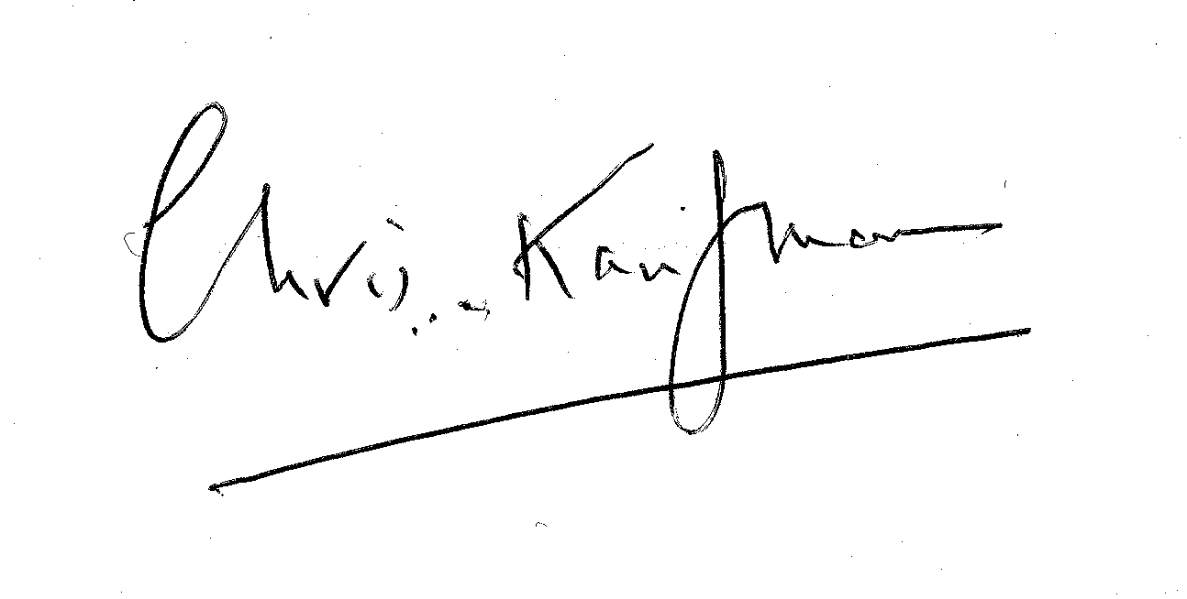
NATFHE

T & G

UNISON

Date of Commencement of this Agreement
July 2004

Joint Agreement on guidelines for the development and implementation of a Job Evaluation Scheme in Further Education Colleges

Chair of Trade Union side Chair of Employers side
Signed: Signed: Signed:

PRINT: Peter Pendle PRINT: Nick Lewis

Date: July 2004 Date: July 2004

