Joint Agreement on Guidelines for Performance Management in Further Education Colleges

Between

The Association of Colleges (AoC)

and

Association for College Management (ACM)

Association of Teachers & Lecturers (ATL)

GMB

National Association of Teachers in Further and Higher Education (NATFHE)

Transport & General Workers’ Union (T&G)

UNISON

July 2004

Joint Agreement on Guidelines for Performance Management in Further Education Colleges

- Objectives
1.1 A successful college is dependant on teams and individuals who are clear about what is expected of their role, who regularly receive feedback on how they are performing and are encouraged to develop their capabilities. Success for All requires colleges to review and where necessary implement strategic and operational change for quality staff and student success. It requires a new system of targets and performance management. This change will impact on individual roles and responsibilities and will need to be reflected in any performance management scheme.
  - It is therefore recommended that all colleges introduce a performance management scheme in which all college staff would participate.
  - Both sides recognise that a performance management scheme is a shared process between managers and the individuals and teams they manage and should be subject to regular review and evaluation of effectiveness.
  - These guidelines provide a framework for the introduction and operation of a performance management scheme which would be developed locally with staff and within the existing consultation/negotiation arrangements with trade unions at the college.
  - Most colleges already have effective appraisal arrangements in place and this guideline agreement should encourage development of these existing schemes. It is expected that completely new schemes need only be introduced where no scheme currently exists or where the existing arrangements are not considered to be suitable.
  - This is a national agreement on guidelines (hereafter known as the agreement) which has been jointly agreed between the trade unions and the AoC in the National Negotiating Joint Forum. The guidelines constitute a Joint Agreement on guidelines for the operation of a performance management scheme to all employees in colleges and are recommended by both sides to their constituent memberships.
- Key Principles that would apply to any Scheme
  - In designing the performance management scheme, linkages must be made to other aspects of employee motivation and development including training and development and promotion.
  - The agreement provides for a developmental model of performance management in which objectives and outcomes are focussed on the professional development of staff related to colleges training and development policies and procedures. Issues of discipline or capability should be handled separately under the relevant local specific procedural agreement. This agreement is not intended to require the performance management scheme to be used for the determination of salary increases or bonuses where paid. Issues of pay should be determined through the college’s pay review policy.
  - All employees irrespective of status, hours worked, or type of contract must be able to participate in the scheme.
  - The design must ensure that no bias or unfair discrimination is permitted either directly or indirectly.
  - The scheme should be owned by all parties with ownership created through involvement in the design, implementation and review.
  - Appropriate training should be provided to all staff (appraisers and appraisees) on the operation of the scheme and the skills needed.
  - When managing the performance of teams and individuals, it is recommended that both inputs and outputs as well as the means of achieving them are taken into account.
  - Clear and detailed information should be provided to all staff prior to the introduction of a scheme.
- Suggested Model to be used or Adapted

3.1 There should be three parts to the process; planning performance, managing performance and reviewing performance.
  - “Planning Performance” would normally involve establishing individual/team objectives, discussing job expectations, personal training and development planning and the setting of performance standards. The requirements of Success for All and the need to deliver agreed funding targets will provide college staff with a major source of suitable personal objectives against which their performance can be assessed.
  - “Managing Performance” is an on-going process which takes place during the year and would include coaching, mentoring, feedback, interim formal reviews, self-monitoring, motivating management styles and the monitoring of training and development activities.
  - “Reviewing Performance” revolves around the formal review of performance and performance measurement. This process should involve a dialogue between appraiser and appraisee. Key outcomes of this review, and in particular training and development needs, would feed into the next performance planning cycle.
  - A mechanism for appeal should be provided. This appeals process may be a purpose-designed scheme or it may be included within an existing grievance procedure.
- Values That Underpin Any Performance Management Scheme

4.1 “Transparency”. All staff should be briefed on and be familiar with all aspects of the process, the respective roles of everyone involved and the potential outcomes. People affected by decisions emerging from the performance management process should have the opportunity to scrutinize the basis upon which decision were made.
4.2 “Respect for the individual”. Staff should be treated with dignity and respect.
4.3 “Procedural fairness”. The procedures incorporated in performance management should be operated fairly, ensuring equity and openness.
4.4 “Honesty”. The outcomes of a performance management process are only as good as the objectivity and honesty of all who are involved.

4.5 Agreed targets and objectives set as part of performance management scheme should be ‘SMART’(Specific, Measurable, Achievable, Realistic and Time framed).

- Training to Support Effective Operation
5.1 It is agreed by both parties that thorough training for both managers and individuals in the skills required to operate performance management effectively must be provided prior to commencement of the scheme.
5.2 Such training might include role play activities to help in developing skills in setting objectives, providing objective feedback and handling poor performance.

5.3 Steps must be taken to ensure that all new staff are provided with training at the earliest available opportunity preferably as part of their induction programme.

- Sharing Best Practice

6.1 Sharing best practice within and beyond an individual college is recognised as a cost-effective way of maximising the value added benefits that can be achieved from performance management and ensuring consistency and best practice across the college.
- Evaluation
7.1 The implementation of the college’s performance management scheme will be monitored and evaluated against clear criteria. The results of the evaluation should be communicated to all staff and to recognised trade unions through locally recognised consultation/negotiation arrangements at the college and will inform the next performance management cycle.

7.2 Particular care should be taken in the monitoring and evaluation process to ensure that there is no discrimination on the grounds of age, disability, family responsibility, marital status, race, colour, ethnicity, nationality, religion and belief, gender, sexual orientation, trade union activity, or unrelated criminal conviction and that all staff, full-time, part-time or fixed-term have equal access to the scheme. In respect to all these issues colleges are advised to refer to the relevant National Joint Forum Agreements on Guidelines.
- Implementation

8.1 This agreement is recommended to Corporations.

8.2 Both sides recognise the guidelines of this Agreement fulfil the requirements of the Employment Relations Act 1999 in respect of consultation with recognised trade unions.
8.3 The principles of this Agreement in respect of access to performance management shall be commended to employment agencies and third party providers engaged by the colleges.
8.4 Colleges may seek access to professional support where requested to assist in the development and introduction of a performance management system.

- Interpretation, Monitoring and Review
9.1 The interpretation of any aspect of this Agreement may be referred to the Joint Secretaries of the National Joint Forum for comment and advice.
9.2 This Agreement will be subject to regular monitoring and review and any amendment will be, by agreement, within the National Joint Forum.

Draft Joint Agreement on Guidelines for Performance Management in Further Education Colleges

Signatures of the parties to this agreement


AoC

ACM

ATL

GMB
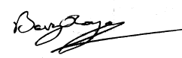
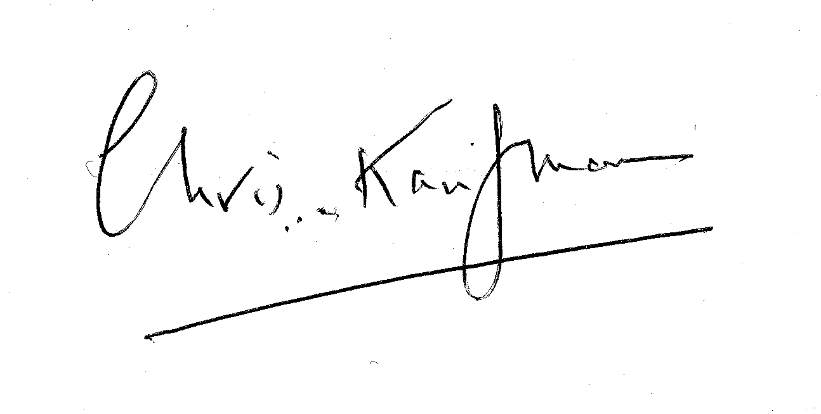
NATFHE

T & G
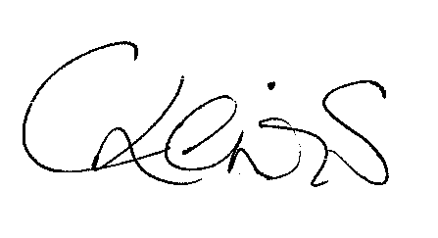
UNISON

Date of Commencement of this Agreement
July 2004

Joint Agreement on guidelines for the development and implementation of a Job Evaluation Scheme in Further Education Colleges

Chair of Trade Union side Chair of Employers side
Signed: Signed: Signed:

PRINT: Peter Pendle PRINT: Nick Lewis

Date: July 2004 Date: July 2004

