Joint Agreement on Guidelines for
Sex Equality in
Further Education Colleges

Between

The Association Of Colleges (AoC)

and

Association for College Management (ACM)

Association of Teachers & Lecturers
(ATL)

GMB

National Association of Teachers in Further and Higher Education (NATFHE)

Transport & General Workers’ Union (TGWU)

UNISON
- Introduction

  - This guidance has been developed jointly to equip Colleges to meet their obligations under The Sex Discrimination Act 1975, The Equal Pay Act 1970, The European Equal Treatment Directive (75/207) and other relevant legislation.

  - The Government has stated its intention to extend the positive duty on employers to promote equality and good relations between members of different groups to cover sex as well as race. This document is intended to support Colleges towards achieving that end.

- Our Commitment.

  - The College celebrates and values the diversity brought to its workforce by individuals, and believes that the College will benefit from employing both women and men at all levels of responsibility, and across all areas of work, thus hoping to provide role models for both female and male students in whatever area of the curriculum they are interested in. The College will treat all employees and students with respect and dignity, and seek to provide a positive working and learning environment free from sex discrimination, harassment or victimisation.

  - The College will seek not only to eliminate sex discrimination, but also to create a working and learning environment based on good relations between women and men. To this end, the College undertakes to provide diverse, non-stereotypical images of women and men in any material which it produces for learners and staff. The aim is to create a positive inclusive ethos where issues of sexism and stereotyping can be discussed openly, with a shared commitment to challenging and preventing sexism and sex discrimination, to respecting diversity and difference, and to encouraging good relations between women and men.

  - The College will work towards the elimination of sexism whether overt or covert, and will seek to ensure that male and female students have equal access to all learning programmes and facilities.

- Our Legal Duties.

The College undertakes to fulfil all the legal duties put upon it by

  - The Sex Discrimination Act 1975 and The Equal Treatment Directive (75/117) (i.e. there will be no discrimination against staff, either directly or indirectly on grounds of sex or marital or family status in access to employment, training, working conditions, treatment at work, promotion or dismissal; nor will there be discrimination in the way the College admits or treats students.).

  - The Equal Pay Act and The Equal Pay Directive (75/117) (see The Equal Pay Policy for more details.)

  - The wide range of other legislative provision which relates to sex discrimination, including:

The Employment Rights Act 1996
The Human Rights Act 1998
Pensions Act 1995
Protection from Harassment Act 1997
Maternity and Parental Leave Regulations 1999
The Employment Act 2002

- Meeting our Legal Duties

The College already has many policies in place which allow it to meet its legal duty not to discriminate on grounds of sex.

  - The College will not discriminate on grounds of sex in the way it recruits and selects staff. Details are to be found in The Recruitment and Selection of Employees Policy.

  - The College will ensure that all of women’s maternity rights are met, as are parent’s rights to parental leave. For details, see The Maternity Leave Policy and The Parental Leave Policy.

  - The College will ensure that male and female members of staff have equal access to all forms of training and staff development, and will monitor to ensure equal take-up of training opportunities by women and men. For more details, see The Training and Development of Employees Policy.

  - The College will ensure that there is no sex discrimination in relation to dismissal of staff. In particular, should a redundancy situation occur, it will ensure that sex is not a factor in the selection of those to be made redundant. For more details see The Redundancy Handling Procedure.

  - Sexual harassment is viewed by the College as a very serious offence, which if proven may in certain circumstances lead to the dismissal of a member of staff, or the expulsion of a student. For details of handling harassment claims, see The Harassment Policy.

- Ensuring Equality Between Women and Men.

The College is committed in its role both as employer and as education provider to work to eliminate sexism in its structures, employment practices and curriculum content, as well as to encourage changes in individual behaviour and attitudes, and ensure equality of opportunity and treatment for women and men.

  - The College recognises that, despite legislative attempts to achieve equality, women are still subject to discrimination, lack of opportunity and social injustice. Women are still disproportionately found in lower-paid employment, concentrated into a narrow range of jobs, and under-represented in management jobs in society generally.

  - The College will try to mitigate the effects of these social trends by a) encouraging students of both sexes onto the whole range of the curriculum and b) by auditing its staff to see if there is any sex discrimination in terms of recruitment to senior positions and in promotion.

  - If the result of a staff audit shows that there is an under-representation of women at higher levels, or that women are less likely to be promoted, the College will review its practices, including recruitment and promotion practices, to ensure they are free of sex bias. In addition, women only training in management should be offered.

  - The College recognises that there is a continued expectation that women should take the major responsibility for childcare, care of other dependent relatives and housework, and that in practice, women still bear the brunt of these responsibilities. The College accepts that, as a result of these inequalities, it will need to undertake special measures to ensure genuine equality of access for women staff and students. These will include the provision of nurseries/crèches for both staff and students, the provision of facilities for pregnant women and mothers, and a flexible approach to timetabling to assist those with family responsibilities.

  - The College recognises that stereotyped gender roles can be harmful to both women and men, who may feel constrained to behave in ways, and work in areas traditionally considered appropriate for their sex. Encouragement and support will be given to staff and students who are trying to step outside the constraints of stereotypes in any area of the College’s work.

6 Provision for those with dependents.

The College recognises that both staff and students are likely at times to have special issues in relation to the care of dependents, and that while this is likely to impact disproportionately on women, men too are sometimes affected. The College will make every effort to meet the needs and requirements of staff and students with such responsibilities.

  - Details relating to compassionate, adoption, paternity, fertility treatment and dependents’ leave are set out in The Family Purposes and Dependents Leave Policy.

  - The College will provide support for staff returning after a break caused by caring responsibilities, and induction courses for mature students returning to study.

  - For staff with significant caring responsibilities returning to work after a career break, the College will treat sympathetically requests to Job Share, or to move from a full-time to a part-time contract for a specified period.

  - The College, when producing timetables for teaching staff or work patterns for support staff, will adopt a flexible approach which endeavours, whenever possible to meet the individual needs of staff with caring responsibilities.

  - Timetabling of courses, particularly those with a high proportion of mature students, will take account of the needs of students with caring responsibilities.

7 Part-Time Working

The College recognises that a disproportionate number of its part-time workers are women, for reasons related to the greater burden of caring responsibilities that they bear. The College therefore accepts that any unequal treatment of part-time workers is likely to have more adverse impact on women than on men. To avoid sex discrimination, the College resolves to adhere closely to The Employment of Part-Time Employees Policy.

8 The Curriculum

The College recognises that the content and delivery of the curriculum can be a major factor in either challenging or sustaining sexist attitudes and actions.

8.1 The College will audit the curriculum in all subject areas to ensure that it contains no sexist or discriminatory material, and that it provides positive, non-stereotypical content for both women and men.

8.2 Recognising the overwhelming extent to which take-up of courses by students reflects traditional gender roles, thus perpetuating the segregation of the job market, the College will do all in its power to encourage male students to consider courses traditionally taken by women, and female students to consider courses traditionally taken by men. Accepting the importance of role models, the College will also try to increase numbers of women teaching staff in male-dominated areas and vice-versa.

8.3 Equality training programmes for both staff and students will include anti-sexist material.

9 Monitoring and Positive Action.

9.1 The monitoring process will be used to ensure that male and female staff and students are treated equally.

9.2 To inform the setting of targets and the measurement of progress in achieving them, the College will collect and analyse the following information by sex.

9.3 For Learners

- Ratio of male to female students in the college overall, and on each course.
- Applications, success and failure rates for admissions to courses.
- Retention rates.
- Achievement rates.
- Disciplinary action.

9.4 For Employees.

- Sex profile of employees by grade/salary scale and type of work.
- Job application rates.
- Selection success rates.
- Type of contract (permanent, temporary)
- Training/Staff Development
- Promotion application and success rates
- Disciplinary/capability proceedings
- Grievances
- Exit Surveys.

9.5 The College undertakes, once the results of monitoring are available, to consider targets to reduce any disadvantage suffered by male or female employees or learners. The targets will be published annually in an Action Plan.

10 Division of Responsibilities

10.1 Governors are responsible for ensuring that:

- The membership of the Corporation has near-equal representation of women and men

- The College’s strategic plan includes a commitment to sex equality

- Equalities training features as part of the College’s strategic plan

- They are aware of the Corporation’s statutory responsibilities in relation to sex legislation as an employer and service provider

- They receive and respond to the sex monitoring information on learners and staff.

10.2 Managers are responsible for ensuring that:

- The College Principal/Chief Executive and Senior Management Team are responsible for taking the lead in creating a positive, inclusive ethos that challenges sexist behaviour on the part of the managers, staff or learners

- They are aware of the College’s statutory duties in relation to sex legislation

- All aspects of College policy and activity are sensitive to gender issues

- Sex monitoring information is collected and analysed

- Curriculum areas are required to assess performance in relation to gender issues and take action as appropriate

- The procedures for the recruitment and promotion of staff enshrine best practice in equal opportunities

- Targets are set on the recruitment and promotion of staff based upon the analysis of sex monitoring information

- The College’s publicity materials present appropriate positive and non-stereotypical messages about women and men.

- Learner induction programmes and tutorial programmes reflect the College’s commitment to promote equality of opportunity

- Appropriate training and development is provided to support the appreciation and understanding of diversity.

10.3 Staff are responsible for ensuring that:

- They are aware of the College’s statutory duties in relation to sex legislation

- Their schemes of work, lesson content and teaching resources demonstrate sensitivity to issues of cultural diversity

- They challenge sexist behaviour by learners, work placement providers, outside contractors or other members of staff

- The College and each of its individual staff confront sexism, whether witting or unwitting, whenever it occurs.

11 Publicising Our Policy and Progress

11.1 To the public (including learners, work placement providers and staff):

- Our commitment to sex equality will be highlighted in our prospectus, annual report and annual financial statement

- A summary of the results of our monitoring information will be included in our annual report and annual financial statements, where this does not breach individual confidentiality.

11.2 To learners:

- All learners will receive a summary of this policy. Copies of the policy will be on display in the College.
- The induction programme for learners will highlight the College’s commitment to sex equality, the action to be taken by learners who suffer discrimination and the action to be taken against such perpetrators of discrimination

- Student tutors will reinforce this information during tutorials or work-based monitoring visits.

11.3 To work placement providers:

- All work placement providers will receive a summary of their responsibilities under the policy and will signify their understanding of, and agreement to, these responsibilities.

11.4 To staff:

- All staff will have access to or receive a full copy of the policy as part of the Staff Handbook

- The staff induction programme will highlight the College’s commitment to sex equality, action to be taken by staff who suffer discrimination and the action to be taken against any perpetrators of such discrimination

- A summary of the results of our monitoring information will be included in the appropriate College publication (e.g.newsletter). Any published information will have due regard for individual confidentiality.

12 Complaints

12.1 The College will seek to provide a supportive environment for those who make claims of discrimination or harassment.

12.2 Acts of sex discrimination (direct or indirect), harassment, victimisation or abuse will be treated as a serious disciplinary offence.

12.3 Staff who feel they are being discriminated against on grounds of sex by other members of staff should raise the matter under the Grievance/Harassment Procedure, which will, if the accusation is upheld, be treated as a serious disciplinary offence.

12.4 If, in the course of their work, College staff suffer sex discrimination from members of the public, the College will take appropriate action and provide appropriate support.

12.5 Any sexist behaviour directed against staff by students will be dealt with under the student disciplinary procedure.

13 Review and Consultation

13.1 This policy will be reviewed on a regular basis in accordance with legislative developments and the need for good practice, by the College Equality Forum.

13.2 As part of the review the Equality Forum will seek and take into account the views of stakeholders including; learners, work placement providers, the local consultation/negotiating arrangements within the College, and appropriate equality bodies (i.e. EOC).

14 Implementation

14.1 The College, working in consultation with the recognised trade unions and employee representatives, will seek to ensure that all staffing policies and procedures (e.g. Recruitment and Selection Procedure) are non-discriminatory, and that monitoring and positive action processes are regularly reviewed and monitored.

15 General

15.1 This policy should not be read in isolation, but cross-referenced with all relevant College employment and student policies.

16 Definition of Joint Agreement

16.1 The Agreement on this guidance is intended as a recommendation to Colleges relating to Sex Equality issues.

JOINT AGREEMENT ON GUIDELINES FOR SEX EQUALITY IN FURTHER EDUCATION COLLEGES

SIGNATURES OF THE PARTIES TO THIS AGREEMENT

AoC ……………………………………………


ACM


ATL


GMB
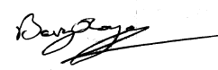

NATFHE
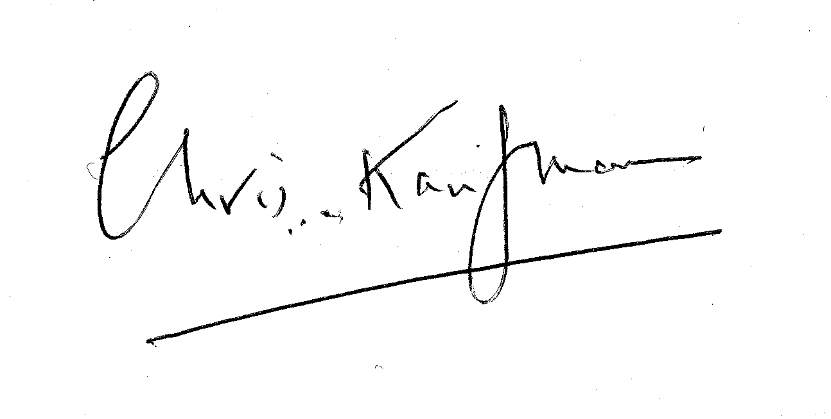


TGWU

UNISON

Date of Commencement of this Agreement

……………………………………………….

