
IN THIS ISSUE OF HE NEWS:-

No 13 May 2008

- PACKED AGENDA FOR HE CONFERENCE
- LIFE CHANGERS 2008 – MAJOR AWARDS PRESENTED
- INTO STRUGGLES AS UCU CAMPAIGNS STEP UP IN GEAR –
- ESSEX VC FEELS THE HEAT
- GLASGOW CALEDONIAN UNIVERSITY LAUNCHES PETITION
- HIGHER EDUCATION AT WORK CONSULTATION: VIEWS/COMMENTS SOUGHT
- ORGANISING SUCCESS AT REGENT’S COLLEGE

PACKED AGENDA FOR HE CONFERENCE
HE delegates to the UCU Annual Congress HE in Manchester next week have a full agenda for the Sector Conference during the Thursday session.
As well as our continuing campaign to retain national bargaining and the debate over new bargaining structures, other key topics include the future of research assessment, our campaign against the withdrawal of funding for equivalent and lower qualifications, employers equality duties, professorial pay, protection for hourly paid staff, academic workloads, the organisation of academic related staff, the pressures on health educators, the waiving of fees for students seeking asylum and the future of pensions.
More at www.ucu.org.uk/index.cfm?articleid=3279
If you have any views on these issues let your LA/Branch delegates know before they attend.
LIFE CHANGERS 2008 –
Peoples’ Lawyer and 24/7 tutor win major prizes at second Life Changers Awards:
UCU’s second Life Changers Awards celebration took place on the evening of Wednesday 14 May with 13 awards presented and major awards going to Professor Donald Nicolson from the University of Strathclyde and Sarah Thorrington from Stoke-on-Trent college.
Professor Nicolson was chosen by the judges’ panel for his work in setting up a Law Clinic in Glasgow that gives law students hands on experience giving advice to people who would otherwise not be able to get legal assistance. A political refugee from Apartheid South Africa, Professor Nicolson was inspired by his experience of a similar scheme at the University of Cape Town, working with the local townships.
Sarah Thorrington was recognised for her commitment to bringing literacy learning to workers in ‘hard-to-reach’ industries, in particular, those who work unsociable hours and in difficult locations. Sarah’s dedication has seen her delivering classes at the Post Office or Sainsbury’s in the small hours of the morning.
UCU general secretary, Sally Hunt, said: “Donald Nicolson has transformed the lives of thousands of people - students and clients alike - in his quest for a more just society where everyone has access to legal advice, not just those who can afford it. Donald represents the commitment to causes and subjects that we find across education; exceptionally bright, talented people who could go off and earn obscene amounts of cash elsewhere, but choose not to because they want to make a real difference and change lives.
“Many people want to learn but practically it is not possible due to work and family commitments. Through her dedication, Sarah Thorrington is making learning convenient and opening up opportunities to people who would otherwise have been denied them. I am immensely proud that UCU had the opportunity to recognise the work of these two fantastic Life Changers and the work they and so many UCU members do day in day out.”
Sarah and Donald were two of 13 Life Changer nominees; the other 11 all won £300 prizes. More information on Sarah and Donald and details of all the nominees can be found at http://www.ucu.org.uk/changinglives

Life Changers is about building greater public awareness of and support for the work our members do every day. The Life Changers Awards enable us to tell stories that are about collective effort and
commitment through individual stories. You can read more about the Life Changers Awards celebration at: http://www.ucu.org.uk/index.cfm?articleid=3292

ESSEX VC FEELS THE HEAT
UCU's campaign against the higher education privatising company INTO has stepped up a gear. At Essex University, UCU's all-staff referendum on the proposed joint venture has drawn a defensive response from the VC.

After a lengthy quiet period at Essex when the university said very little about its negotiations with INTO University Partnerships, Essex' VC Professor Colin Riordan broke his silence in response to an email headed HELP STOP PRIVATISATION AT ESSEX sent to Essex staff on 14 May from UCU’s campaigns team, inviting all staff to vote in a UCU referendum on INTO at Essex.

In his email to staff the next day, the VC said that “discussions are still at an exploratory stage, but we have entered them on the clear understanding that ... all staff would be employed by the University on University terms and conditions” repeating the formula that he has stated before. He also said that discussions are expected to continue for “some time” before any formal proposal can be made, and assured staff that the University's full decision making processes would apply, including Senate and Council.

The University Council meets on 21 July and Essex UCU, working with the Campaigns Unit, is determined to put the case against INTO to Council members and staff before that meeting. The VC has previously stated that no decision would be taken before 21 July, but he has never stated that the decision would be later than that.
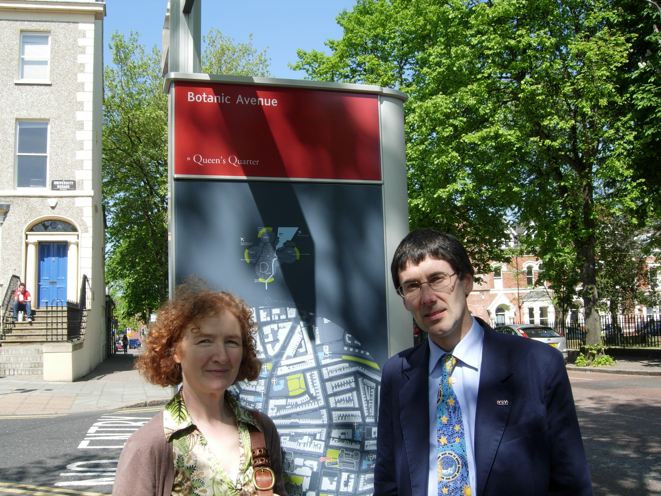
Essex UCU Vice-President, Dr Steve Sangwine, said “Our members voted overwhelmingly in February to call on the VC to cease negotiations with INTO, and we intend to stop this company setting up its business at Essex.

We are especially keen to make sure INTO cannot operate at Essex from October 2008, which there is every indication they are trying to do.”

As part of the wider campaign against INTO, Steve travelled to Queen's University in Belfast on 14 May to speak to a General Meeting of Queen's UCU in support of a motion on INTO, which was passed unanimously (in pictures, Steve in Belfast with Renee Prendergast, President of the branch there).

Overall it has been bad news for INTO.
INTO the Scottish Parliament
At Glasgow Caledonian university, the branch has launched a petition for all Scotland UCU members.
Staff at Glasgow Caledonian University, GCU, are taking their campaign against the privatisation of foreign student recruitment by INTO to the Scottish Parliament. The Combined Union Committee is collecting signatures for a petition to the public petitions committee. Residents in Scotland can sign this online at the UCU Scotland web page, www.ucu.org.uk/Scotland/ or print off the petition to circulate. Additionally Elaine Smith MSP has put down a members motion which is attracting cross party support from MSPs and UCU is encouraging Scottish members to ask their MSPs to support the motion.
INTO has attempted to strike a deal with GCU without the knowledge of unions by claiming the deal is commercially sensitive and thus pushing it through Court in confidential meetings. Hence all branches should be vigilant to ensure secret deals are not being pursued at your institution.
At Queen's University Belfast, the Local Association this week passed a motion pledging to campaign against any deal that did not protect academic standards and staff terms and conditions.
With INTO's chairman Andrew Colin admitting publicly that his company paid staff less and was currently running a loss, now is the time step up the campaign against INTO. The company badly needs to sign more deals.
WHAT CAN YOU DO: UCU has produced briefing materials which include the testimony of UCU members and employees of INTO ventures and we are looking to update this all the time. If you think your university is negotiating with INTO, contact us by emailing campaigns@ucu.org.uk
HIGHER EDUCATION AT WORK CONSULTATION: VIEWS/COMMENTS SOUGHT
In April the Department for Innovation Universities and Skills (DIUS) published its higher level skills strategy paper. Entitled ‘Higher Education at Work – High Skills: High Value’, the paper outlines official plans to increase the proportion of adults with level 4 qualifications and above. The Government seeks to do this by changing the nature and extent of ‘employer engagement’ in higher education. In essence, they want “…to make real a vision for the future where businesses are willing to pay for provision because they can see a direct connection between what students are learning and increased productivity. We need HE providers to win new markets as businesses and employers become convinced of the value of high level skills.”
Some of the proposed initiatives include:
- setting targets for more students to take ‘two year’ degrees;
- empowering Sector Skills Councils to increase the number of employer “co-funded” courses, including testing a new “co-purchasing” role;
- encouraging the movement of staff between business and higher education;
- expanding university accreditation of employers in-house training;
- devising new ways of measuring and rewarding HE employer engagement work.
UCU welcomes members’ views and comments on the DIUS consultation paper. Please can you send them to Rob Copeland rcopeland@ucu.org.uk no later than Friday 20 June.
A full list of the consultation questions can be found on pages 35-6 in the DIUS paper www.dius.gov.uk/consultations/documents/Higher_Education_at_Work.pdf
ORGANISING SUCCESS AT REGENT'S COLLEGE

The Higher Education Committee meeting in April authorised the formation of a new branch at Regent’s College in London.
This follows a significant expansion of membership at the institution. Branch officers have been elected, and an approach has been made to the senior management requesting full recognition for UCU.
Regent’s College is a charitably-funded higher education institution which is currently seeking degree-awarding status. Our members are committed to making a contribution towards the achievement of this status, but it is crucial that the staff voice is heard in the development of the strategy.
Staff at the College are making it clear that they want UCU to be the vehicle for their views to be articulated, and we hope that management will respond positively to our recognition approach.

_______________________________________________________________

STOP PRESS

News that Rachel Curley, assistant general secretary (HE) gave birth to a baby boy on Sunday 18 May - Mother and baby are doing fine.

Congratulations from HE NEWS!

_________________________________________________________

