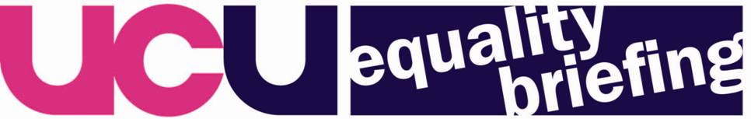

16 July 2009

Consultation on the specific duties

The Government Equalities Office has recently published its proposals for a set of specific duties for the new general public sector duty in the Equality Bill.

UCU’s Equality Committee has discussed the consultation document and has a number of detailed concerns which are set out below.

The closing date is 30 September 2009. You are asked to send comments or items for inclusion in UCU’s submission to Rachel Curley, rcurley@ucu.org.uk, by 31 August. It would be particularly helpful if you could provide examples of where the current specific duties have helped to achieve better equality outcomes for staff or students.

The full consultation document is available at: http://www.equalities.gov.uk/pdf/Specific%20Duties%20Consultation%20DocumentWEB.pdf

Proposed specific duties

a) Develop and publicly set out equality objectives

The consultation document proposes that public bodies will be required to develop and publicly set out their equality objectives, taking account of the evidence they have gathered and as a result of consulting and involving representatives from protected groups. The consultation document proposes that public bodies should not be required to set equality objectives in respect of each protected characteristic.

UCU comment

UCU is extremely concerned about the proposal that public bodies should not be required to set equality objectives in respect of each protected characteristic. We very much welcomed the extension of the general duty to cover age, religion and belief and sexual orientation. However, if employers are given the choice not to set objectives against one or more of the protected characteristics this will significantly weaken the potential impact of the legislation. We have very real concerns that a number of areas will be put in the “too difficult” box.

UCU is also concerned about the emphasis given in the consultation document to service delivery and service users. We not do want any focus on the obligations on public authorities as employers to be lost.

b) Reporting on progress in achieving the equality objectives

The GEO proposes that public bodies should have a specific duty to report annually on progress against their equality objectives but do not intend to prescribe the means by which they should do so.

UCU comment

UCU believes that the regulations to introduce the specific duties should prescribe the means by which public bodies should report on progress. This should include detail about how and to whom progress should be published.

We believe that public bodies should be required to report annually on progress against equality objectives relating to all protected characteristics.

c) Reporting on important equality data in the workforce

The consultation document proposes that all public bodies with 150 or more employees will be required to report annually on their gender pay gap, their ethnic minority employment rate and their disability employment rate.

There is no requirement to publish any more than an overall median gender pay gap figure, and their employment rates, although public bodies are encouraged to supplement these figures with more information that helps put the figures into context.

UCU comment

UCU believes this proposed specific should be strengthened to require all employers to carry out regular comprehensive equal pay audits. The pay gap between male and female employees remains shamefully wide. In Higher Education the gender pay gap between the mean average earnings of teaching professionals is 18.2%. In Further Education it is 8.6%. (Annual Survey of Hours and Earnings 2008).

In the further education and higher education sectors UCU, along with the other recognised unions, has national agreements based on EOC guidance calling on employers to undertake regular equal pay reviews. Very few employers have complied and the pay gaps in each sector remain too wide. Numerous national pay agreements have required employers to take steps to address the disparity in pay between male and female employees. The voluntary approach is not working.

d) Demonstrating the impact on equality of policies and procedures

The GEO proposes that public bodies should demonstrate how they have taken into account evidence of the impact on equality in the design of key policy and service delivery initiatives, and what difference this has made. They state this represents a shift away from the current emphasis on the process of impact assessment onto outcomes.

UCU comment

UCU does not want to see a watering down of the current requirements to impact assess all existing and new policies and procedures. The consultation document wording of “key policy and service delivery initiatives” is therefore concerning. While we agree that the outcome of impact assessment is important, the focus on the process should not be lost.

Unless the process, including the timing, nature, involvement of relevant people and publication of impact assessments is specified our experience demonstrates that there is a real danger they will become a meaningless exercise.

- Involvement and consultation

A specific duty is proposed which would require public bodies to “take reasonable steps to consult and involve employees, service users and others who have an interest in how they carry out their functions; or where appropriate their representatives, such a lobby groups and trade unions. In particular, public bodies should take reasonable steps to involve and consult the protected groups for whom the duty is designed to deliver benefits”.

UCU comment

UCU believes this proposal represents a significant weakening of the current requirement within the disability duty to involve disabled people and the requirement within the gender duty to consult with trade unions. We oppose the proposal of introducing a test of reasonableness for consulting and involving employees, service users and others. We also oppose the proposed appropriateness test for the consultation and involvement of trade unions. This should be an absolute requirement.

- Procurement

The consultation seeks views on the possible legislative options for using public procurement to deliver equality objectives.

