
No 31  July 2009

Contents
- Swine flu for the last time this term
- Reps not committees
- Hazards 2009
- Developing UCU organisation
- Health and safety in universities
- HSE acts on stress
- UK WorkStress Network Annual Conference 2009
- Training

Swine flu for the last time this term
How not to ensure the co-operation of your staff in preventing the spread of the virus.

One college is issuing guidance that says “in cases where one of a lecturer’s family members develops swine flu, that lecturer should ask the family GP if they would recommend the lecturer stay away from work in case they themselves are infected and could spread the virus.” The college concerned goes on to point out that this would be treated as an unpaid absence, although the staff member concerned could apply for annual leave, or use a flexitime allowance or TOIL.

Given the circumstances of this viral assault, good practice might dictate that an employee who has a family member with swine flu should inform their employer, so the employer can judge what steps might be appropriate. But we consider that attitudes like the one instanced above are not likely to encourage this; and it is doubtful there is any legal requirement on an employee to declare a family member’s illness. If by requiring employees to “self-declare” they would put themselves at a disadvantage that puts employers who adopt such a course of action into a pretty disgraceful position. What price co-operation in such cases.

If any other employer suggests this to staff, our advice is clear and unambiguous:

Members should go into work as normal. If the employer has done an effective risk assessment, they may have decided that such people are a particular risk – if so, it is the employer who takes the decision to send people home, and so they have a contractual obligation to pay them. UCU members shall not bear the cost of an employer’s poor quality control measures.

- Recommended TUC guidance at: http://www.tuc.org.uk/extras/fluguidance.pdf

- The HSE has a web page on pandemic influenza which includes advice on what to do now a pandemic has been declared: http://www.hse.gov.uk/biosafety/diseases/pandemic.htm

- The Department of Health pandemic influenza website, which includes the current contingency plan is at: http://www.dh.gov.uk/en/PandemicFlu/index.htm

- Advice is also available on the Health Protection Agency Website: http://www.hpa.org.uk/infections/topics_az/influenza/pandemic/default.htm

- The Faculty of Occupational Medicine advice is at: http://www.facoccmed.ac.uk/library/docs/panflu09.pdf

Reps not committees

More questions are looming over the horizon about the membership and performance of joint employer-union safety committees in colleges and universities; and we’ll give you more information about this when the new academic year starts. Meanwhile, can we just emphasise a couple of points.

- Our primary approach to workplace health, safety and welfare is to appoint and train UCU safety representatives. Only by having an active, knowledgeable and well-organised group of safety representatives in the workplace, undertaking the statutory functions given to them by the Safety Representatives and Safety Committees Regulations and working with the other campus trade unions, can we hope to improve poor working conditions. We still need to deal with perennial issues like poor temperature and ventilation, open-plan offices, inadequate welfare facilities, employers’ failures to act when our reps raise things and a host of other issues. We also need to ameliorate the toll of injury, illness and absence occasioned by things like stress and its many causes in the workplace, including bullying. Branches and LA’s need to start a campaign to recruit and train safety reps in sufficient numbers for UCU to make a real difference.

- We need to ensure that our employers observe their statutory duties to provide paid time-off, facilities, assistance and information to our appointed safety representatives; and improve their performance in terms of the duty on them to consult with unions. In the past year, we know of four safety reps who have resigned simply because their employers made it difficult, if not impossible for them to do the job. We need to ensure employers are aware of the duties imposed on them, and that we consider making more use of the mechanism outlined in the SRSC Regulations to enforce paid time-off – application to an employment tribunal. We also hope to talk to the HSE more formally about their role in enforcing the other employer duties, as set out in their guidance to inspectors in the topic pack on worker involvement, available to download from http://www.hse.gov.uk/foi/internalops/fod/inspect/workerinvolve.pdf .

Hazards 2009
The 20th national Hazards Conference took place in Manchester on 10th – 12th July. Almost 500 delegates attended – slightly fewer than in previous years, but given the current financial and economic uncertainty, was a respectable number, and slightly more than the organisers expected. UCU sponsored 4 delegates to Hazards 2009.

Satinath Sarangi from the Bhopal Campaign was a key guest, accompanied by UCU member Eurig Scandrett from the Scottish Hazards Campaign. Satinath spoke movingly about the situation in Bhopal, where an estimated 35,000 people have died as a result of an incident at the Union Carbide pesticide factory in 1984. 42 tons of highly toxic methyl isocyanate gas escaped and poisoned over half a million people in Bhopal, killing between 8,000 and 10,000 immediately, with over 25,000 in the years since. Bhopal is held to be the world’s worst industrial disaster, but few victims have received adequate compensation for their injuries. The Wikipedia entry for Bhopal is reliable: http://en.wikipedia.org/wiki/Bhopal_disaster.

Solihull College UCU Branch presented a cheque for £5,000 to the national Hazards Campaign to further its campaigning work. The money was raised through the Workers Beer Company – an organisation that provides staff to serve in the beer tents at festivals. Volunteers staff the bars during the festival, and the wages they earn are paid into a fund and used to support whatever causes they nominate. UCU members who work in the Solihull Trade Union Education Centre, along with former colleagues have been volunteering for the past few years, and have raised this money for the Hazards Campaign.

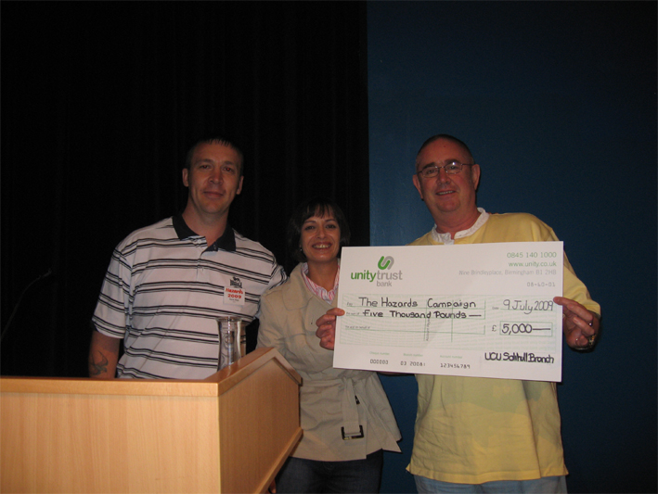

John Bamford accepting the cheque on behalf of the Hazards Campaign from Julia Matthews and Martin Binge of the Solihull College UCU Branch

Developing UCU organisation

Congress 2009 passed a motion to set-up a small national committee to look at how UCU can develop its organisation for health, safety and welfare, based on progress so far, and to make recommendations for further action. The group will have its first meeting at the UCU regional offices in Manchester on 25th September.

If any of our readers (or branches or LA’s) have any particular suggestions they think we should consider, please e-mail John Bamford at jbamford@ucu.org.uk by early September.

- Health and safety in universities

The July issue of Health and Safety Bulletin, (HSB) one of the professional health & safety publications that tends to be usefully critical of the political and organisational issues around occupational health, safety and welfare carried a 4-page article on health and safety in universities.

What was surprising for an HSB article is the lack of any critical appraisal of the state of health and safety in UK universities. It is an uncritical reporting of what the Universities Safety & Health Association (USHA) has done, and the comments of the chair of USHA. USHA is the collective organisation of university safety officers and specialists. Apart from including a topic box headed Stressful Times, which briefly reported the recent UCU survey results, the trade unions are invisible. It’s as if we don’t exist in HE.

The other topic box lists what it describes as the 5 university prosecutions in the HE sector in the past 5 years. That’s OK, apart from the fact that one of those listed is City of Bristol, an FE college, where a UCU member was severely injured by a bottle of nitric acid that exploded in his hand. And having decided to include this case, then why did the article ignore the more recent City of Bristol case where they were convicted of exposing people to asbestos fibre?

We are surprised that the author appeared to make no effort to contact UCU or the other unions; we have written to the HSB editor about this. Perhaps HSB would like to invite UCU and the other campus unions to have a 4-page response, where the views of our members could be more openly discussed – with as uncritical an approach as was given to the employers side.

- HSE acts on stress

This link is to a THES report that is quite optimistic, and should give those of you struggling to deal with work-related stress and its effects a bit of a boost. It CAN happen - but we'd say it SHOULD happen much more frequently, given the overwhelming occurrence of the issue in many institutions.

So despite our concerns that the HSE inspectors do not take action sufficiently often, when you feel that you have gone the extra mile to try to persuade your employer to act with little or no result, do contact your HSE inspector for some advice. Like our members at Liverpool Hope, you may be pleasantly surprised. We know that the HSE has also intervened in a number of other universities and colleges, so we hope this might be the start of a more consistent approach to the problem. Some of you may wish to draw this article to your employer’s attention.
http://www.timeshighereducation.co.uk/story.asp?storycode=407358

- UK WorkStress Network Annual Conference 2009

To remind you all that this year’s conference takes place on Saturday and Sunday, November 21st and 22nd at the NASUWT Hillscourt Conference Centre, Rednall, Birmingham.

The conference theme is “Stress – the 21st Century Epidemic”. Work-related stress remains one of the most common workplace hazards, with significant numbers of workers and trade union safety representatives reporting the problem in surveys by the Samaritans and the TUC. Recent UCU research confirms the prevalence of the issue in both further and higher education.

UCU sponsors 4 delegates to the conference. To secure one of these places, ask your Branch or LA secretary to e-mail Janet Pantland at jpantland@ucu.org.uk giving your details, and confirming that the local organisation supports your nomination as a UCU delegate. UCU will pay the conference delegate fee and reasonable travel.

Applications will be accepted on a first come – first served basis. Local organisations can send delegates at the Branch or LA expense, or even seek employer support. See http://www.workstress.net/ for more information and a report from the 2008 conference.

The 2009 conference information and booking form can be downloaded from http://www.workstress.net/downloads/networkconference2009.pdf. Please do not send the form off until you have received confirmation from Janet.

8. Training

Safety Reps: new course content
The safety reps pathway has been updated and revised to reflect legislative changes, respond better to the needs of UCU safety reps, and meet UCU’s objectives as set out in the national organising plan. The four two-day modules aim to equip UCU safety reps with the skills, knowledge and understanding they need to organise, bargain and campaign effectively on safety issues in their area.

For further information on all health and safety training, or to book a place, visit:
www.ucu.org.uk/training

TUC Diploma in Occupational Safety & Health
This course will develop your understanding of health and safety principle and practice and includes modules on: Health and safety organisation; Health and safety law; Health, safety, welfare in the environment; Research, communication, problem solving. The TUC Certificate in Occupational Safety and Health at OCN Level 3 is accredited to meet the academic requirement for IOSH Technician Safety Practitioner membership.

Information on locations and dates is available from: http://www.unionlearn.org.uk/courses/index.cfm/sb/5/pg/2/citem/4596
This course is also available as an online course.
We wish all our reps and activists a great summer break, and hope you all return to the fray refreshed and reinvigorated in the new year.

Don’t forget to visit the UCU Health and Safety web page

