
No 34  November 2009

Contents
- Government publishes details of new ‘fit note’
- More employer diversions from reality
- HSE strategy and the pointless ‘pledge’
- Lead, you and the HSE
- Fire safety again
- New Safe Colleges guidance website launched
- Up to date information for safety reps
- Art can be unsafe too
- New build
- Review of HE funding
- UCU health and safety training courses

Government publishes details of new ‘fit note’

The Government has announced details of a new ‘Statement of fitness for work’ (the ‘fit note’) to replace the current ‘sick note’. The form used by GPs to record an individual’s fitness for work has remained largely unchanged since the NHS was set up. It simply records whether or not an individual is fit for work.
The new statement, part of the Government’s response to the Dame Carol Black review of the health of Britain's working age population, Working for a Healthier Tomorrow, will enable GPs to record whether an individual is fit for their normal job, but will also provide an option for them to indicate whether they consider an individual may be fit for some, if not all of their normal work. This would apply if a GP considered that an individual could return to work if some aspects of work were changed, either temporarily or permanently. GPs will be required to provide general details of the functional effect of an individual’s condition and to record information about whether any changes to the work environment or job role could assist in achieving an early or earlier return date. The changes set out in the draft form include a phased return to work, altered hours and amended duties and workplace adaptations. How such a system will ensure employers make any necessary adjustments is not covered. There has been trade union criticism of the focus on this particular aspect of possible reform rather than on better prevention and enforcement.
Researchers at Nottingham University, who surveyed 440 GP’s in Nottinghamshire, found that few currently took any responsibility for managing the work issues of patients with back problems. Considerable training and a change in culture will be needed for GPs to take on a role where they advise on the work a patient can do, the report in the journal Family Practice concluded. Thus the current government expectation that GPs will be able to successfully manage this role may be unrealistic.
This is tinkering at the edges. The TUC has already expressed its concern about the Government’s limited response to Black’s report. In November 2008, General Secretary Brendan Barber, expressing regret that the Government had not gone further said:
“Workers made ill by their jobs need early access to rehabilitation and better support to help them get back to work as soon as they are able to. While the 'Fit for work' pilots go some way towards achieving this, they will have little relevance to the vast majority of workers who fall ill or are injured through work. More must be done to stop employees from becoming ill or injured in the first place. But without additional resources to the Health and Safety Executive and local councils, there is unlikely to be any increase in the number of safety inspections.”
It is intended that the new fit note will come into effect in the Spring of 2010.

More employer diversions from reality
More evidence of the shift in emphasis away from ‘a safe workplace and a safe working environment’ towards an overall ‘wellbeing’ agenda, where work-related factors affecting workers’ health are fudged together with external and personal factors, in this case obesity, and individual employers start to behave as though they have the right to control all aspects of their employees lives. Stagecoach buses in Hull have apparently been provided with new driver’s seats, which the company says will be broken if people weighing more than 20 stones sit on them. Heavyweight drivers have been told they will not legally be allowed to drive buses unless they lose weight, because of “health & safety”!!!. Bus driver’s seats have been a bone of contention for years – airline pilots who on average spend less time in their seats than a bus driver, are provided with seats that have cost tens of thousands of pounds to design, develop and build. Bus drivers used to get a couple of slabs of foam cushion with limited adjustment and suffered back problems as a result. Not much evidence of concern for drivers’ health there.
Work and wellbeing may be a laudable concept, but its basis has to be the safe workplace that is without risks to health and adequate in respect of welfare facilities for staff – overweight, smoker or pie & chips-eater or not – and about employers not victimising staff for personal reasons. Our aim is to improve the quality of working life for our members, and that is based on ensuring decent workplace standards and management are in place. We’ve already seen attempts to impose dress codes; how long before physical personal characteristics becomes a factor in the employment contract. Air India, for example sacked 10 cabin crew in January this year for being overweight. How long before a college employer decides not to employ what they define as overweight lecturers because they may damage the image of the institution.
As we move towards the Mandelsonian model of tertiary education as a shopping experience – students as customers – education and qualifications as goods – institutions as supermarkets - our NVQ, A-level and degree providers will need to look commercially attractive. http://www.ucu.org.uk/index.cfm?articleid=4265 Now where do they keep the pot noodles?
Reported in the October issue of “Occupational Health”. Read more, and comments, at
http://www.thisishullandeastriding.co.uk/news/Bus-drivers-sent-road-fitness/article-1302435-detail/article.html

HSE strategy and the pointless ‘pledge’
The new HSE strategy published in July contained nothing controversial or new, but trade unions identified a serious weakness in that it still fails to say anything meaningful about enforcement, or the HSE’s ability to deliver it. Following the publication of the new strategy, the HSE also launched a “pledge” and invited employers to sign-up to it. The pledge says:

We, the undersigned:
Agree to play our part in reducing the numbers of work-related deaths, injuries and ill-health in Great Britain.
Call on employers to put health and safety at the heart of what they do and to take a common sense approach to health and safety.
Commit to debunking myths around health and safety that trivialise the impact of injuries, ill health and deaths on individuals and their families.
Recognise the importance of health and safety in difficult economic times and the dangers of complacency.
Pledge to work with the Health and Safety Executive and its partners to Be Part of the Solution.
We are not quite sure what this is supposed to achieve, as it’s generally pretty meaningless when you consider the statutory duties on employers. For example, if the statutory duties on employers were observed and effectively enforced, that would do more than anything else to reduce the toll of death, injury and ill-health caused by work. Here employers are being invited to commit themselves to observing the law – perhaps there is a hidden point we’ve failed to grasp.
In respect of commonsense, we like Einstein’s comment that – "Common sense is the collection of prejudices people acquire by the age of eighteen."– more seriously we’ll take Gramsci’s proposition that cultural hegemony determines how one social class exerts cultural "leadership" or dominance over other classes to maintain the socio-political status quo, and persuades the subordinated social classes to accept and adopt the ruling-class values of bourgeois hegemony – then calls this ‘commonsense’.
We would expect that employers recognise the importance of health and safety at ALL times, not just in difficult economic ones, although that’s questionable given the continuing high levels of work-related death and injury reported by the HSE. And in our sectors, we have to report that the numbers of employers that still fail to accord proper recognition of UCU safety representatives (one of the HSE’s ‘partners’) and observe the duties imposed on them by the Safety Reps & Safety Committees Regulations remains unacceptably large. That is a pretty important bit of health and safety organisation at workplace level.
Who has signed up so far?
Plenty of employers in the private health and care industry, and lots of fire & rescue authorities have signed up, as have many major construction employers (construction has such a poor death and injury record that the Government established a committee of enquiry into safety failures, but the report has yet to be acted upon), lots of H&S consultancies and other professional organisations, including the HSE (how could they not?) The quality of some of those signed up is questionable – for example:
UK Coal and two managers at the group’s last remaining West Midlands colliery are to be prosecuted following three deaths at the flagship mine in just eight months. The Health and Safety Executive (HSE) has announced it is to prosecute UK Coal Mining Ltd and two of its managers for alleged health and safety breaches. Three men died underground in separate incidents at Daw Mill Colliery, near Coventry between June 2006 and January 2007. The HSE is also taking court action after a fourth man died at Welbeck colliery, Meden Vale, near Mansfield, Nottinghamshire in November 2007.
UK Coal has signed the pledge. For more information see:
http://www.birminghampost.net/birmingham-business/birmingham-business-news/manufacturing-and-skills-business/2009/10/15/uk-coal-charged-over-deaths-of-daw-mill-colliery-miners-65233-24933985/

Another ‘Pledger’, Corus the steel manufacturer, has been responsible for a number of deaths over the past 10 years. For example, following an explosion in November 2001 which destroyed a blast furnace and killed 3 workers, Corus was fined £1,333,000 with costs of almost £1.75 million. See http://www.hastam.co.uk/hands/corus.html According to Mike Hutin, whose son Andrew was one of the victims, Corus benefited from this tragedy by a successful £75 million insurance claim for a new blast furnace! See the second box in http://www.hazards.org/deadlybusiness/whopays.htm
Or what about this one? http://www.guardian.co.uk/education/2007/nov/06/highereducation.uk and to update http://www.yorkshirepost.co.uk/leeds-met-turmoil/Leeds-met-Staff-with-bullying.5643031.jp Another pledge signer.
The GMB has asked the HSE to remove their logo as they do not support this approach. It appears a number of union logo’s were added without making a formal application.
So far only a small number of tertiary educational institutions where we have members have signed up and sent a logo. These are the ones that we can find where UCU recruits, who have ‘pledged’ to be good employers.
Universities: Bangor; Cardiff; Leeds Metropolitan; Manchester Metropolitan; Newcastle; Thames Valley; Bolton; Liverpool; Sunderland; Wolverhampton (twice!); Edinburgh, and the estates department(?) of Southampton.
Colleges: Calderdale; City College Coventry; City College Plymouth; South Tyneside; York.
Are they really good at it? These institutions must be proud of the way they manage the health, safety and welfare of their staff, otherwise, why boast about it? Just to confirm how good they are, we’d like UCU safety representatives in these institutions to let us know what they think about the way their employer complies with the duties on them in respect of safety representatives; to consult with safety reps on everything that matters; resolve problems when reps raise them; listen to what reps have to say on all H&S issues; permit the time-off that reps need without let or hindrance; provide full facilities and assistance to the union; give reps information without a quibble; run a safety committee that’s not ‘packed’ with managers etc. Tell us how the risk assessment process is working. Let us know the level of stress related illness and absence. Has the HSE inspector visited recently – if so, what did they say? Please let us know - how do they match up? Do they accord our reps the respect they are due? Are you happy with their performance? E-mail the newsletter at jbamford@ucu.org.uk and we’ll report in the next issue.
Frankly, we’d be happier to see the HSE doing more enforcement of the actual regulatory standards rather than wasting its time on providing this platform for employers to proclaim to the world they are committed to the health, safety and welfare of their staff – even those whose records are abysmally poor and have been the subject of enforcement action and prosecutions in the recent past.

Lead, you and the HSE

UCU member Professor Andy Watterson of Stirling University, researching a report for Hazards magazine says that the HSE has got it wrong over lead poisoning. A report in the current issue of Hazards magazine also featured in the Guardian, and was the subject of an 8 minute report on Channel 4 News on Thursday 5th November. Professor Watterson says that the HSE leaflet “Lead and you” seriously underplays the danger of lead contamination of the blood, and ignores the toxic effects of very low levels of contamination. The article exposes real concerns about the toxicity of lead at much lower levels that are currently set-out in UK legislation as the action levels, which implies they are safe. The leaflet has been withdrawn.
Read the Hazards article at www.hazards.org/lead and for the Guardian article & Channel 4 News report:
http://www.guardian.co.uk/society/2009/nov/05/hse-lead-poisoning-safety-limit http://www.channel4.com/news/articles/uk/exclusive+hse+withdraws+lead+safety+advice/3411697 or
http://link.brightcove.com/services/player/bcpid1184614595?bctid=48381934001
- Fire safety again

We’ve recently had a couple of issues about fire precautions and risk assessments, and the role of the fire service as an enforcer. On the first issue, the following information has already been circulated, so reps should find this a useful reminder.
Guidance for employers on how to conduct fire risk assessments, and additional information about fire safety and fire precautions in educational premises is published by the Department for Communities & Local Government. This is downloadable free of charge from http://www.communities.gov.uk/documents/fire/pdf/150865.pdf
Like any other risk assessment, the employer needs to record the main points of the fire risk assessment, so this becomes a document. Employers have an absolute duty to give safety reps a copy of any document they are legally required to keep, if the reps request it. When you have read this, go and ask your employer for the fire risk assessments for your building.
Similar guidance documents for a variety of workplaces are accessible from this index page http://www.communities.gov.uk/fire/firesafety/firesafetylaw/

UCU reps will also be interested in the guides for “Sleeping accommodation” (includes student halls of residence) and “Means of escape for disabled people”.

http://www.fseonline.co.uk/articles.asp?article_id=8894&viewcomment=1 reports a recent case against Shell International who failed to keep their fire risk assessments under review and were fined a total of £345,000 for various breaches of the Fire Safety Order in their London offices. Employers need to be careful to keep their assessments up to date. UCU reps should be involved in the review process.
We have also previously recommended that reps subscribe (free of charge) to the Fire Safety Engineering newsletter at http://www.fseonline.co.uk/register.asp which often contains interesting and relevant news items on fire safety issues.
The second issue is more problematic. The 2006 changes in legal regulation of fire safety have thrown-up a problem that we are trying to get to the bottom of. The Regulatory Reform (Fire Safety) Order 2005 replaced all previous workplace fire safety regulation. Article 25 of the Order states very clearly that:
For the purposes of this Order, "enforcing authority" means—
- the fire and rescue authority for the area in which premises are, or are to be, situated…

One UCU representative has been engaged in an exchange of correspondence with the London Fire Service legal department about safety reps having contact with fire service inspectors attending workplaces in their enforcement or advisory capacity. As you all know, the SRSC Regulations, Regulation 4(1)(f) gives safety representatives the function of “representing the employees he was appointed to represent in consultations at the workplace with inspectors of the Health and Safety Executive and of any other enforcing authority”
So our interpretation of this is that safety representatives can make representations to the fire authority inspector at the workplace because that’s what the Regulation provides.
The LFS legal person threw our rep at first because he baldly stated that the Safety Representatives Regulations had been repealed (good to see the LFS legal department is up-to-date), and anyway, the LFS couldn’t give our representative any information because of data protection legislation.
After being challenged on this, he acknowledged he was mistaken about the SRSC Regs, but insisted the DPA applied, and that there was no legislation that covered safety reps either having contact with, or receiving information from the fire service, so fire service inspectors did not have to deal with safety representatives.
UCU is now trying to establish exactly what the position is. We have asked the HSE and await a reply with interest. We’ll keep you informed.

- New Safe Colleges guidance website launched

The Safe Colleges website was launched on 21 October 2009 and features guidance drawn up by colleges and Learning& Skills Improvement Service (LSIS) working with BIS, DCSF and the Home Office, to assist colleges in keeping young people safe from guns, gangs and knives. This presents an opportunity for local organisations to raise security issues with the employer where Branches are concerned that personal safety issues for staff are not adequately catered-for. The guidance suggests selecting direct security measures appropriate for the local situation that may include passes, ID cards, turnstiles, “hoods down” policy, knife arches, metal detector wands, random testing and searching. The employer should be discussing these issues with UCU before making decisions on security matters.
The website can be accessed at www.excellencegateway.org.uk/safecolleges which includes advice and guidance on a whole-organisation approach to tackling problems.

- Up to date information for safety reps

i) Hazards: The November issue of Hazards, the award-winning, worker-oriented health, safety & welfare magazine has just been published. Hazards is a lively mix of technical and political information around health, safety and welfare at work issues, it keeps an eye on what the HSE and Government are doing, and has up-to-date news of trade union initiatives, while offering a useful and informative international perspective. UCU encourages all Branches, LA’s and safety reps to subscribe. The annual single copy subscription is £15 for 4 issues; multiple-copy subs are available at reduced cost per copy. If the local funds will bear it, branches and LA’s should consider taking out a multiple subscription and giving every safety rep a copy. For more information, and to take-out a subscription, contact Jawad Qasrawi at sub@hazards.org or telephone 0114 201 4265.
ii) Risks: The weekly Risks bulletin from the TUC is equally valuable in keeping reps up-to-date. Risks is free; subscribe at http://www.tuc.org.uk/newsroom/register.cfm

- Art can be unsafe too

This HSE photo shows the hands of a 16 year old who lost most of her fingers and suffered major burns when she put her hands into a bucket of plaster of Paris during a school art lesson. She wanted to make a sculpture of her hands. Plaster of Paris generates temperatures of up to 60º Celcius as it sets. No risk assessment had been done, and not even limited safety information and precautions were in place. | 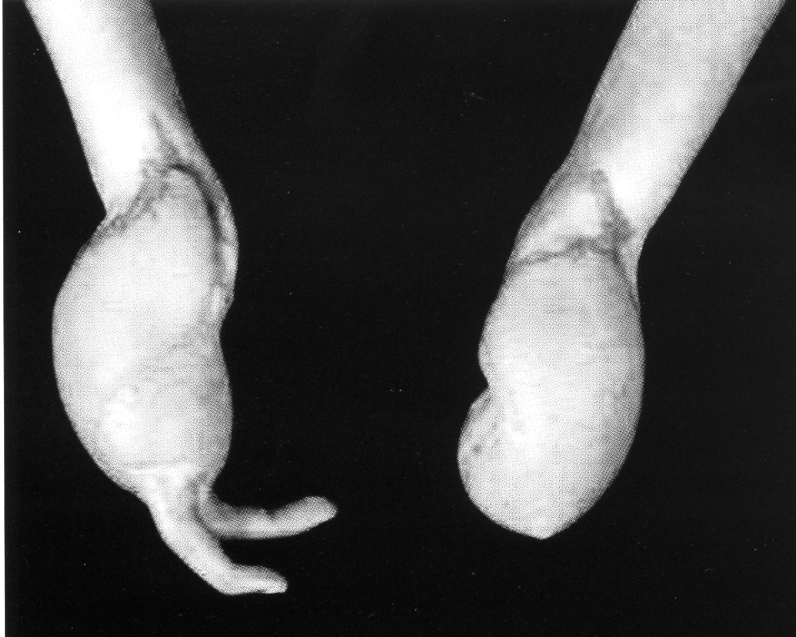
The school didn’t even bother to inform the HSE; it was the girl’s surgeon who did that 6 weeks later. The HSE prosecuted the school, a foundation school, and Boston magistrates fined the governing body £16,500 with £2,500 costs. The HSE press report can be seen at http://www.hse.gov.uk/press/2009/coiem7809.htm

9. New build

New build invariably brings new conditions; in many cases imposed on staff by employers who ignore the duties on them to consult with unions, and refuse to involve UCU safety representatives in the design, facilities and layout of new buildings right from the start. A new building will have a substantial impact on the quality of working life of our members, and just because it is new doesn’t mean it will be safe, without risks to health or adequate as regards facilities for staff welfare. New build is all student centred and focussed and it’s as if staff just don’t matter. Facilities for staff, especially staff rooms, are seen as very expensive, so not a priority. Judging from the enquiries we receive, many new buildings are patently not suitable and are inadequate in respect of staff facilities.
The most common complaints are:

- employers unilaterally changing staff working conditions by imposing open-plan offices instead of providing individual or small-group staff rooms;
- imposing shared staff/student toilet provision;
- lack of anywhere secure to leave coats or bags, confidential material or work-related personal effects like books;
- no welfare facilities such as a rest room where staff can make hot drinks or warm-up a pie or tin of soup for lunch or tea;
- nowhere quiet to go if staff feel ill at work;
- no pre-occupation risk assessments;
- lack of ventilation and no temperature control;
- disruptive background noise in multi-occupied open-plan offices;
- no fire escape training for staff, and no special training for fire wardens, or those who have volunteered to help mobility-impaired people leave the building;
- centralised computer facilities with LAN’s that don’t deliver, printers that don’t print; e-mails that cannot be accessed or sent and voicemail messages that get lost

You can find more information about building design on “The informed design” website, provided by the University of Minnesota. Some useful information about different aspects of design and many related issues, and the abstracts are generally quite comprehensive and informative, although lots of topics that won’t be of interest to safety reps. You can search for relevant material from this link - try a search for “Open plan offices” for example. Register from the home page http://www.informedesign.umn.edu/Rs.aspx?s=issues
We need to insist that unions are consulted in good time on new building proposals – before the employer makes the final decision to go ahead, and to ensure we are consulted by the architects when the building is commissioned. If we cannot influence the overall design principles from the outset, it is almost certain that changes won’t be able to be made after the building is completed.

10. Review of HE funding

Secretary of State for BIS Peter Mandelson has announced that Lord John Browne of Madingely will chair the review of HE funding. He’s obviously a fit person to undertake this task, according to his biographical details on the review website at http://hereview.independent.gov.uk/hereview/members-biographies/
Strange it doesn’t mention that, while he was chief executive of BP, the company pleaded guilty to federal charges related to an explosion at its US Texas City refinery in 2005 which killed 15 workers. BP agreed to pay $50 million, the largest criminal fine ever assessed against a company for Clean Air Act violations. Six months after the explosion, BP agreed to pay a further $21.3 million Occupational Safety and Health Administration (OSHA – the HSE equivalent in the US) fine, then the largest in the agency's history. It happens in Britain too. In 2002, BP was the recipient of what was then a UK record safety fine of £1m, for offences at the Grangemouth refinery. http://www.hse.gov.uk/press/2002/pn02004.htm
Now BP has been hit with an even larger safety fine for failing to correct safety problems identified after the 2005 explosion. On 30 October US labour secretary Hilda Solis announced that OSHA had levied the largest fine in its history - $87.4 million (more than £53m) - against BP. OSHA has issued 271 notifications to BP for failing to correct hazards at the Texas City refinery since the explosion. The agency also identified 439 'wilful and egregious' violations of safety controls at the refinery. Lord John Browne spent two further years at BP after Texas City exploded. Jordan Barab, acting head of OSHA, said the safety problems at BP are systemic. 'There are some serious systemic safety problems within the corporation, specifically within this refinery as well. I think that just the fact that there still are so many life-threatening problems indicates they have a systemic safety problem at this refinery.'
A “safe” pair of hands? http://www.osha.gov/dep/bp/bp.html for details of BP’s criminality in the US. The HSE has also now removed BP from its “director leadership” case histories following complaints by Hazards magazine editor Rory O’Neill.

11. UCU health & safety training courses

Don’t forget to register for one of UCU’s health and safety training courses: www.ucu.org.uk/training

Safety Reps 1: induction  8 & 9 Dec - Belfast  24 & 25 Feb 10 – Birmingham  22 & 23 April - London | Safety Reps 2: the management of health & safety  25 & 26 Jan 10 – London  15 & 16 Feb 10 – Belfast
Safety Reps 3: preventing injuries and ill health  18 & 19 Mar 10 – London  12 & 13 May 10 – Belfast | Safety Reps 4: bargaining for health & safety  12 & 13 Nov 09 – Birmingham  2 & 3 Dec 09 – London  10 & 11 June 10 - London  17 & 18 Jun 10 - Belfast
Contact UCU Health & Safety Advice
UCU Health & Safety Advice is provided by the Greater Manchester Hazards Centre, and is available for 3 days each week during extended term times. The contact person is John Bamford: jbamford@ucu.org.uk (t) 0161 636 7558

Visit the UCU Health and Safety web page

