CIRCULAR CEF 2010/01

To: Directors/Chief Executives of Colleges of Further Education
Chairs of Governing Bodies of Colleges of Further Education
DEL Further Education Branch
DE Salaries Branch
Education & Library Boards
UCU
NASUWT
ANIC

2 February 2010

Amendment to the FE Threshold Scheme

In accordance with the provisions of Article 11, Schedule 3, paragraph 10.3 of the Further Education (Northern Ireland) Order 1997 and the Constitution for Negotiating the Salaries and Conditions of Service of Lecturers Employed in Incorporated Colleges of Further Education, it has been determined that the enclosed Addendum which was ratified at the LNC forms part of the Further Education (NI) Threshold Scheme effective 1 September 2009.

Please pass this circular to your HR Department.

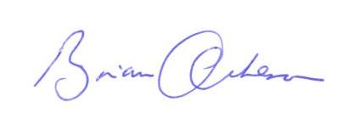

Brian Acheson
Chairman
College Employers’ Forum

Addendum two to the further education (northern Ireland) Threshold Scheme

Promoted Staff with Five Years or More Service

It has been agreed at the Lecturers Negotiating Committee that the following will apply

‘Lecturers* who have not completed one year at the top of the lecturers scale prior to being promoted, but who have five years or more service within the College shall be eligible to apply for a threshold payment at the first of September of the academic year following the date on which they reach the five years service. The implementation date of this agreement is September 2009.’

*This reference to Lecturer means Lecturer, Senior Lecturer, Principal Lecturer and Head of Department.

** To be eligible to apply for a threshold payment under these arrangements, a lecturer shall:
- be party to the contract for full time permanent lecturers in colleges, apart from principals and vice-principles.

