May 2010

Student: teacher ratios in higher and further education
The ratio of students to teachers provides an indication of workload for teaching as well as support or academic-related staff in higher and further education. It can also be viewed as one indicator of the quality of education provided for students and learners on the basis that the more teaching and support staff per learner, the better the learner’s educational experience is likely to be.
It should be pointed out that these ratios – the student:staff ratio in higher education, and the learner:teacher ratio in further education – are not the same as class sizes. In higher education institutions in particular, the size of teaching groups can range from a 1:1 tutorial to lectures with more than 100 students. And a different dynamic will operate in a distance learning environment, for example, where learners access teaching materials online; nevertheless, the number of students to distance learning tutors is also important to the quality of learning experience.
The ratio is normally measured in a full-time equivalent. However, it is arguable whether, put simply, the workload relating to two 0.5 part-time students is equivalent to one full-time student. Many teaching staff would consider that there is usually more work related to several part-time students compared with one full-time student. Also, in higher education, students from a non-traditional higher education background may require greater support than other students, with a corresponding workload implication for teaching staff working at higher education institutions with a large proportion of ‘widening participation’ students.

Higher education
Student:staff ratios (SSRs) provide an indication of workload conditions for academic staff (directly) and academic-related or support staff (indirectly) in UK higher education. The ratio is not a direct measure of classroom size – teaching groups in higher education can range from 1:1 tutorials and small seminar groups, to large lectures attended by hundreds of students. Rather, the SSR indicates the numbers of students to numbers of teaching staff.
There are also implications for our understanding of the SSR in terms of the function of academic staff in higher education. While one-quarter of academic staff are categorised as teaching-only staff, the majority (51% in 2008-9) are considered to be engaged in both teaching and research; the remaining group, research-only academics, are not included in the SSR calculation. Although the Higher Education Statistics Agency attaches equal weight in the calculation of the SSR to teaching-only and teaching-and-research academics, it may be that the latter have proportionately less time than the former to give to their teaching and their students because of their research commitments.

UK
Table 1 shows that in recent years, the UK average SSR has fluctuated around 17.0:1, and has decreased in a small but steady fashion since 2005-6, when it was 16.8:1, to 2008-9, when it was 16.3:1, according to data produced by the Higher Education Statistics Agency. The UK SSR is still higher than the average for member states of the Organisation for Economic Co-operation and Development, although the most recent OECD average figure was 15.3:1 in 2007.
The data used for student and staff numbers were full-time equivalents. The FTE of students who were recorded as being on industrial placement and those recorded as being on partly franchised programmes was reduced by half. Students on fully franchised courses were excluded. The staff FTE comprised teaching-only and teaching-and-research academics, and atypical teaching staff (atypicals have been included in the staff FTE since 2004-5). The SSR calculation followed the standard HESA methodology. Data for individual institutions indicate a wide range, with SSRs as low as 5:1 in some small specialist institutions, to nearly 30:1 in other HEIs. Similarly the studies by the Higher Education Policy Institute of the academic experience of students in English universities have indicated a wide range in hours of teaching and workloads by subject at different institutions.

Table 1 UK HE SSR average
1996/97 | 1997/98 | 1998/99 | 1999/00 | 2000/01 | 2001/02
16.5 | 17.0 | 16.7 | 16.4 | 16.3 | 16.6

2002/03 | 2003/04 | 2004/05 | 2005/06 | 2006/07 | 2007/08 | 2008/09
17.1 | 18.1 | 16.6 | 16.8 | 16.6 | 16.4 | 16.3

Source: HESA

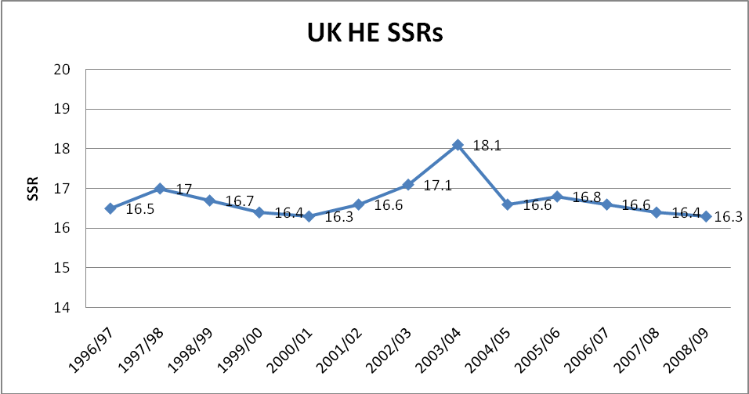

Source: HESA

England
Government figures for the student:staff ratio in England for the period 2003-4 to 2006-7 indicate that it fluctuated as follows: 18.4:1, 16.7:1, 17.0:1, and 16.8:1.

Pupil:teacher ratio (PTR)
In recent years, the pupil:teacher ratio in schools and the SSR have been at a fairly similar level, with the PTR showing a small but steady decrease. The PTR in England was 17.1:1 in 2006/7, 16.8:1 in 2007/8, and 16.5:1 in 2008/9. The PTR in the UK was 16.8:1 in 2006/7, 16.5:1 in 2007/8, and 16.4:1 in 2008/9.

International picture
The UK’s SSRs have consistently been higher than for the OECD as a whole, and for economic competitor countries such as the United States, Germany and Japan (table 2). The UK’s SSR has fluctuated around the 18.0:1 figure, without a clear trend appearing; however, the lowest SSR was 16.4:1 in 2006, the year that top-up fees were introduced in England and Northern Ireland, and when first-year full-time undergraduate student numbers temporarily decreased.

Table 2 OECD ratio of students to teaching staff in tertiary educational institutions*
 | 1999 | 2000 | 2001 | 2002 | 2003 | 2004 | 2005 | 2006 | 2007
France | 16.9 : 1 | 18.3 : 1 | 18.1 : 1 | 17.9 : 1 | 17.6 : 1 | 17.8:1 | 17.3:1 | 17.0:1 | 16.6:1
Germany | 12.3 : 1 | 12.1 : 1 | 12.3 : 1 | 12.6 : 1 | 12.5 : 1 | 12.7:1 | 12.2:1 | 12.4:1 | 12.1:1
Japan | 11.5 : 1 | 11.4 : 1 | 11.3 : 1 | 11.2 : 1 | 11.0 : 1 | 11.0:1 | 11.0:1 | 10.8:1 | 10.6:1
UK | 18.5 : 1 | 17.6 : 1 | 17.6 : 1 | 18.3 : 1 | 18.2 : 1 | 17.8:1 | 18.2:1 | 16.4:1 | 17.6:1
USA | 14.0 : 1 | 13.5 : 1 | 13.7 : 1 | 17.1 : 1 | 15.2 : 1 | 15.8:1 | 15.7:1 | 15.1:1 | 15.1:1
OECD country mean | 15.3 : 1 | 14.7 : 1 | 16.5 : 1 | 15.4 : 1 | 14.9 : 1 | 15.5:1 | 15.8:1 | 15.3:1 | 15.3:1

Based on full-time equivalents
* All tertiary education: includes Type A 3+ year mainly theoretical degrees & advanced research programmes, and Type B shorter more practical courses
Source: OECD Education at a Glance, series, Table D2.2

Further education

Learner:teacher ratio (LTR)
In FE colleges in England as a whole, the LTR was 19.9:1 in 2008-9. While the ratios in agriculture and horticulture sector, general FE colleges and tertiary colleges were close to the overall figure, ratios in art and design colleges and in 6th form colleges were higher (22:1 and 25:1 respectively), and lower in the small group of ‘DC’ colleges, such as Mary Ward Centre, the City Lit, and including residential institutions.
Given the very diverse nature of FE provision these LTR figures can only be taken as an average. There will be some classes where numbers far exceed this average, and some curriculum areas such as Skills for Life programmes where the nature of the curriculum and of the students will necessitate a much lower LTR. For some low level Skills for Life work good teaching and learning and student achievement will mean that much teaching will be virtually one–to–one. LTRs in FE will also be subject to a range of health and safety issues, as well as how many students workshop teaching and learning can adequately be accommodated. The state of FE plant will also be a determinant of LTRs. Until recently many FE college buildings were what nobody else wanted, often Victorian school buildings. These rarely had large teaching spaces. Even with the recent FE building crisis, the sector has seen in the last 10 years a great deal of new build and refurbishment of plant. This may have also seen the creation of teaching spaces able to accommodate greater numbers.

Table 3 Learner:teacher ratios in English further education
 | 2004-5 | 2005-6 | 2006-7 | 2007-8 | 2008-9
Total A&HC (agriculture & horticulture) | 15.6 | 14.1 | 14.3 | 14.1 | 19.9
Total AD&PA (art, design & performing arts) | 15.6 | 15.2 | 16.6 | 15.0 | 21.9
Total DC (group of 9 ‘Designated Colleges’, including residential) | 17.5 | 15.9 | 15.6 | 14.6 | 15.7
Total GFEC (general FE colleges) | 16.7 | 16.2 | 15.9 | 16.0 | 19.2
Total SFC (6th form colleges) | 16.9 | 17.1 | 17.4 | 17.5 | 25.4
Total TC (tertiary colleges) | 15.5 | 14.9 | 14.0 | 15.8 | 19.1
Total FE | 16.6 | 16.1 | 15.8 | 16.1 | 19.9

Source: LSC 2008-9 College accounts

Endnotes

http://www.dius.gov.uk/reports_and_publications/~/media/publications/2/21076_DIUS_AR_A_Web_NEW table 3, DIUS annual report 2008
http://www.dcsf.gov.uk/rsgateway/DB/VOL/v000891/UKVolume2009.pdf table 1.7, Education and Training Statistics for the UK 2009
http://skillsfundingagency.bis.gov.uk/funding/financialmanagement/financialmanagement/collegeaccounts/
http://www.hepi.ac.uk/466-1393/The-Academic-Experience-of-Students-in-English-Universities-(2009-report).html

