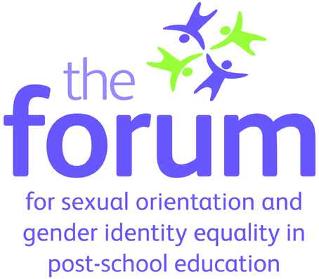
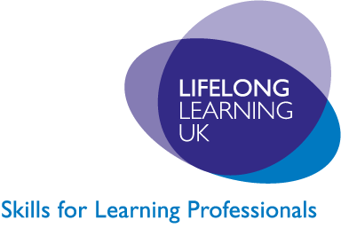

Managing the interface: sexual orientation and faith – workshops and guidance for further and higher education

How do you create a safe and inclusive environment for all staff and learners?
Are you worried about tensions between people of different sexual orientations and religions or beliefs?
Join experts from across the sector for an interactive workshop in your region, where you can get the latest guidance on how to promote both sexual orientation and religion or belief equality in your organisation.
The Forum for Sexual Orientation and Gender Identity Equality in Post-School Education (the Forum) is working with Lifelong Learning UK (LLUK) and the National Council for Faith and Belief in Further Education (fbfe) to provide practical advice and facilitate discussions on these issues.
Why do I need to know about this?
The advice you receive will help you meet the requirements of the new Equality Act 2010. The events are for professionals who work within higher or further education, including work based learning and adult and community learning.
If you work in the post-school education sector then this workshop is for you. Roles may include:
- Equality and diversity practitioners
- Front line and support staff
- HR practitioners
- Managers in the post school education sector
- Student leaders
- Teachers, lecturers, tutors and trainers
- Union representatives.

Why should I attend?
At this event, delegates will have the opportunity to:
- Receive tailored advice from a panel of experts.
- Learn how to apply good practice within their organisation
- Share experiences with other providers
- Explore related issues in a series of workshops
- Receive a copy of the research and guidance ‘Managing the interface: sexual orientation and faith’, which has just been published by Lifelong Learning UK and the Forum
- Engage with the Equality Act and its implications for providers.
Workshops include:
- Turning policy into practice: Identifying effective communication and good practice
- Visible and Valued: Discussing issues of inclusivity, conflict management, inclusivity and monitoring.
Submit your questions in advance to make sure you get the guidance you need in the Question and Answer session.
When and where can I attend a workshop?
Workshops run from 9.30am – 4pm on the following days:
London: Wednesday 20 October 2010
Birmingham: Wednesday 10th November 2010
Newcastle: Wednesday 24 November 2010
Manchester: Thursday 20 January 2011
Exeter: January 2011, date TBC
Peterborough: February 2011, date TBC

The events are FREE to attend, including lunch and refreshments.
Places are limited and will be offered on a first come first served basis.

If you would like to register go to: www.lluk.org/sexual-orientation-and-faith-equality-roadshows.htm, where you can also submit the questions you would like answered on the day.

Contact us now to find out more: equalityanddiversity@lluk.org
