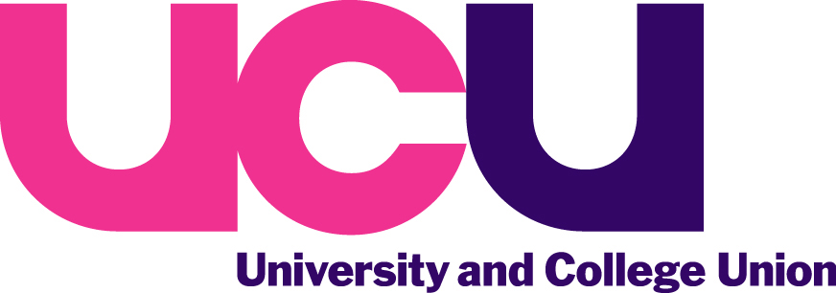

Every day trillions of dollars change hands in currency exchange, share dealings, and more complex financial products like futures, derivatives and so on. The market in these transactions has exploded over recent years and all the transactions together constitute an amazing 75 times global GDP. Often, the trading is done by computers which react to small shifts in price, and money, shares and exotic financial products change hands many times an hour, all over the world. Most of the trading is speculative, and serves little useful purpose – indeed it can harm companies, livelihoods and even whole national economies, as the Asian financial crisis in the 1990s did.

A Robin Hood Tax would put a tiny tax (0.005% to 0.5%) on each of the millions of financial transactions that take place every day, would provide a new source of finance to pay for a range of public goods: protecting our public services, helping to deliver the Millennium Development Goals, and tackling the challenge of climate change.

The Robin Hood Tax campaign
Over 110 environmental, development, trade union and faith-led organisations support the campaign in the UK, together with over 230,000 individuals. We are calling for greater taxation of the UK’s financial sector to raise a further £20bn. We think a financial transaction tax is the best way to achieve this, but there could be other ways of doing it: through expanding the Government’s proposed bank levy, or introducing a sort of VAT on financial services called a Financial Activities Tax. We will support whatever works.

More information can be found at www.robinhoodtax.org.uk/how-it-works/everything-you-need-to-know

Why are trade unions and the TUC supporting it?
Twenty-four British trade unions – including ours - are signed up to support the campaign, with the TUC, Oxfam, Stamp Out Poverty, ActionAid, Unicef UK and Comic Relief leading the coalition.

Trade unions are leading the calls for a Robin Hood Tax as an alternative to the unfairness of the Government’s ‘deficit reduction at all costs’ approach. A Robin Hood Tax would ensure that those who caused the crisis make a fair contribution to the costs of cleaning it up.

In the UK, we want to use the money raised by the Robin Hood Tax to protect public services from the cuts, and in developing countries we want to see more money spent on reducing poverty and dealing with the effects of climate change.

How easy would it be to collect?
The Finance Sector can afford to pay, and it’s only fair that they do. A Robin Hood Tax on the finance sector is far more progressive than other tax rises as it would ensure that those with the broadest shoulders contribute most to the cost of the economic recovery.

The tax would be easier to collect than most, because all the financial transactions to be taxed are conducted or registered electronically. A minor change to computer programs would deduct the tax at source and direct it straight to the exchequer. This has been tested by supportive financial institutions, and already operates in many share transactions.

Does it need a global agreement?
No. A global agreement to tax financial transactions – perhaps through the G20 – would be the best solution and would raise the most money. But the International Monetary Fund found that 16 G20 countries already have some sort of financial transactions tax, all implemented unilaterally – like the 0.5% Stamp Duty on share transactions in the UK, which already raises £3bn a year. The European Union is considering introducing such a tax at European level, or in the Eurozone countries, which would also be a step forward.

Threats that banks would leave the UK have proved to be false in the past (eg the bank bonus tax under the last Government) and some financial transaction taxes couldn’t be avoided by moving country anyway (eg UK stamp duty, which falls on share trading in British companies wherever they are bought and sold).

The Robin Hood Tax campaign is working with sister campaigns in Germany (the Tax Against Poverty), Italy (Zero Zero Cinque, or 005), Make Poverty History Canada, and Robin Hood Tax campaigns exist in Australia and Spain. Bodies like the Global Call to Action Against Poverty, the International Trade Union Confederation, Greenpeace International, ActionAid International, Oxfam International and many other global groups with branches all over the world support the campaign.

Would the tax be passed on to ordinary people?
Some opponents of the Robin Hood Tax say that the tax would be passed on to ordinary people – bank customers, holiday makers changing their currency, or pension funds investing in the stock market.

Small currency transactions could be exempted from taxation (and at 0.005%, you’d pay £1 on every £20,000 you changed – some holiday money!) So could small share transactions, although they’re already taxed at 0.5% - and pension funds would pay the tax, but they tend to hold shares for many years: the people who would really pay the Robin Hood Tax would be speculators like hedge funds and merchant banks who buy and sell shares every hour.

There is always a risk that any tax on the banks will be passed on, but there are ways to design the Robin Hood Tax to stop that happening. Studies show that the majority of any financial transactions tax would fall on the richest – those most able to pay.

What can individual union members do?
Sign up to the campaign at www.robinhoodtax.org or join the Facebook group at www.facebook.com/robinhoodtax for campaign updates and news of action you can take or events you can attend.
Follow Robin Hood on twitter @robinhood and keep spreading the message with the #RHT hashtag.
Write to your MP asking for support.
Write to your local media, linking local cuts to services with the fact that there is an alternative.
Spread the word. For every cut announced, think: “could a Robin Hood Tax have paid for that?” and tell your colleagues, friends and family that there is an alternative and Robin is it.

