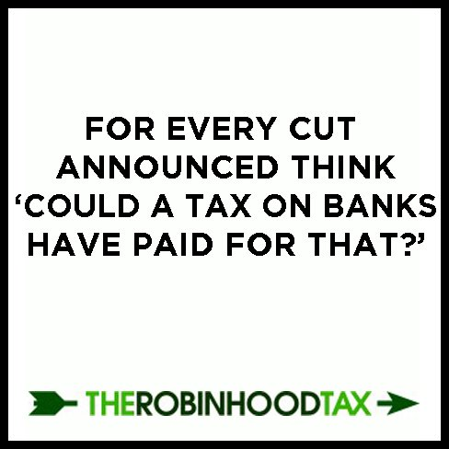
There IS an alternative. Robin Hood can save public services and protect the world’s poor.
As the devastating cuts announced in the comprehensive spending review begin to bite in the UK, with front line public services taking a serious hit and spiralling jobs losses, it is starkly clear that the wrong people are being punished. In the UK and all around the world tens of millions of people are suffering from a global crisis they didn’t cause, and the rich bankers, who certainly did, aren’t paying their fair share. Robin Hood could save our public services and protect the poorest both in the UK and all over the globe from the destructive effects of the global financial crisis.
In the UK, with the words, ‘we are all in it together’ ringing in our ears, cuts are being announced with alarming zeal and regularity. The TUC’s cuts watch now lists over 300 cuts that will have far reaching effects on families, communities and services. The government is slashing services and benefits for the unemployed whilst imposing cuts that will mean unemployment will soar. They are cutting corporation tax and letting multinationals off their tax bills whilst trebling student fees and they are putting up VAT whilst the price of essential goods such as food, cotton and oil continues to rise. We are told we are all sharing the pain, but the reality is that these cuts will hit the poorest and most vulnerable in society hardest.
Globally, the poorest have also been hit hard. A wave of ‘austerity measures’ have swept Europe threatening higher unemployment and economic instability, and in developing countries more people are sinking into abject poverty due to rising unemployment and rising food prices, often caused by speculation.
Trade unions, charities and campaign groups are rightly highlighting the injustice and inconsistency in the Government’s approach, arguing for a new economic strategy for the UK based on public investment, job creation, and tax justice. A Robin Hood Tax, a tiny tax (0.005% to 0.05%) on each of the millions of financial transactions that take place every day, would provide a new source of finance. This would be used to tackle the effects of the global economic crisis and pay for the recovery, protecting our public services and the most vulnerable at home and abroad.
The campaign, with over 110 domestic, international, faith-led and environmental organisations, and over 230,000 supporters in the UK, is calling for greater taxation of the UK’s financial sector to raise a further £20bn through an expanded bank levy, a financial transaction tax or a financial activities tax.
The revenue would be used to help fight poverty in the UK and mitigate the impact of the financial crisis, to help the poorest countries cope with the financial crisis and climate change.
Since the campaign was launched international momentum has grown. Europeans for Financial Reform and the trade union movement have been heaping pressure on EU governments. Austria, Belgium, France, Germany, Greece and Spain are all supporting the introduction of a European Financial Transactions Tax. It is expected that this will become a central feature of the French G8 and G20 presidencies in 2011.
Sadly, despite some woolly words, the coalition remains unconvinced. The Government has announced a bank levy of £2.5 billion, and might go further. But the banks have had other taxes cut or held over, so this does not go far enough.
Internationally, the list of countries supporting a Robin Hood Tax keeps on growing. At the UN Millennium Development Goal Review Summit in September, 57 countries backed the call for a Robin Hood Tax and even the International Monetary Fund seem to be coming round to the idea.
The support from civil society is growing rapidly too. 24 trade unions are signed up to support the campaign, with the TUC, Oxfam, ActionAid, Save the Children and Comic Relief leading the coalition. A recent global letter to the G20, calling for the introduction of a Robin Hood Tax, attracted the support of 183 organisations from 42 countries around the world. That’s three times the number who wrote to the IMF this time last year urging a proper consideration of the idea: a measure of how far support for a Robin Hood Tax has grown.
We need to keep up the momentum and pile the pressure on politicians to accept that there is an alternative to swingeing cuts and mass unemployment, there is an alternative to starvation and floods and poverty. The Robin Hood Tax is a key part of that alternative.
Things that you can do:
Sign up to the campaign at www.robinhoodtax.org or Join the Facebook group at www.facebook.com/robinhoodtax for campaign updates and news of action you can take or events you can attend.
Follow Robin Hood on twitter @robinhood and keep spreading the message with the #RHT hashtag
Write to your MP asking for support
Write to your local media, linking local cuts to services with the fact that there is an alternative
Spread the word. For every cut announced, think: “could a Robin Hood Tax have paid for that?” and tell your colleagues, friends and family that there is an alternative and Robin is it.

