
No 20  April 2011

Contents

1. New Equality Administrator
2. Equality Act – Positive action in recruitment and promotion
3. Age discrimination consultation Q&A
4. Public Sector Equality Duty Update
5. Sign up to be an Equality Officer
6. Women’s TUC Conference 2011
7. Disabled march and lobby of Parliament - May 11th
8. Congress – Equality Fringe Meetings
9. Fear and Hope – The new politics of identity
10. Parental Leave and Flexible Working

1. New Equality Administrator

There is a new face in the Equality Department as Equality Administrator James Taylor joined the team at the end of January. James says: “I’m really pleased to be joining an organisation that stands up for those working in education, especially in the current political climate, and I’m very much looking forward to being a part of the important work done here in the Equality Department”.

You can contact James at jtaylor@ucu.org.uk

2. Equality Act – Positive action in recruitment and promotion (April 2011)

What exactly is positive action?
The term ‘positive action’ covers a range of measures which organisations can use where those with a “protected characteristic” (age, disability, gender reassignment, marriage and civil partnership, pregnancy and maternity, race, religion or belief, sex, sexual orientation):
- experience some sort of disadvantage because of that characteristic;
- have particular needs linked to that characteristic; or
- are disproportionately under-represented in a particular activity.
Where any of these conditions apply, positive action can be taken to overcome that disadvantage, meet that need or encourage participation in that activity.
Positive action can be taken in relation to a wide range of activities, such as employment, education, training and service delivery.

Does the Equality Act 2010 allow the use of positive discrimination?
No. Positive discrimination means favouring someone solely because he or she has a particular protected characteristic. Positive discrimination is generally unlawful in the UK and there are currently no plans to change that position.

Is it a requirement for organisations to use the positive action provisions?
No. All forms of positive action are entirely voluntary, whether those measures relate to employment, the provision of services or the work of political parties. There is no compulsory requirement for any organisation to use any of the positive action provisions.

What will the new positive action provisions in relation to appointments allow that can't already be done by employers anyway?
Unlike existing positive action provisions, section 159 applies specifically to the process of recruitment and promotion. It allows an employer, when faced with making a choice between two or more candidates who are of equal merit to fill a particular vacancy, to take into consideration whether any of the candidates is from a group that is disproportionately under-represented or otherwise disadvantaged within the workforce.

For further information on any of these issues contact Helen Carr, National Head of Equality at: hcarr@ucu.org.uk

3. Age Discrimination

What is happening about the ban on age discrimination in the provision of services?
The Equality Act 2010 includes provisions enabling a ban on age discrimination in the provision of services to be introduced.

On 3 March 2011 the Government launched a consultation, which provides further details about implementation of the age discrimination ban. The consultation sets out areas where it believes that different treatment of people of different ages is justified, where specific exceptions from the ban are necessary and how the legislation will be drafted to take account of these.

- Age-based concessions. This exception will allow any organisation to use age to determine eligibility for concessions or benefits, provided that the purpose of the concession is to benefit the age group to which it applies.
- Financial services. This exception will allow the use of age in the assessment of risk, in the financial services sector to continue, provided that this is based on relevant information from a source on which it is reasonable to rely. Age-banding and age limits will also be allowed. In addition, we will use voluntary measures to improve access to insurance products through sign posting and to increase transparency regarding how age is used when pricing these products.
- Group holidays. This exception will allow specialist holiday providers to continue to provide holidays for people in particular age groups, e.g. Saga and Club 18-30 holidays.
- Immigration. When determining a person’s eligibility to enter and remain in the UK, age needs to be one factor that is given consideration in some applications along with other factors such as earnings.
- Residential park homes. This exception will allow residential park homes to continue to include age limits in their park admission rules.
- Sport. This exception will allow for the continuation of age-restricted sports competitions, for example under-21s’ football competitions and tennis veterans’ competitions.

The consultation runs from 3 March 2011 to 25 May 2011, and you can view the consultation document at the following link:-

http://www.equalities.gov.uk/equality_act_2010/age_consultation_2011.aspx

Removal of the default retirement age (DRA)
Currently the DRA enables employers to make staff retire at 65 regardless of their circumstances. The default retirement age (DRA) is to be phased out between 6 April and 1 October 2011. The Government’s written response to the 2010 consultation on the DRA, and new guidance on the removal of the regulation, were published on 13 January 2011.
The change means that:

- From 6 April 2011, employers will not be able to issue any notifications for compulsory retirement using the DRA procedure.
- Between 6 April 2011 and 1 October 2011, only people who were notified before 6 April, and whose retirement date is before 1 October 2011 can be compulsorily retired using the DRA.
- After 1 October 2011, employers will not be able to use the DRA to compulsorily retire employees.

Links to useful documents:-
DRA consultation and written response
http://www.bis.gov.uk/Consultations/retirement-age?cat=closedwithresponse
Guidance
http://www.acas.org.uk/index.aspx?articleid=3203

For further information contact Seth Atkin at: satkin@ucu.org.uk

3. Public Sector Equality Duty Update

The Government has published a policy review paper which seeks views on new draft regulations on the specific duties of the public sector equality duty for England. The role of the specific duty is to give direction to public bodies on how to approach the general duty.
These new proposals make the specific duty even more light touch . The key differences of the new draft regulations from those published on 12 January are the removal of requirements on public bodies to publish details of the
- Engagement they have undertaken when determining their policies
- Engagement they have undertaken when determining their equality objectives
- Equality analysis they have undertaken in reaching their policy decisions
- Information they considered when undertaking such analysis
UCU will respond to this consultation and we will need to consider the implications for UCU at the Equality Committee on 14 April 2011. Consultation closes on 21 April 2011. We will also be asking branches to respond to the consultation.
The general duty still comes into force on 5 April 2011 and it is important to remember that under the general duty employers must have regard to the need to
- eliminate discrimination, harassment, victimisation and any other conduct prohibited under the Act
- advance equality of opportunity between those who share a relevant protected characteristic and those who do not
- foster good relations between persons who share a relevant protected characteristic and those who do not
and we need to continue to argue that having evidence that an institution has assessed and considered impact at a formative stage of decision making is a key part of compliance with the general duty. The EHRC are redrafting their guidance and will be retaining this message.
For further information contact: Helen Carr hcarr@ucu.org.uk
Chris Nicholas cnicholas@ucu.org.uk
Seth Atkin satkin@ucu.org.uk

5. Sign up to be an Equality Officer
Active members are the heart of any union. The more people we can count on to do something, however small, for the union, the more powerful we are. This power will ensure that management will have to listen to what we say.
UCU are looking to recruit members to become branch Equality Officers. Branch Equality Officers play an important role to promote equality in the workplace, give support to members (either individually or collectively) as well as supporting the branch in negotiations with employers to improve working conditions for all UCU members.
Changes to equality legislation means that we have to be ever more vigilant to ensure that the principles of equality that UCU and the wider trade union movement holds dear are maintained to ensure all UCU members are treated fairly and that our work environments are free from discrimination, harassment, victimisation or bullying.
If you are interested in becoming a branch equality officer, read our factsheet on ‘Organising for Equality’ at:
http://www.ucu.org.uk/index.cfm?articleid=2131#org
Or, alternatively email:
eqadmin@ucu.org.uk
For further information. UCU also offers training for anyone interested in equality – visit:
http://www.ucu.org.uk/index.cfm?articleid=3311
For further information on all UCU training courses.
6. Women’s TUC Conference 2011
Equality Support Official for Women Charlotte Nielsen reports on the Women’s TUC Conference 2011, which this year was held in Eastbourne over the 9th – 11th of March.
“A delegation of 12 UCU women delegates joined 205 trade union women activists at the 2011 TUC Women’s Conference in Eastbourne, entitled “Women against the cuts”. Conference Chair Lesley Mercer (CSP) highlighted the fact that women bear the brunt of the global economic crisis, as the TUC’s recent publication entitled as such makes clear.
The conference was addressed by Pemba Lama, General Federation of Nepalese Trade Unions; Yvette Cooper, Shadow Home Secretary and Minister for Women and Equality; and Helen Kelly, President of the New Zealand Council of Trade Unions.
The UCU delegation members spoke to a number of motions, including “No cutting back on women’s equality: women united against the cuts”, “Women organising in defence of public services”, “Public sector equality duty”, “Women and cuts in education”, “Children and poverty”, Liliany Obando – human rights in Colombia”, “Maternity rights and the cuts”, “support for women suffering mental health problems” and “championing education”.
Maire Daley was elected to the TUC Women’s Committee. Maire works as a teacher in an FE college. She has held officer roles at Branch, Region and National level within UCU (and NATFHE), was four times elected to a women’s seat on the NEC and she is a longstanding, active member of UCU’s women’s committee.
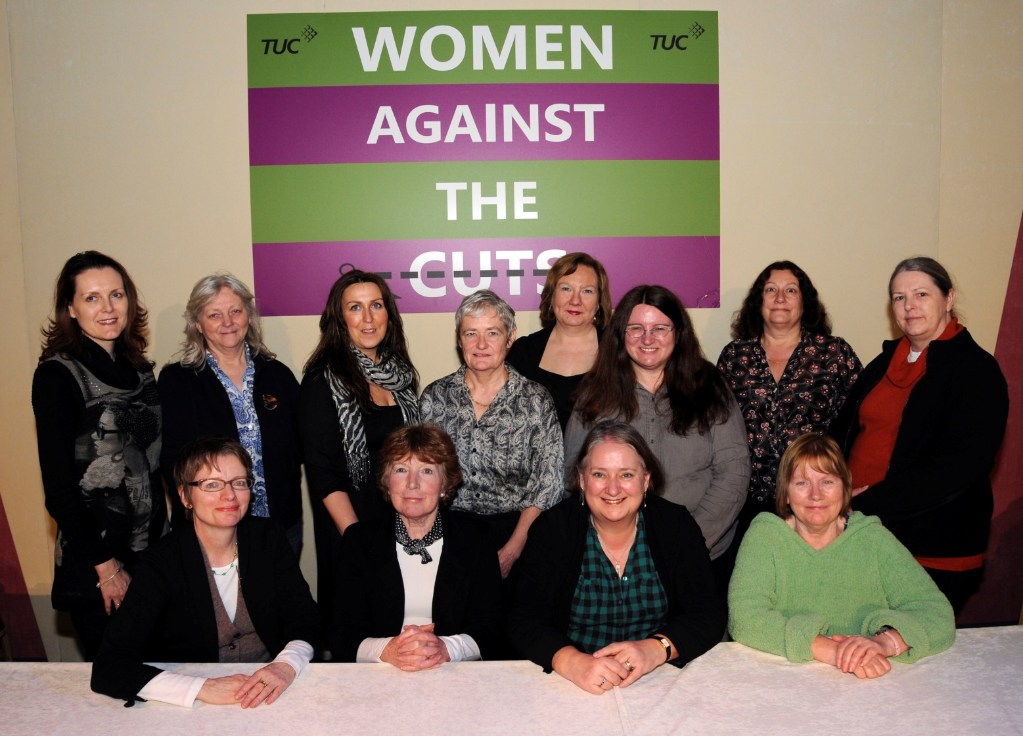
UCU Women’s TUC Delegation 2011

7. Disabled March and Lobby of Parliament – 11th May

The UKDPC (United Kingdom Disabled People’s Council) is planning a major march and lobby of Parliament on 11th May. This is an opportunity for disabled people to engage with their MPs on the Welfare Reform Bill as it reaches a critical stage in the Commons and via the march to express a collective anger at the impact of the cuts on benefits, services, employment opportunities and rights.
The provisional plan for the march is to assemble at Victoria Embankment from 11.30 and head off at around 12.30. It would take in Bridge Street, turn into St Margaret's St (passing Parliament) then on to Milbank, finishing at about 13.30. The lobby of MPs will run from 14.30 to 17.30 and they are hoping to get permission to use Westminster Hall for this. Methodist Central Hall will be where the rally will be held and provide a base for people who may have travelled very long distances to rest and meet with friends prior to returning home.
To sign up for this March or receive further information visit:

http://www.ukdpc.net

and email:

info@ukdpc.net

8. Congress – Equality Fringe Meetings
UCU Congress will be held this year from the 27th to the 30th of May in Harrogate. The Equality Department committees are holding the following Fringe meetings:
- Equality Committee: Equality under attack (Monday lunchtime)
- Disabled Member’s Standing Committee: The struggle for equal rights for disabled people (Sunday lunchtime)
- Black Member’s Standing Committee: Education and multiculturalism (Sunday lunchtime)
- Women Member’s Standing Committee: Work-life balance (Saturday lunchtime)

9. Fear and Hope – The new politics of identity
The Searchlight Educational Trust has produced one of the largest and most comprehensive surveys ever examining attitudes to English identity, faith and race. You can find the report at the campaign website here:
http://www.fearandhope.org.uk/welcome/

10. Parental Leave and Flexible Working
Additional paternity leave
The new right to additional paternity leave is now in force and will affect parents of children born or on or after 3 April 2011 and to adoptive parents who are notified that they have been matched with a child on or after that date.
Additional paternity leave (APL) will allow an employee to take up to 26 weeks' leave to care for the child, on top of two weeks of ordinary paternity leave.
This can only be taken 20 or more weeks after the child's birth or placement for adoption, and once the mother has returned to work from statutory maternity or adoption leave or ended her entitlement.
The rate is £128.73 a week, or 90% of average weekly earnings if that is less.
To qualify, the father must have been on a continuous contract with his employer for at least 26 weeks by the end of the 15th week before the baby is due.
Flexible working
The government has shelved the planned extension of the right to request flexible working to parents of 17 year olds, which was scheduled to be introduced in April. The press release read as follows, “The Government is committed to extending the right to request flexible working to all employees in due course, as set out in the Coalition Agreement. The aim behind delaying the extension of flexible working is to allow businesses breathing space in the current economic climate. Flexible working is currently available for parents with children 16 and under and carers”. For more information on this please contact Charlotte Nielsen at: cneilsen@ucu.org.uk
Get involved
If you would like to join one of our networks, please send an email to eqadmin@ucu.org.uk stating your preferred email address along with the name of the network you would like to join. You should note that these networks are not discussion forums, but that you will be sent information relating to the area of equality. The networks available for joining are:

Black Members Network
Women Members Network
LGBT Members Network
Disabled Members Network

