The growth of managerial staff in UK higher education

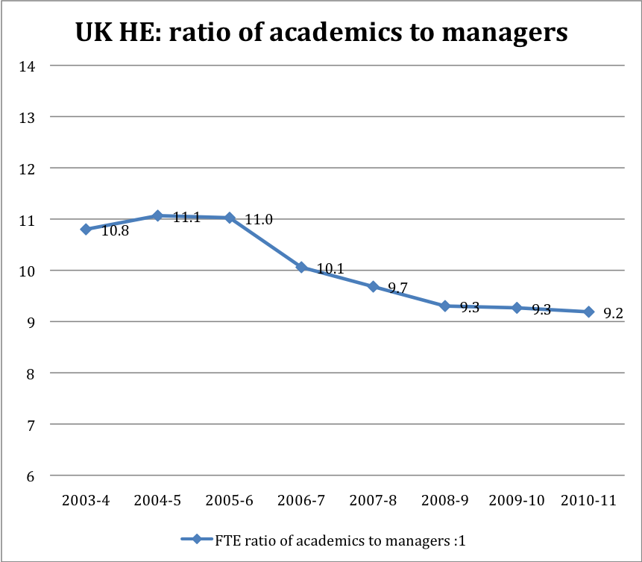
The full-time equivalent number of managers in UK higher education has increased by 40% in the past eight years. At the same time the number of academic staff has only increased by 19%. In other words, the number of managers has risen at more than twice the rate of the number of academics. Meanwhile the full-time equivalent ratio of academics (including teaching-only, research-only and teaching-and-research academics) to managers has fallen from 10.8:1 to 9.2:1, according to UCU analysis of data provided by the Higher Education Statistics Agency.

Managers and academics in UK higher education

FTE | Managers | Academic staff | FTE ratio of academics to managers:1
2003-4 | 11,305 | 122,100 | 10.8
2004-5 | 11,920 | 131,930 | 11.1
2005-6 | 12,120 | 133,645 | 11.0
2006-7 | 13,550 | 136,330 | 10.1
2007-8 | 14,400 | 139,405 | 9.7
2008-9 | 15,330 | 142,610 | 9.3
2009-10 | 15,410 | 142,795 | 9.3
2010-11 | 15,795 | 145,165 | 9.2
Change 2003-4 to 2010-11 | 39.7% | 18.9%
FTE = full-time equivalent
Source: Higher Education Statistics Agency Staff Record, series; numbers rounded to nearest 5; ratios and percentages calculated on unrounded data; % and ratio calculations: UCU. 2010-11 data do not include Liverpool Hope University. Numbers of managerial staff first published by HESA in 2003-4
UCU | March 2012

