
No 20  April 2012

Contents
1. New Equality Administrator
2. Congress – Equality Fringe Meetings
3. Women’s TUC Conference 2012
4. Guidance on Trans Equality in Post-School Education
5. EHRC Begins to Monitor Public Bodies’ Compliance with Equality Act
6. Learning from Disability Equality Schemes in HE
7. TUC Paternity Leave Briefing
8. ESOL Campaign Launched
9. Hidden in Plain Sight – EHRC Report on Disability Related Harassment
10. Holocaust and Women’s Wall Charts Updated
11. UCU Religious Attire Policy finalised
12. LGBT Research Conference
13. Mental Health Awareness Week
14. Model Policies


1. New Equality Administrator
There is a new member of the team in the Equality Unit. Yasue Fadhlaoui has taken up the position of Equality Administrator while James Taylor acts up as Equality Officer, covering Sharon Russell’s adoption leave. Yasue says:
“The first interesting thing about me is that I am half Japanese and half Tunisian. I was born and raised in London, currently living in the Heart of the Olympics in Stratford. My career background is Social Housing. I have worked mainly for Housing Associations during the last eight years. I have done many varied roles and choose to leave that sector for more of a challenge…hence I am here for six months. In September 2011 after months of planning and hard saving I left my role of Property Services Administrator and embarked on a four month journey alone, which lead me to India, Thailand, Singapore and Laos. The experiences and sights were amazing, so with fond memories and missing the sunshine I am now here working at the UCU, which I am very much looking forward to”
You can contact Yasue at yfadhlaoui@ucu.org.uk

2. Congress – Equality Fringe Meetings

This year’s UCU Congress runs from the 8th to the 10th of June in Manchester. The Equality Unit will be running a joint equality fringe meeting on the Saturday 9th of June from 13:00 – 14:00. The speaker is yet to be finalised, but the theme of the meeting will be equality and negative stereotyping in the media, a particularly pertinent topic in the current economic climate. There will also be a Black Members’ fringe on race in education on the Friday lunchtime from 13 -14:00. If you are attending Congress please do come along and take part in the debate.

3. Women’s TUC Conference 2012
UCU sent a full delegation of 16 to the TUC Women’s Conference at Congress House in London, from the 14th to the 16th of March.

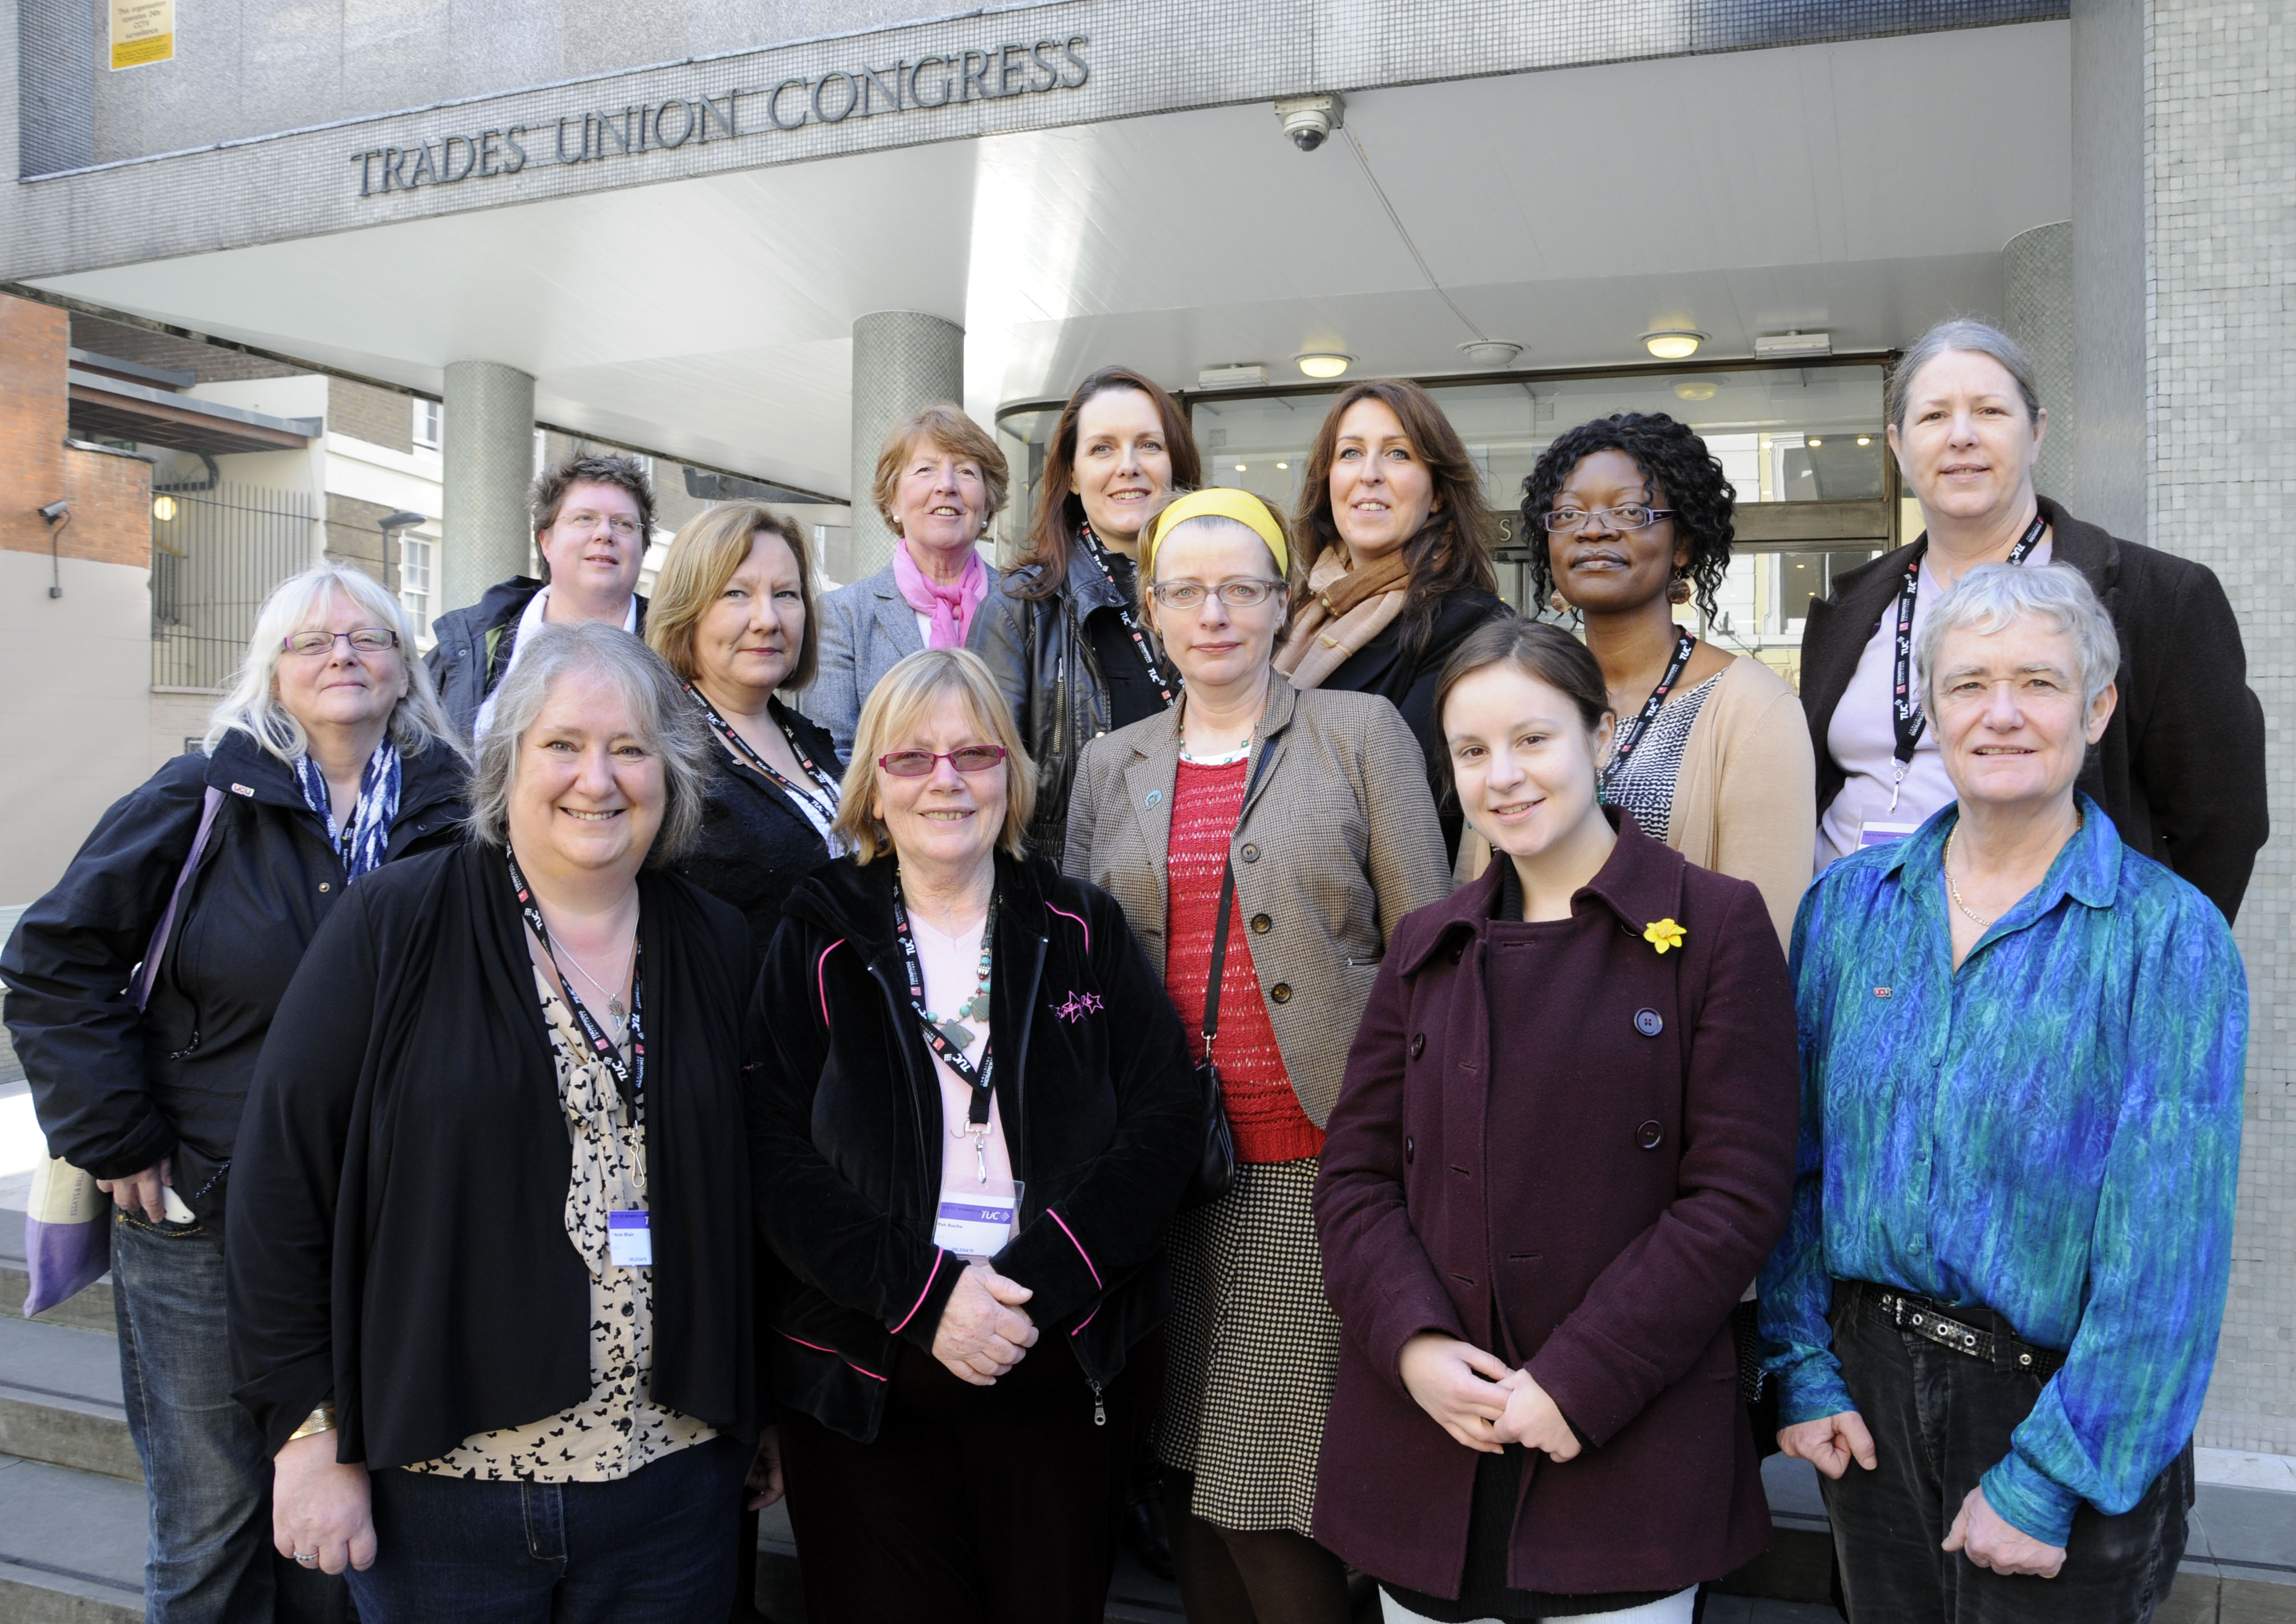
The UCU delegation at this year’s TUC Women’s Conference

The theme was “Every woman in every workplace, stronger together” and once again UCU delegates played an active part, speaking on a wide range of motions, including our own motions on the disproportionate impact of the cuts on women, and girls’ and women’s right to learn. Maire Daley was re-elected to TUC Women’s Committee. We also hosted a very successful joint fringe meeting with NUT and Unison on the impact of the cuts in education.
For enquiries relating to the TUC Women’s Conference, please contact Charlotte Nielsen at cnielsen@ucu.org.uk

4. Guidance on Trans Equality in Post-School Education
Marking LGBT History Month the Forum for Sexual Orientation and Gender Identity in Post-School Education has published updated guidance on trans equality in post-school education. It provides information and suggests effective approaches for ensuring that trans equality is embedded in all policies and practices in post school education. It is relevant for education providers, managers, staff, students, students’ unions, trade unions and other sector organisations. You can download the guide here for free: http://www.ucu.org.uk/media/pdf/i/5/forum_trans_guide_20121.pdf
Seth Atkin, UCU Equality Support Official, is Chair of the Forum for Sexual Orientation and Gender Identity in Post-School Education. You can contact Seth at satkin@ucu.org.uk

5. EHRC Begins to Monitor Public Bodies’ Compliance with Equality Act
From February 2012, the Equality and Human Rights Commission will begin monitoring the information published by public bodies to show that they are complying with the Equality Act 2010. Public bodies in England and non-devolved bodies in Scotland and Wales which are subject to the specific duties had until 31 January 2012 to publish information that demonstrates how they complying with the aims of the general equality duty. Schools and referral units had until the 6th April 2012 to publish their information. This must include information relating to people who share a relevant protected characteristic and who are the authority’s employees (for authorities with more than 150 staff) or people affected by the authorities’ policies and practices. The commission will review authorities’ websites to assess to what extent they have demonstrated their compliance, and whether they are preparing to comply with the requirement to publish equality objectives by the end of April. A report of findings should be available in Spring 2012. The commission intends to highlight any particular issues or examples of good practice.

You can download UCU’s own guide to the Public Sector Equality Duty here:
http://www.ucu.org.uk/media/pdf/i/3/UCU_Equality_duty_toolkit.pdf
The TUC toolkit:
http://www.ucu.org.uk/media/pdf/2/o/TUC_Equality_Duty_Toolkit.pdf
For a guide to the duties in Wales:
http://www.ucu.org.uk/media/pdf/0/s/Public_sector_equality_duty_in_Wales.pdf
Information on Scotland: http://www.scotland.gov.uk/Topics/People/Equality/PublicEqualityDuties
And Northern Ireland:
http://www.equalityni.org/sections/default.asp?cms=Policy_Section%2075%20-%20the%20statutory%20duties&cmsid=89_98&id=98&secid=6

UCU wants to hear your feedback on how the Public Sector Equality Duty is being implemented in your institution. Please send your testimonies to Equality Support Officer James Taylor at jtaylor@ucu.org.uk

6. Learning from Disability Schemes in the UK
EIA’s (Equality Impact Assessments) should be a key tool for improving employment practices and education services, recommends a research report looking at the experiences of Higher Education institutions (HEI’s) in drawing up disability equality schemes. The report considers lessons learnt from the disability equality duty and what they mean for meeting the requirements of the public sector equality duty under the Equality Act 2012.

The report recommends that equality objectives should be “specific and measurable”. It gives examples of equality objectives that a HEI might develop, with examples of specific actions that could be taken to achieve the objectives. It also emphasises the importance of involving disabled people in the development of objectives, as the research shows that meaningful change is more likely when disabled people are involved in the process.

The report supports the use of equality schemes, though it warns that the “tick box” approach should be avoided. It states that “While [equality] schemes are no longer a requirement of the specific duties, they can still be a useful means of publishing an institution’s objectives and general approach to equality”. It adds: “This research found that the process involved in producing a scheme ensures institutions think about disability equality and set out how and why they are going to implement their plans. Having a process that aids an institution to be both proactive and reflective in achieving equality of outcome for disabled people is useful and necessary, regardless of what the process is called”.

The report concludes: “Equality schemes, impact assessments, action plans and involvement exercises are all tools that can help to ensure legal compliance and assist HEIs in mainstreaming equality. Although institutions do not have to use these mechanisms, where they are used they are key tools in changing and developing an inclusive institutional culture. The challenge is to instigate tangible, measurable change and ensure disability equality is at the heart of the educational sector.”
Download the report at the following location: http://www.ecu.ac.uk/publications/meeting-the-equality-act-2010-learning-from-disability-equality-schemes-in-higher-education-in-england

7. TUC Paternity Leave Briefing
A new paternity leave briefing from the TUC is now available for union reps on the TUC website. Looking at recent changes to paternity rights legislation, the briefing explains the new rights of fathers and partners (including same-sex partner) to take additional paternity leave and pay, so that a couple can share the care of their baby. You can access the briefing here:
http://www.tuc.org.uk/tuc/paternity.pdf

8. ESOL Campaign Launched
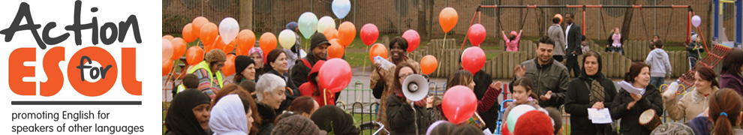
Action for ESOL launched its manifesto on March 2012, and you can download it from the new Action for ESOL website http://actionforesol.org/action-for-esol-manifesto. Action for ESOL has already scored a major victory as the government announced that the huge U-Turn on their plans to make students on benefits pay for English (ESOL) classes would now stay until 2013. Many feared the changes were ‘just for one year’ but this has now been extended for a further year until 2013/14. For more information or to get involved in the campaign you can contact UCU’s Dan Taubman at dtaubman@ucu.org.uk.

9. Hidden in Plain Sight – EHRC Report on Disability Related Harassment
'Hidden in plain sight' is the final report of the Equality and Human Rights Commission's Inquiry into disability-related harassment. The report uncovers that harassment is a commonplace experience for disabled people, but a culture of disbelief and systemic institutional failures are preventing it from being tackled effectively. As well as reporting on the extent of harassment the report also includes case studies and makes recommendations to public authorities to help them deal with the problems uncovered.
The EHRC have produced a briefing for schools and colleges which can be downloaded here (.doc).
Key areas for improvement for schools and colleges
- Promote positive attitudes to disabled people
- Better integration of pupils who are disabled or have special educational needs
- Increase reporting of harassment and bullying
- Recognise that bullying may be motivated by hostility or prejudice against disabled people
- Intervene effectively to prevent escalation of bullying
- Better support for disabled pupils
- Reduce harassment of disabled people by pupils outside school, particularly on public transport
- Improve joint working with other agencies
UCU will be raising the report with the Higher Education Equality Challenge Unit and the Association of Colleges particularly how they will support staff in delivering the recommendations.

UCU responded to the Inquiry and raised our concern that the Inquiry would not look at disability related harassment of staff in the workplace.
Further information about the Inquiry can be found on the Equality and Human Rights Commission website: www.equalityhumanrights.gov.uk

10. Holocaust and Women’s Wall Charts Updated
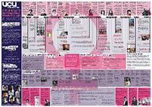
To mark two significant dates, the 27th of January, National Holocaust Memorial Day and 8th March, International Women's Day, UCU has updated its popular commemorative history wall charts. They are great learning tools, and you can download copies from here: http://www.ucu.org.uk/index.cfm?articleid=1868 or contact Yasue Fadhlaoui (yfadhlaoui@ucu.org.uk) for a hard copy, stating how many copies you would like sent.

11. UCU Religious Attire Policy finalised

Following concerns that some institutions were excluding students due to the banning of certain religious head-dress, the following motion was passed at Congress 2011:

- Congress notes the importance of people of all faiths having the right to wear the religious head-dress and other religious attire appropriate to their faiths.
Congress also notes the importance of the right to wear the appropriate dress in ensuring and increasing participation in further and higher education, and in enabling people, particularly women, to access education at all levels, and calls on NEC to formulate a policy which reflects this.
In light of increasing Islamaphobia eg. the French ban on wearing the veil, the Swiss ban on minarets, moves to outlaw the burkha in various countries, and the alarming precedent of a UK college prohibiting students from wearing the veil in college, Congress resolves to work with the NUT, NUS, Unite Against Fascism and other anti-fascist organisations to:
- hold a conference on fighting Islamaphobia in education and
- produce an anti-Islamaphobia teaching pack

UCU has therefore formulated the following religious attire policy that has been approved by the Equality Committee, and will be shared with institutions.
A recent report by the Equality Challenge Unit entitled, Religion and belief in higher education: the experiences of staff and students noted that’
‘10% of students and 3.7% of staff identified that their religion or belief required them to wear specific dress or symbols. The majority of those who indicated that they have dress requirements are Muslim, Sikh and Jewish respondents. Members of staff and students feel that the campus is, in general, a place where individuals feel comfortable wearing symbols and religious dress. 85.6% of staff (118 respondents) indicated that they were able to fulfil their dress requirements without difficulty, and 79.3% of students (431 respondents) feel this to be the case. A greater proportion of female staff (92.4%) and students (81.5%) feel able to fulfil their dress requirements compared with male members of staff (77.1%) and students (76.9%).’

UCU welcomes the variety of appearance brought by individual styles and choices. The wearing of items arising from particular cultural/religious norms is seen as part of this welcome diversity.
The only limitations to the above may occur when:
- Health and safety requirements may mean that for certain tasks specific items of clothing such as overalls, protective clothing etc need to be worn. If such clothing produces a conflict with an individual’s belief the issue will be sympathetically considered by the line manager with the aim of finding a satisfactory outcome.
- Clothing displaying slogans which are discriminatory (e.g. racist or sexist slogans) causes offence.
- There are particular legislative requirements. In Northern Ireland, dress or symbols that associate individuals with a particular religion or belief group are regulated. Items of clothing which may be related to sectarianism would be considered problematic and fall under the regulations i.e. football shirts. In the case of dress or symbols associated with other minority religion or belief groups, this is not an issue, and the dress code raises no specific issues about wearing other garments associated with minority religions.
- Particular educational ceremonies or practices, such as graduation, require the wearing of traditional outer garments. In such instances the institution would be expected to ensure that the traditional garb allows the wearer to fulfil their cultural or religious affiliations.
- Exam verification/identification may require institutions to conduct identity checks. Such checks must always be discreet and conducted in a manner which respects the religious, social or cultural norms of the individual
12. LGBT Research Conference
Reconsidering Coming and Being 'Out'? Lesbian, Gay, Bisexual and Trans Research in the 21st Century, Friday 18th May 2012, London South Bank University. Please see the following document and application form for more information: http://www.ucu.org.uk/media/pdf/3/c/arac_flyer.pdf
All are welcome to attend and contribute - If you wish to be involved, please fill out the form in pdf and email to arac@london.com
13. Mental Health Awareness Week
Mental Health Awareness Week this year runs from 21st – 28th May. The focus for 2012 will be Altruism and Giving, including random acts of kindness, volunteering and peer support. If you would like to be kept up to date with the latest developments for Mental Health Awareness Week, please join their Facebook page by clicking this link: http://www.facebook.com/mentalhealthfoundation, follow them on twitter (@mhf_tweets) or sign up to their newsletter at www.mentalhealth.org.uk/our-news/newsletter.

UCU has published its own Mental Health guidance, “1 in 4” which you can download here: http://www.ucu.org.uk/media/pdf/r/q/ucu_1in4_mentalhealthatwork_jun11.pdf

14. Model Policies
UCU wants to collect model equality policies you feel work well in your institutions. We would like to collect and share good examples of collective agreements on issues relating to equality, disability leave, maternity, paternity, other family friendly policies (flexible working, career breaks), union facilities and other subjects that may be covered by union negotiations. The purpose is to provide good examples to other branches who are negotiating equality policies in their institutions. Please send your policies, how you arrived at them and why you feel they work, to James Taylor jtaylor@ucu.org.uk

Get involved
If you would like to join one of our networks, please send an email to eqadmin@ucu.org.uk stating your preferred email address along with the name of the network you would like to join. You should note that these networks are not discussion forums, but that you will be sent information relating to the area of equality. The networks available for joining are:

Black Members Network
Women Members Network
LGBT Members Network
Disabled Members Network

