No.12 September 2012

 Newsletter

East Midlands Retired Members Branch

In this newsletter
1. September branch meeting
2. TUC 20th October march and rally
3. Campaign: 68 is too late
4. Age discrimination: no surprise
5. Pension age: to infinity and beyond
6. NPC meeting – disappointing!
7. Crisis in pensions
8. Care white-paper fudges funding
9. Pension updates: USS and TPS
10. Women in Action, Action for Women
11. UCU retired members branch
12. May Day rallies
13. Chesterfield Trades Council
14/15. TUC and NPC rallies

1. Branch meeting
11.00 a.m. Tuesday 18th September
The Swan in the Rushes Inn, The Rushes,
Loughborough

Speaker: Geraldine Egan,
UCU National Pensions Officer

on “Pensions in the future”

Geraldine will speak on the pension situation for both TPS and USS. She will be available to answer questions.
Note: All meetings are 11.00 - 1.00 p.m. tea/coffee provided with a place for lunch afterwards. Put the date in your diary.
The Swan Inn does very nice pub meals and excellent filled toasted cobs and ciabattas. Join other members for a quiet drink with and after lunch. The Inn is in the centre of Loughborough if you wish to do some shopping.

2. TUC rally: Saturday 20th October
There will be a massive TUC march and rally on 20th October to which UCU is giving strong support. The protest is to make clear the opposition to the Governments’ present economic policies and austerity. The march will assemble from 11.00 a.m. onwards on the Embankment before heading to Hyde Park, where there will be a rally.

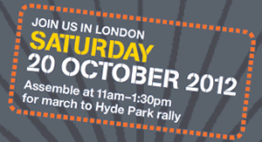
For further information about the event check out the TUC’s website at www.afuturethatworks.org.uk
Information about transport to and from London on the day is being posted on the False Economy website at: http://falseeconomy.org.uk/oct20

Why we are marching - Austerity isn’t working

Our country faces long-term economic problems. But our political leaders have failed to face up to them.
 For the next five years or more, unless policies change the economy will not grow, incomes will not rise, and there will be almost no new jobs.
 If the government keeps on with big spending cuts and austerity we face a lost decade. To close the deficit we need a healthy growing economy that generates tax income. Austerity has led to a vicious circle of decline.

Instead of just letting the banks go back to business and bonuses as usual, we need policies that promote new and old industries.
 This new approach would create jobs, especially for young people.
 It would encourage companies to raise average pay, penalise big bonuses and invest in training and new industries. It would crack down on tax evasion by big companies and the super-rich.
 Rather than deep, rapid spending cuts, we need to reverse our decline and build an economy that works.

Email addresses please!
* Inform us changes to your email address
* If you receive this newsletter by post,
please inform us of your email address.
We encourage retired members to use their home email for when you give up your work email address. We send out a quarterly newsletter by email but only an annual newsletter by post. This is to save money on post and the effort of stuffing over 500 envelopes. The increase in the price of postage is exorbitant.
Please inform us of
change of address or email

3. Campaign: 68 is too late
This Government's new pension legislation could increase the retirement age to 68. That's too long to work and too late to retire. Trade Unions, including UCU and other teaching unions, have set up a campaign called ’68 is too late’ to try to get changes. While some university and FE staff may wish to work beyond 68, no-one should be forced to do so. Changes in the law last year allow members to work past the old 65 years old retirement age if they so wish and if their health allows.

The Campaign is urging UCU members to join and also to email the Prime Minister. Please email David Cameron now and tell him how damaging these changes will be to workers in GB. Go onto the website below to join and send an email:
http://www.68istoolate.org.uk/page/speakout/cameron-speakout?js=false

“British people work until they drop is another hijacking of our living standards and shows no care for the lives of ordinary people. How can it be that the seventh richest nation on the planet denies its people a healthy retirement? This is not the sort of achievement any government can be proud of. This is unpopular, impractical and will strain our society. The government must rethink and do so now."

The founding unions also say the UK plans are out of step with the rest of Europe, where only four nations, Germany, Denmark, Poland and Spain, are planning to increase their retirement age above 65 to 67. The retirement age is due to increase to 68 in 2044.

Key points to remember:
 Too long to work. 68 will be the highest state pension age in Europe. The UK government is planning further increases.
 Too late to retire. Life expectancy is increasing – but government figures show that women only stay healthy to 69 and men to 67.
 Young people on the scrap heap. More than one million young people are already out of work – increasing the state pension age to 68 will mean an extra 1.2 million older people being forced to stay in the workforce.

4. Age discrimination: no surprise
Age discrimination is the most common form of discrimination in the UK and Age UK has campaigned long and hard for legislation to deal with this. The Government’s recent announcement that the ban on age discrimination in the provision of goods and services (with the exception of financial services), will come into force on October 1 2012, is very welcome news. We hope this legislation will herald a sea change in society’s view of older people, a view too often characterised by an emphasis on biological decline and economic burden ignoring the contribution offered by older people in employment, volunteering, and in caring for partners, children and other family members.

The most positive aspect of this legislation is the impact it will have in health and social care services. For example, in cancer care we know that age is a key factor in determining survival, in part because older people are currently under treated and experience poorer outcomes as a result. The Department of Health itself acknowledges that older people currently receive worse outcomes in treatment of cancer as the result of age discrimination. We are also expecting to see changes in mental health services, which frequently discriminate against older people, not offering them access to the range of services available to younger adults despite having the same need.

However, the legislation is not an unmitigated cause for celebration. The wide exception that has been granted to the financial services industry is very disappointing. This exception means that older people can, for example, still be discriminated against when trying to obtain insurance or banking services purely on the basis of their age. We accept providers of risk-related services should be able to use age to assess risk and decide price, provided that they can supply evidence that they are doing so in a way that is proportionate to risk. However, we do not feel that the exception will ensure that this condition is met.

We know that ageism in financial services causes worry and distress for many older people, limiting their choices and increasing costs. We will continue to press for financial services to be subject to the ban and urge the Government to keep the impact of this exception under close scrutiny.

Overall the legislation is very welcome, requiring those providing services to consider their practices and policies in relation to older people. However, by itself it will not be sufficient to change negative attitudes towards ageing. Ultimately we need to learn how to value older people better, appreciating their talents and not just seeing a date on a passport. The ban on age discrimination is a welcome step towards this.

Facts and stats

 51% of people aged 65+ believe that age discrimination exists in older people’s everyday lives

 The UK is in 10th position out of 24 European countries (1=best, 24=worst) for preventable deaths from stroke

 The UK is in 18th position out of 24 European countries (1=best, 24=worst) for preventable deaths from cancer

 39% of people aged 65+ think that businesses have little interest in the consumer needs of older people

Extract from AgeUK

5. Pension age: to infinity and beyond
The good news from the Office of National Statistics (ONS) is that Life Expectancy at birth continues to increase. The major driver in that change is the dramatic decline in infant mortality but life expectancy for 65 year olds is also increasing. Extrapolating the present increase from 2008 to 2051 gives a life expectancy increase for men of 8.3 years and for women of 8.0 years. The bad news is that this has caused a series of pressure groups, most vociferously the Institute of Directors (IoD) (“Roadmap for Retirement Reform 2012” Malcolm Small, IoD 2012), to seize on this projection to argue for an accelerating increase in State Pension Age (SPA) (which now produces the same increase in Normal Pension Age (NPA) in public sector pensions).

The IoD explains its agenda clearly: “We welcome the announcements by government that State Pension Age is to rise to 66 in 2020 and to 67 in 2026. However, this is just a start, and more needs to be done. The next rise remains scheduled as to 68 in 2046. We think this is too slow. Based on a 6 year “gap” each time, we think it should be 2032, 69 in 2038 and 70 in 2044.” The older workers would continue to work, to produce value and the pension bill would fall. It is pure magic and who could disagree?

Let us look at the ONS figures again (“Life Expectancy at birth and at age 65 for health areas in the United Kingdom” ONS). The gap between the longevity of the rich and poor has increased over the last four years. Life expectancy correlates with how well off you are. The gap between the health areas with the highest and lowest life expectancies at birth increased over the period from 9.8 to 11.3 years for males and from 8.2 to 10.1 years for females. At age 65, the gap increased from 6.7 to 8.5 years for men and from 6.3 to 8.3 years for women. These figures make it clear that every increase in SPA redistributes money from poor pensioners with low life expectancies to those from more well off backgrounds. The other problem with the logic of the IoD is that work for those over 65 may be hard to find, particularly for the manual worker. Mean disability-free life expectancy is 68 for those from wealthy areas but for those from poor areas it slumps to 53 years.

In addition to the clear evidence that there is no financial problem with sustaining state and public sector pensions, a strong caveat must be placed on extrapolating already dated statistics to 2051. The cheery news from medical sources is that the increase in longevity may change. This increase in life expectancy in Europe and other high-income countries may soon come to an end due to the global increase in obesity (Leon, D.A. “Trends in European life expectancy: a salutary view”, International Journal of Epidemiology, March 2011).

It is recognised that the recent trends in cardiovascular risk factor prevalence in younger people is disturbing and that obesity levels and type 2 diabetes have been rising for over ten years in people aged 45 and under. Physical activity levels in younger age groups have decreased slightly over the last fifteen years and smoking levels within this age group have remained high (Allender, S.; Scarborough, P.; O’Flaherty. M.; Capewell, S. “Patterns of coronary heart disease mortality over the 20th century in England and Wales: Possible plateaus in the rate of decline”, BMC Public Health 2008; 8:148).

There are other factors such as recreational drugs, cannabis, alcohol, smoking, genetic and acquired heart conditions that can contribute to the increase of the risk of heart attack in younger people (Wallersteiner R., “Heart Health in the Young”, netdoctor website). Needless to say these last outbursts of pure joy are more projections than “facts”; but are a useful corrective to the official speculative projections that are so often used to justify the deterioration in our pensions and welfare state.

Julian Atkinson

6. NPC meeting - disappointing!
The NPC (National Pensioners Convention) to which UCU nationally and locally is affiliated, met with Labour Party shadow ministers on 17th July. NPC officers, Dot Gibson and Neil Duncan-Jordan, met with Rachel Reeves, Shadow Chief Secretary to the Treasury, Ed Balls, Shadow Chancellor.

The meeting followed a pledge made by the Labour Party at the NPC meeting in the House of Commons in April on the issue of the age related personal tax allowances.

The NPC outlined four immediate concerns for discussion and asked for the Opposition’s views:

 The change in pension indexation from the Retail Price Index (RPI) to the Consumer Price Index (CPI)

 The freeze on the age related personal tax allowances

 The current attack on universal pensioner benefits

 The long-term funding of social care and the case for a National Care Service, free at the point of delivery and funded through general taxation

Labour confirmed they would not have introduced the change from RPI to CPI had they been in power. They recognised that under the triple-lock arrangement, with an improved economy, pensions would rise with average earnings and CPI/RPI would be irrelevant. However, the change to CPI would still affect working age benefits. They would come back in due course once they had determined how this anomaly could be addressed, but at this stage they were unable to say whether they would reverse this change.

Labour is currently calling on the Government to reverse the decision to freeze the age related personal tax allowances – especially at a time when those on £150,000 or more were getting a 5% cut in their tax rate. However, at this stage it was not possible to confirm if Labour would reverse this change at the next election.

Labour accepted the case for universal pensioner benefits such as the free bus pass and recognised its social as well as its economic value. The NPC agreed to pass on information in support of universal benefits and the contribution older people make to society. The Shadow Treasury Team was unable to say whether these issues would feature in their next manifesto, but there were no plans to means-test the bus pass.

Labour believed the Government’s proposals on social care, published last week, did not add up to a coherent policy. They were keen to find a consensus on the issue, but talks had broken down and they found it difficult to lead on the issue as an Opposition.

They supported the idea of “progressive universalism” which meant everyone received some free support, and those with assets would be asked to contribute more towards services. They were keen to explore the policy announced by Alistair Darling in the March 2010 Budget which announced a freezing of the Inheritance Tax threshold at £325,000 per person and the money raised being used to fund future care. They were unsure about the Dilnot proposals. They were also reluctant to raise income tax to fund care because of competing priorities for such funding. However, they did not yet have detailed plans and would take some time before this was developed. They recognised it was a complicated issue which needed greater discussion.

It was agreed to meet again at a suitable time to continue the dialogue on these and other issues.

National Pensioners Convention

7. Crisis in private pensions
There is a crisis of confidence in the private sector pensions industry. In 2007 there were 31% of employees in private sector work place schemes but this had fallen to 26% by 2011 (“Employers’ Pension Provision Funds 2011” Department for Work and Pensions). The National Association of Pension Funds found in March this year that 54% of all employees are not confident in pensions as a way of saving.

The Government has favoured two ways of bolstering private pensions: the first involves savaging the more generous and efficient public sector pensions and the second setting up an auto-enrolled private scheme termed NEST. NEST is supposed to provide efficient and cost effective private pensions. Already it is clear that the employers will put in the minimum and the rewards to the pensioner will be small. A rival Danish provider has both undercut the costs of this flagship and offers better returns. This is not the first time that the British pensions’ industry has been shown up. A comparison between similar British and Dutch private pensions showed the Dutch schemes providing a massive 50% increase in returns. It is not surprising that the British pensions industry spends so much effort in attacking the superior public sector pensions.

The reasons why the British pensions industry lets down the pensioners are getting clearer. The RSA (The Royal Society of Arts) has produced a report that clears the mist. (“Seeing Through British Pensions” Pitt-Watson and Mann July 2012). The year long study shows how pension savers are being misled about the hidden costs and charges they have to pay. These charges can halve the value of a typical pension. A 2% charge a year doesn’t sound like much, but over the lifetime of a pension that reduces the pot by over 50%. The Association of British Insurers hit back at the claims. Director general Otto Thoresen said: "Pension charges have been falling steadily for the last decade and are continuing to fall. In newly set up automatic enrolment schemes the ave. annual management charge of our members is 0.52%. The ave. annual management charge for existing schemes is 0.77%.”

This response underlines the major point made in the RSA paper. The industry only acknowledges annual management charges. Harinder Mann makes the point: “ We conducted a survey and contacted a sample of 23 pension providers in the UK. We asked them what charges would be levied to the pension investment? What other charges would be levied apart from the annual management charge? What the breakdown of charges was? Our results showed that 21 out of 23 pension providers denied that any additional charges other than the annual management charge existed. Not one provider was willing to give us a full breakdown of the costs that would be charged.”
The 2% actual charges are incurred by including the costs for the buying, selling and churning of pension fund assets. But the pensions’ industry refuses to acknowledge or reveal these charges since they are carried out by their brokers and are formally not in-house. In Europe such transparency is the norm and is part of the reason why the Dutch and Danish private pensions are better. If the Government actually wanted to be fair to private sector pensioners it would not attack public sector pensions but stand up to the finance and pensions industry.

Julian Atkinson

8. Care white-paper fudges funding
After months of delay, the Government finally published its long awaited white-paper on social care, entitled Caring for our future, on July 11. What disappointed many was the lack of detail on the crucial issue of funding, apart from a commitment to make a further announcement in the spending review next autumn.

Ministers indicated they were in favour of a cap on the lifetime costs of care, and suggested that might be set between £75,000 - £100,000. However, this would still leave 90% of those in receipt of care paying for everything. There was also a general agreement that the means-tested level at which individuals could qualify for financial help would have to be raised, but there was nothing to say how much higher it would eventually be compared to the existing £23,250 threshold.

The white paper also proposes a universal scheme of deferred payments operated by local authorities, which would provide loans to cover care costs that could be repaid after the individual’s property had been sold.

Alongside the headline announcements were also other proposals to give carers the right to have their needs assessed, greater use of direct payments in residential homes, a new website for people to compare care home costs and an initiative for helping older people share their skills with others in return for support in the home.

Dot Gibson, NPC (National Pensioners Convention) general secretary, was widely quoted in the national media following the Government’s announcement saying: “The white paper is short on ideas to solve the care crisis. There is no attempt to end the unfair postcode lottery which allows different councils to charge different amounts for an hour’s worth of care, no effort to widen access to care services for the 800,000 people who are currently excluded from the system desperately need care, and no end to the means- test which penalises many people with small savings and a modest home.”

“It’s a wasted opportunity that adds to the uncertainty for millions of older people and their families.”

In response to the proposals, the NPC continues to call for a National Care Service paid for through taxation. A detailed briefing paper on the proposals is available on the web at npcuk.org. After months of delay, the white paper finally arrived, but crucially ducked the vital question of funding

What’s in and what’s out

 A cap on care costs, but no decision on how much this will be.

 A deferred payment loan scheme to pay for care costs recovered from the sale of any property, but with added interest and admin charges.

 An increase in the level at which means-tested support is made available, but no detail.

 A nationwide eligibility criteria for accessing services which is likely to be set at a level which excludes 800,000 people with moderate care needs.

 The right for carers to have their needs assessed, but bo money to pay for additional; services.

 A new code of conduct for staff, but no change in the postcode lottery of home care charges.

from ‘Campaign’, NPC Aug 2012

9. Pension updates
USS
There has been insufficient progress from our Employers towards agreement on changes to the pension scheme. Therefore, ‘Action short of a strike’ (as previously notified to the employers’ on 29 September 2011) has been resumed.

UCU has instructed its members to abide by the terms of their contracts (including their obligation to perform their duties in an efficient manner but no more); and in particular to:

 work no more than their contracted hours where those hours are expressly stated and in any event not to exceed the maximum hours stipulated by the Working Time Regulations (unless there has been an individual opt-out)
 perform no additional voluntary duties, such as out of hours cover, or covering for colleagues - unless such cover is contractually required
 set and mark no work beyond that work which they are contractually obliged to set/mark
 attend no meetings where such attendance is voluntary on the part of the member.

TPS
The UCU National executive Committee has agreed that if other 'rejectionist' unions (NUT and NASUWT) call strike action in the Autumn term, UCU would ask its TPS members to join such action. The general secretary has been in contact with our sister education unions and other public sector unions about their plans. NUT and NASUWT have agreed a joint campaign on a range of industrial issues, and PCS and Unite have confirmed that they continue to be in dispute with the government in some sectors over public sector pensions but no decisions have yet been taken about further strike action. UCU’s actions be determined in September once other unions' plans become clear.

10. Women in Action, Action for Women
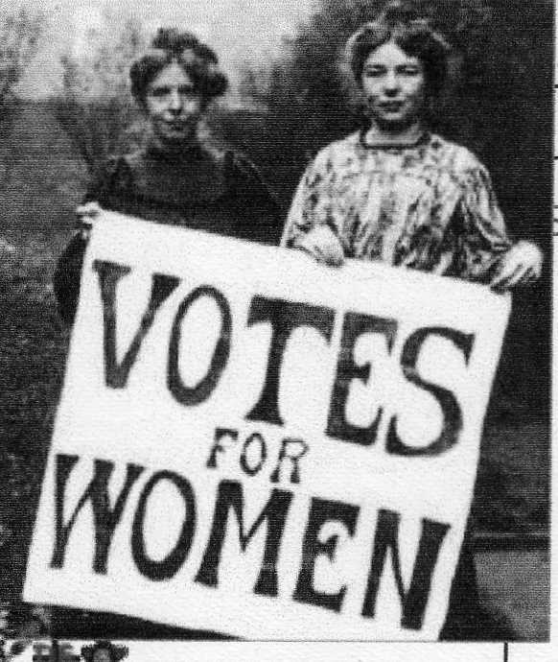
Recent newspaper articles have highlighted the inclusion of a band of “Suffragettes” in the Opening Ceremony of the London Olympic Games. Women taking part were lead by Helen Pankhurst, great grand-daughter of Emeline Pank-hurst. Some have now become better informed and more interested in the Suffragette movement and its relevance today. They are planning to join her in a rally and lobby of MPs to emphasise the need for continuing action on the many still unresolved issues. The event on October 24th will be lead by UK Feminista.

More information on their website: http://ukfeminista.org.uk

Last year I reported on the discussion of Women’s Education with Kat Barnard of UK Feminista at the UCU Women Member’s Conference. She reminded us of continuing inequalities between men and women, suggesting we face triple jeopardy in benefits, access to employment and further embedding of traditional feminine rolls. She said then that two thirds of current job losses have affected women and she asked us to support the “Re-Birth of Feminism”

If any of you are interested in attending this rally do let me know and perhaps we can form a small group to go together.

Rowena Dawson: jeanrowena@hotmail.co.uk
24 market Place, Kegworth DE74 2EE

11. UCU Retired Members Branch
The branch is now fully underway with over 450 members. The aims are diverse, but include bringing together retired members of UCU in the East Midlands, giving advice to branches on pension and retired members’ matters, campaigning on issues relating to retired members and representation to the UCU national congress, National Pensioners Convention, Local TUCs. If you previously worked outside the East Midlands, but lived or now live in the East Midlands please join our branch.

Meetings: We hold meetings some three times a year, in places of interest to make part of a day and lunch out. The meetings centre round important issues for UCU pensioners and give a chance to chat to other retired members.

Newsletter: A termly newsletter with useful articles for retired UCU members is sent to all branch members for whom we have email addresses and to UCU branch secretaries in the East Midlands. Because of the cost of postage other members will be contacted less often.

Email addresses: We encourage retired members to use their home email for when you give up your work email address. Please let us have your email address and also changes to your email address

For more information
please contact Julian Atkinson
e-mail jdatkinson34@btinternet.com
telephone: 01773 532105

East Midlands Branch officers and committee
Chair: Angus McLardy apmclardy@btinternet.com
Vice Chair: Ann Donlan ann@donlan.myzen.co.uk
Secretary: Julian Atkinson jdatkinson34@btinternet.com
Assistant Secretary: vacant
Treasurer: Brian Hambidge brianhambidge@ntlworld.com
Women’s officer: Rowena Dawson
jeanrowena@hotmail.co.uk
Membership and newsletter: Russ Bowman
dorothy.russ.bowman@ntlworld.com
East Midlands regional UCU committee representatives:
Brian Hambidge, Russ Bowman

12. May Day Rallies
Retired members of the East Midlands Retired Members branch joined very successful May Day rallies in Nottingham, Chesterfield and Leicester despite the bad weather. The branch banner with branch treasurer Brian Hambidge is shown in the photo at the Nottingham rally.
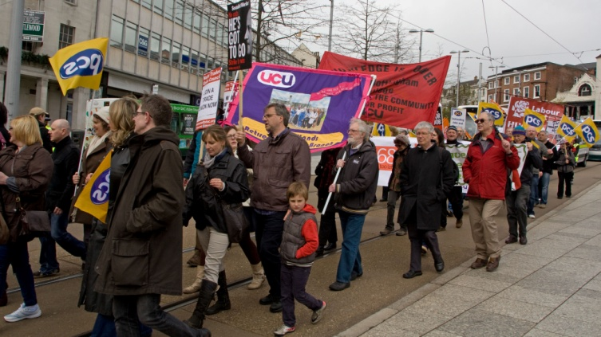
photo: Helen Chester

13. Chesterfield Trades Council
As a delegate of the East Midlands UCU Retired Members Branch, I have attended two meetings of the Chesterfield Trades Council and have reported back to the branch. Other delegates at the meetings comprise representatives from Unite, Unison, UCU and GMB. James Eaden, UCU delegate from Chesterfield College is the chair. Although the number of delegates attending is small, the activity is more than made up by the motivation and determination of the Trades Council to challenge the current imposition of a climate of austerity by the Coalition Government. The Chesterfield Trades Council is also a member of Chesterfield Against the Cuts, which as pensioners on an income under threat, I suggest it is important that we support as a branch.

The Chesterfield Trades Council has been instrumental in instigating and supporting a wide range of initiatives. These include organising the very successful May Day festival, to which we were able to contribute with our committee members bringing our banner. Chesterfield Trades Council have also presented a united front of solidarity with fellow union members facing redundancy or on strike picket lines, supporting unemployed workers and demonstrating against cuts in pensions and working terms and conditions.

Most recently the Trades Council demonstrated with the striking Remploy workers who are facing redundancy or threatened with reduced terms and conditions of employment with the privatisation of Remploy Chesterfield. On July 19th, the first of two days of strike action at Remploy and despite torrential rain, Trades Council members erected a huge banner on the roundabout at the start of the Sheffield bypass, round the corner from the Remploy factory. This drew attention to and support for the plight of the workers with disabilities. The following two Saturdays we also invited Remploy workers to join us in Chesterfield town centre where we were able to collect £150 pounds for their strike fund and elicit massive support from the local community. As a member of our retired UCU members’ branch and a delegate to the Chesterfield Trades Council, I was proud to be supporting some of the most disadvantaged workers in the workforce. Not only did our actions demonstrate the importance and success of worker solidarity, they demonstrated that retirement can be an important time not only to support our own cause, but the causes of those still hopefully in work.

Lucretia Packham, delegate from East Midlands UCU Retired Members branch

14. TUC Rally – Saturday 7th October
The Midlands TUC, supported by Birmingham Against the Cuts will be holding a March and Rally to coincide with the Conservative Party Conference in Birmingham. See:
http://www.tuc.org.uk/events/detail.cfm?event=3510 for details of the event and many national speakers, including Sally Hunt, UCU General Secretary. The next Branch Meeting will be discussing our participation, but please pass on the above link.

15. National Pensioners Convention
Demonstrations on bus passes
Pensioners organisations are concerned that introducing means testing on bus passes could lead to more means testing for pensioners. Many councils, e.g. Leicestershire County Council have started limiting money for free buss travel. This cutting is likely to continue. Please give your support.
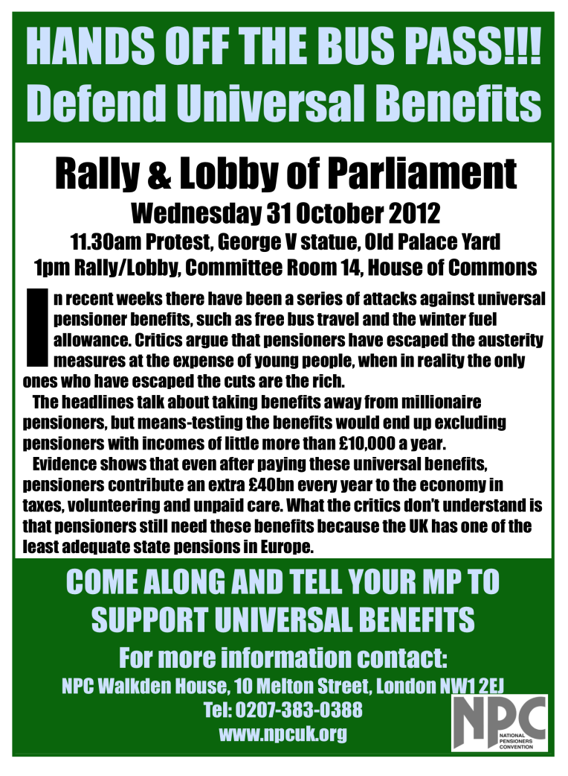
More information
A lot more information and news can be obtained from these websites. We recommend that you have a browse.

UCU National Website:
http://www.ucu.org.uk/?CFID=38885&CFTOKEN=1325329
AgeUK: http://www.ageuk.org.uk/
68 is too late: www.68istoolate.org.uk

