
No. 24 ● Congress 2013 Edition

Contents

1. Count Yourself In!
2. Section 3 of the Equality Act Retained
3. New Joint Agreement for Parental Leave in FE
4. International Working
5. Holocaust Memorial Day Film
6. New Equality Publications
7. HIV in the Workplace – National Aids Trust
8. New EHRC Guidance on Pre-Employment Health Questions


- Count Yourself In!
UCU is keen to improve the equality monitoring information we have about our membership. It’s important to gather this information in order to understand who our members are so our policies and priorities reflect all our members.
UCU encourages institutions to monitor the profile of its workforces and comply with equality legislation such as the Public Sector Equality Duty, and we would like to lead by example.
If you believe your information may be incomplete, then count yourself in by either emailing membership@ucu.org.uk or calling on 020 7756 2567. The information will be treated in confidence.

2. Section 3 of the Equality Act Retained
On Monday 22nd April, the House of Lords defeated the Government by 210 votes to 180 to retain the general equality duty (Section 3) of the Equality Act 2006.
The debate in the House of Lords heard an impassioned contribution from Independent crossbencher Baroness Campbell of Surbiton, who moved the amendment to retain section 3. She said ‘The general duty symbolises our commitment to preventing the kind of injustice faced by the Lawrence family, or the routine abuse of disabled young people in institutions because of indifference and cruelty. It aspires to a society founded on dignity, respect and equality – notoriously absent in these cases. However, contrary to what Ministers claim, the general duty is not, in fact, merely symbolic. Its repeal could have major implications for the commission’s role in monitoring equality and human rights.’
Lord Lloyd of Berwick (crossbench peer) said ‘...the Government have not given one single solid reason why we should repeal a provision that both Houses were in agreement on as recently as 2006’. Baroness Hussein-Ece (Liberal Democrat Peer) went further to say ‘...for these reason I profoundly disagree with the Government’s reasoning that they wish to repeal the general duty that originated as part of their Red Tape Challenge on the basis that it is vague, unnecessary and obsolete provision from the Equality Act 2006. This is not red tape, and it costs business nothing. Where is the evidence of that? It is about vision and about the mission, principles that matter and are important. We cannot risk sliding back if we become complacent on these defining principles.’
We believe the point was well made!
Could it be a coincidence that the decision to retain section 3 just happened to fall on the 20th anniversary of Stephen Lawrence’s murder and that the Government, who had attended a memorial service earlier that day, would have had an extremely difficult job in explaining their reasons for its repeal? Whatever the reason, we must not lose momentum and neither must we be complacent.
We would like to thank you for writing to your MPs to vote to retain section 3. Our combined action (grass roots organisations, the trade union movement, equality organisations) shows that collective action works!

UCU continues to work with the TUC to prevent further dilution of the Public Sector Equality Duty. The Government is due to report on the review in June. You can find our response to the review: HERE – James add.
Notes:
1. The campaign to save the EHRC is being steered by the PCS and Unite the Union with support from UCU.
2. Full text of the debate in the House of Lords – Hansard Reports pages 40-46 http://www.publications.parliament.uk/pa/ld201213/ldhansrd/lhan135.pdf


3. New Joint Agreement for Parental Leave in FE
UCU, along with the Association of Colleges (AoC), Association of Managers in Education (AMiE), Association of Teachers & Lecturers (ATL), GMB, University and College Union (UCU), UNISON and Unite – The Union have updated the joint agreement on parental leave in FE. You can access the full agreement on the website at the following location:
http://www.ucu.org.uk/media/pdf/2/8/Joint_Agreement_on_Guidance_for_Parental_Leave_in_Further_Education_Colleges_(May_2013_Final).pdf

4. LGBT International Working
UCU is developing a guide relating to sexual orientation and gender identity equality in international working. We have identified some main themes and are looking for examples drawn from members to inform what is included.
The framework we are working within is expressed using these 5 key points
- UK organisations, in or funded by the public sector, have responsibility for ensuring equality duty is met within all their operations. These organisations must be able to demonstrate that due regard to equality in relation to all their decisions involving new and current policies and practices including procurement.
- UK HE, and some FE, organisations are operating globally either directly or through franchises. Following point 1 these operations should include due regard for equality.
- There are countries in the world that are not LGBT friendly in law and / or in culture.
- UK HE, and some FE, organisations either now or may in the future operate in countries that are not LGBT friendly in law and / or in culture.
- When UK organisations secure and / or offer working arrangements in countries that are not LGBT friendly measures should be taken to ensure that staff and students are not discriminated against within the provision of the UK organisation’s employment and learning practices. As indeed they should within all their policies and practices.
There are some nuances in the implementation of this, particularly in relation to point 5. This includes the extent of the duty of care and boundaries between organisational and individual responsibility.
It is our hope that organisations are supportive of individuals who may experience problems from conduct and behaviour that would not be problematic in the UK. We recognise that there may be difficult local circumstances experienced by organisations in implementing support measures and that there are often differences between UK based contracts and those initiated and agreed locally. These areas we will expand on further within the guide and any examples from members are most welcome.
We are also aware that at times people may, on the grounds of sexual orientation and / or gender identity, be actively discouraged from taking up opportunities and that this could affect career development. Alternative ways of operating that do not present bars to such development need to be explored.
From individual members we wish to know whether there have been instances where you have been
- required to undertake work in countries that are not LGBT friendly
- dissuaded from taking up opportunities in other countries which may have affected your career development
- provided with support by your organisation when engaging in work in countries that are not LGBT friendly
- received, or not, information from your employer relating to postings in other countries pertaining to the laws related to sexual orientation and / or gender identity equality
All information will be treated confidentially and no examples will be attributed to an individual without prior permission.
If you wish to discuss please contact Seth Atkin satkin@ucu.org.uk
Please send any contributions to Seth Atkin satkin@ucu.org.uk or James Taylor jtaylor@ucu.org.uk by Friday 28th June 2013.


5. Holocaust Memorial Day Film
For Holocaust Memorial Day on the 27th of January this year, UCU commissioned a film to commemorate the holocaust and subsequent genocides by sharing the testimonies of survivors and their descendants amongst our members, providing a unique insight into the experience of those who have suffered exclusion and persecution. It also includes contributions from UCU Equality Committee and Equality Standing Committee members, as well as General Secretary Sally Hunt. In addition, a booklet was produced compiling members’ written testimonies.
The film has been viewed by over two thousand people It will be shown every day at Congress, in a room away from the main hall (ask at the Equality Stall if you are not sure where to find it).
We have had some very positive feedback so far, and hope it can form part of all our activities around Holocaust Memorial Day in future years.
You can access the film and the booklet on the UCU website here: http://www.ucu.org.uk/6442
To watch the film on YouTube, visit this link: http://www.youtube.com/watch?v=m86B9WDvCiI
6. New Equality Publications
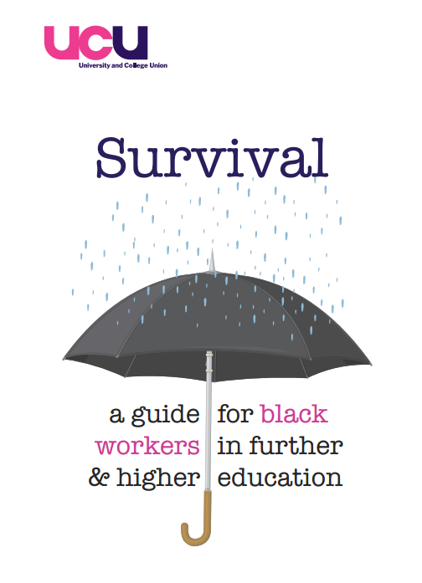
We would like to draw your attention to new publications that have been produced by the UCU Equality Unit recently. A limited number of hard copies will be available from the Equality Stall at Congress.
Firstly, the Black Members Survival Guide (published last year) provides vital information, advice and support for black members to defend their rights at work, progress in their careers and combat discrimination and racism in the workplace. It contains information on union structures, what to do if you are being discriminated against, the law, as well as guidance on applying for jobs and promotion and progression.
Download the guide from the UCU Equality Pages, under Race Resources. http://www.ucu.org.uk/media/pdf/o/c/black_members_survival_guide.pdf
Also published was the campaigning pamphlet, Equality Matters, giving concise equality campaigning and recruitment support and advice. http://www.ucu.org.uk/media/pdf/p/r/Equality_matters_DL_leaf.pdf
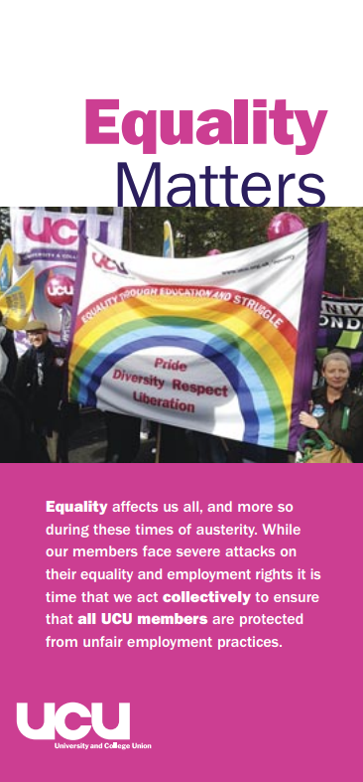

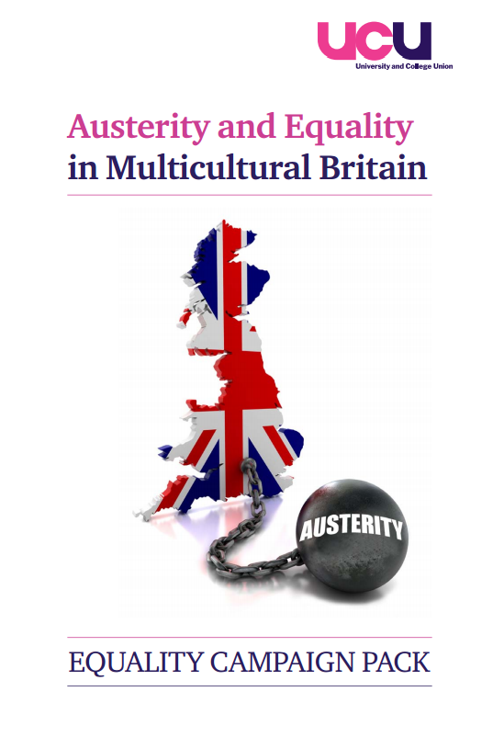
To coincide with UCU’s Equality and Multiculturalism in Austerity conference on the 17th of May, UCU produced this Equality Campaign Pack. It contains detailed information and resources around UCU's equality campaigning and how to get involved. You can download it here:
http://www.ucu.org.uk/media/pdf/b/f/equality_campaign_pack_for_emailing_and_web.pdf
UCU is also launching at Congress Supporting Members with Mental Health Issues and Conditions. This toolkit aims to help reps in dealing with cases that involve mental health issues and conditions, and will be officially launched at the joint Equality Fringe Meeting on Friday 31st May at 13:00. It will appear for download on the website shortly after Congress. Watch out for an announcement being on the Equality Networks and branch mailing.

Access all of UCU’s Equality resources and publications on the website here: http://www.ucu.org.uk/eqres
7. HIV in the Workplace – National Aids Trust
The following article was written for the Equality Newsletter by Josie Anderson of the National Aids Trust.
There are many teachers living with HIV. A NAT (National AIDS Trust) survey of employed HIV positive gay men revealed 7% of them worked in the education sector.
Your HIV status does not affect your ability to work in a higher education setting. There is no risk of HIV transmission occurring between you, your colleagues or students through any normal day-to-day contact.
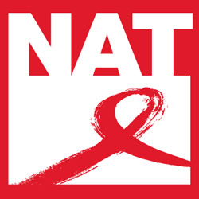
You are also under no obligation to disclose your HIV status to your college or university, though of course to make a complaint about unlawful discrimination you would need to disclose your status to certain individuals.
HIV is viewed as a disability in the Equality Act 2010 and those living with HIV are protected, from the moment of diagnosis, from discrimination and harassment arising from the condition.
Equality legislation ensures it is your employer's responsibility to deal effectively with any situations of bullying, from both fellow staff and students. They are also obliged to acknowledge all requests of reasonable adjustments to your working environment and job, and if they are not able to implement them they must provide written, substantiated reasons for why requests were turned down.
Encouragingly, NAT has found 89% of reasonable adjustment requests were either fully or partially met.
If your employer is not taking incidents of harassment seriously, or is directly responsible for the bullying, you can seek legal redress.
UCU would be your first point of call to access advice and support if you did want advice . In 2010 a trade union was instrumental in winning the case of a teacher unfairly dismissed from an independent school because of her HIV positive status.
To get the benefits of current equality protection, it will be necessary to disclose your HIV status. However your confidentiality is protected by the Data Protection Act and any person you disclose to is required to keep the information strictly confidential, unless you give express permission for it to be shared.
Most HIV positive people who disclose their status have a positive experience. Yet, in an instance where disclosure does negatively affect your ability to work, the UCU will be able to offer support and guidance.
In addition, most universities and colleges produce easily accessible HIV policies, towards students as well as staff who have HIV. It is a good idea to acquaint yourself with your institution's own policy. If there is incorrect, offensive or missing information, your union or an HIV organisation such as NAT will be able to offer advice on how to address this issue.
To find out the facts about HIV please visit the National AIDS Trust’s website
www.hivaware.org.uk
8. New Guidance on Pre-Employment Health Questions & Disability Leave
Two new pieces of guidance on disability at work have been published by the EHRC and the TUC.
Pre-Employment Health Questions is an EHRC publication that gives guidance to job applicants on section 60 of the Equality Act. Section 60 makes it generally unlawful for an employer to ask questions relating to a potential employees health in advance of making a job offer. You can download the publication here:
http://www.equalityhumanrights.com/uploaded_files/EqualityAct/pre-employment_health_questions_guidance_for_job_applicants_final.pdf
Employers' guidance is available here:
http://www.equalityhumanrights.com/uploaded_files/EqualityAct/pre-employment_health_questions_guidance_for_employers_final.pdf
And the research report is available here:
http://www.equalityhumanrights.com/uploaded_files/research/rr87_final.pdf
Sickness absence and Disability Discrimination is an updated publication from the TUC. It is a useful toolkit for trade union negotiators on the issues and the law surrounding sickness and disability absence, covering areas such as when and what should be counted as disability leave, reasonable adjustments, disclosure and includes model agreements. You can download the document from our website here:
http://www.ucu.org.uk/media/pdf/c/t/Sickness_Absence_and_Disability_Discrimination_Feb2013.pdf
Get involved!
If you would like to join one of our networks, please send an email to eqadmin@ucu.org.uk stating your preferred email address along with the name of the network you would like to join. You should note that these networks are not discussion forums, but that you will be sent information relating to the area of equality. The networks available for joining are:

Black Members Network
Women Members Network
LGBT Members Network
Disabled Members Network

http://www.tes.co.uk/article.aspx?storycode=6043013

