
No 74  March 2014

Contents
1. College fined over workplace death
2. Launch of European Agency biennial ‘Healthy Workplaces’ Campaign
3. New LRD Stress and mental health booklet
4. Fire, fire – again!
5. TUC Courses for H&S reps: regional programmes
6. Phil Evans – health & safety cartoonist
7. HSE Triennial review 2013
8. TUC Biennial safety reps survey 2014
9. Workers’ Memorial Day April 28th 2014

1) College fined over workplace death
York College has been convicted of health and safety breaches that led to the death of a 3 year old child in the college nursery in 2012. The college was fined £175,000 with £45,000 costs at Leeds Crown Court on the 14th February 2014.
http://feweek.co.uk/2014/02/14/york-college-fined-175k-over-nursery-death-of-three-year-old-lydia-bishop/

2) Launch of European Agency biennial ‘Healthy Workplaces’ Campaign
Our last issue reported on the European Agency for Safety and Health at Work campaign around managing the causes of work-related stress, ‘Healthy workplaces manage stress’, to be launched in early April and run until late 2015. The target audience for the campaign is primarily SMEs and intermediaries who can reach them. HSE now says it will use the campaign as an opportunity to promote their stress management standards and related guidance for tackling work-related stress. That promotion should also be useful to our sector, even though most institutions are large employers, rather than SME’s.

The European Agency is looking at the standards as part of developing its own campaigning material; HSE's campaign activities will include e-updates to stakeholders and promotion of its stress web pages. However, UCU health & safety advice remains concerned that, by their own admission, HSE’s stress management standards have made little impact on the problems. See http://www.hse.gov.uk/statistics/pdf/pwc2010.pdf

Given this message, we hope that HSE will deliver the campaign to employers, that it will have a positive effect, and that HSE will produce materials that will be useful for us; we’ll let you know when it happens.

3) New LRD Stress and mental health booklet
Labour Research Department will publish an updated version of their Stress and Mental Health booklet in April. The booklet will provide information, advice and practical examples of how unions and reps have dealt with work-related stress across a range of industrial and service sectors and in a variety of workplaces. It will:
- Look at the causes of stress at work and its consequences, both in financial terms and in terms of ill-health for organisations and for workers;
- Evaluate the impact of the Coalition government’s austerity policies and public spending cuts , and outline how unions are taking action to protect workers;
- Set out the law in relation to work-related stress, including recent case law; and
- Examine guidance from other relevant organisations.
A 2014 version of Health and Safety Law will follow in the autumn.

4) Fire, fire – again!
Those of you with longer memories will recall our report of the fire at the national fire service college in May 2009 that destroyed 11 fire engines and a building, together worth about £1.5 million.

Now the fire station at Downham Market in Cambridgeshire has burnt down. The fire engine and fire-fighting equipment was destroyed in the fire. Replacement equipment has been provided, and is being kept at the nearby police station.
Despite being a relatively new building, it wasn’t fitted with a sprinkler system. In a wry comment, the deputy chief officer said:

“Normally we go to other people’s fires, but tonight we had to go to our own. I think there is a fire safety message there for us. If the building had been fitted with sprinklers, we wouldn’t be here today because the fire would’ve been put out very, very quickly automatically.”

As part of fire prevention strategy, the fire service recommends that all new building developments consider installing sprinkler systems as part of their precautionary measures. These events always prompt me to check the fire precautions in our office building – perhaps you should too – if the fire service can’t get it right…

http://www.ifsecglobal.com/blaze-norfolk-fire-station-follows-similar-fires-2012-2009/

5) TUC Courses for H&S reps: regional programmes
The TUC Education Service provides a range of short courses on a variety of issues that usefully supplement our internal programme. UCU safety reps may find these of interest, and encourages reps to participate in the TUC programme. The TUC publishes regional course programmes on the UnionLearn website, but this seems to be in a process of continual change, and it isn’t the easiest to find your way around. This is the current link to their regions, where you can select and download the regional course programme brochures and find contact information for TUC course providers. So if you are looking for a course that UCU isn’t currently running, do look here and contact a local TU Education centre. Arrangements for time-off your normal job to attend TUC courses applies as it does to UCU courses.
http://www.unionlearn.org.uk/regions

6) Phil Evans – health & safety cartoonist
Political cartoonist Phil Evans died at the beginning of March; he was 67. His cartoons on health and safety issues were particularly strong, and in 2004, we invited Phil to organise an exhibition of his health and safety cartoons at Hazards Conference, which was very well received. Phil’s cartoons appeared in a wide variety of political and trade union publications, but most people probably know of his work for LRD, as his cartoons added pointed comment and emphasis to their booklets and magazines for many years, and a lot of the points he made remain as valid today as when they were originally drawn.

A fine collection was published in the 1980’s in “The Joke Works” – second-hand copies are readily available. He took an ‘open source’ approach to his work, and copyright protection had no place in Phil’s philosophy; in the book he encourages activists to cut-out and paste his work into their own leaflets and bulletins. Here’s a couple we’ve used here at the Hazards Centre for a leaflet on risk assessment, and a DSE factsheet; my favourite is about the new way of working – an issue very familiar to many UCU reps and members today; where IS the risk assessment that should have been done before the new way of working was implemented?
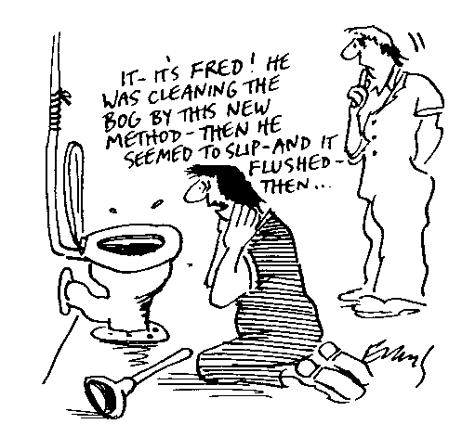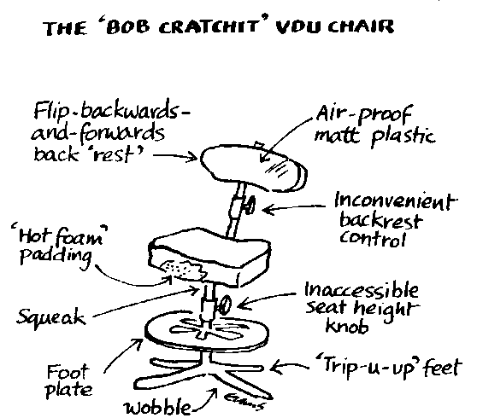

7) HSE Triennial review 2013
I’ve been hanging on to this in the hope I could do a more comprehensive report that included a formal and detailed response from the government (I’m ever the optimist), but that hasn’t happened, so here’s a comment to add to those already published by various occupational H&S bodies and organisations.

The government asked Martin Temple of the EEF to conduct the revue; hoping, I suppose, he would adopt an approach in line with current governmental prejudices. In the report published in January, he didn’t. He said that, without question, the HSE was essential as a regulator, it was broadly fit for purpose, and it should remain a non-departmental public body.

UCU Health & Safety advisor was one of those who met him to give evidence in person, jointly with the Hazards Campaign. We made the point very strongly that there were a number of perceived weaknesses in relation to the way HSE interacts with trade union safety representatives, particularly not giving this the level of priority we believe it should have. We discussed the point that the ability to raise issues with an inspector was seriously curtailed when HSE removed office telephone numbers from the website, and that partly as a result of work we had done, HSE had now made a contact telephone number available, but only to express “concerns”. We emphasised how valuable the open access to the priced publications catalogue is for safety reps; how we believed that the Fee for Intervention was problematic and should be abolished; the weakness in dealing with occupational health issues and the demise of EMAS; that there was much evidence to suggest that “wellbeing” was increasingly being confused with statutory requirements and duties, and we raised the question of HSE Board membership, particularly in the light of the Secretary of State’s decision last year to appoint an employee representative without reference to, or approval of, the appropriate representative body, the TUC, a move that was widely criticised.

The report contains positive recommendations on most of our points, including the need for HSE to set out clearly what employers must do to control work-related health risks, and to challenge those who misrepresent what the law requires to promote the wider wellbeing agenda. The government, meanwhile, in the person of junior minister Michael Penning has stated that they want “to go further to introduce reforms to HSE to ensure that it delivers value for money for the taxpayer”. For more information on that, see the article in the current issue of Hazards magazine.
https://www.gov.uk/government/uploads/system/uploads/attachment_data/file/275233/hse-function-form-governance-triennial-review.pdf

To see the appendices, and what appears to be a warning for the future, go to https://www.gov.uk/government/publications/triennial-review-report-health-and-safety-executive-2014

8) TUC Biennial safety reps survey 2014
LRD are conducting the survey for the TUC, and it has just been published. Please encourage as many individual safety reps as possible to complete the survey. The closing date is Friday 27th June 2014, and you can take the survey on-line at the TUC website http://www.tuc.org.uk/health-and-safety/health-and-safety-reps-survey-2014

Those of you who get Hazards magazine will find a copy enclosed in the new issue, and we’ll make sure there are some paper copies on the H&S stand at Congress in Manchester.

9) Workers’ Memorial Day April 28th 2014
Just to remind you that WMD is 5 weeks away, and that we publicised resources in last month’s H&S News. For more details and information, contact the Greater Manchester Hazards Centre at mail@gmhazards.org.uk. The official WMD symbol, the purple forget-me-knot ribbon, can be purchased from GMHC; £30 per hundred; car stickers are £25 per hundred; posters free of charge.

Contact UCU Health & Safety Advice
UCU Health & Safety Advice is provided by the Greater Manchester Hazards Centre, and is available for 3 days each week during extended term times. The contact person is John Bamford: (e) jbamford@ucu.org.uk
(t) 0161 636 7558

