 Editor: Jim Thakoordin  May 2014

Contents
1. Foreward from the Dawn Livington – Chair of BMSC
2. Motions and Amendments to Congress from BMSC
3. TUC Black Workers Conference

4. TUC boss urges unions to tackle the toxic debate around

immigration
5. Jim Thakoordin Awarded the TUC Silver badge for services to
trade unions

6. First Muslim President of the TUC

7. University students will be repaying loans into their 50’s

8. Disability and Ethnicity – A Trade Union Issue

9. White students get better degrees

10. Congress 2014 – BMSC Fringe Event

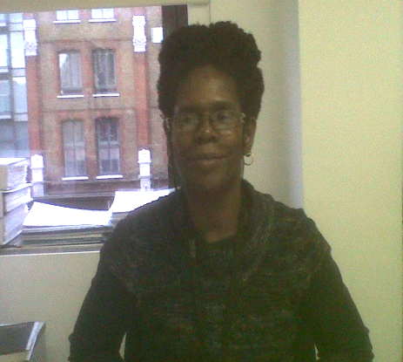
1. Foreword from the chair of the BMSC
Dawn Livingston

Solidarity!

For my clarion call this time I choose to share with you the address I made to the TUC Black Members’ Conference when moving our UCU motion:

Our motion was about black representation. It gave me the opportunity to acknowledge and appreciate comrades that represent our black members here at Conference with music and song, with fun and humour, with photo shoots and with confidence gained from experience, knowledge, commitment and persistence. I am grateful for and proud of the skills in black representation demonstrated at Conference every year. I am in awe of you all!

I am encouraged by all of you (in spite of shaking with nerves every time I get up to speak. I do my best to share, in realising the aims of the Conference to represent black workers effectively. As some of you know from personal experience I am in my element in the classroom, in my work. Facing my fear in this box each year is necessary for me to represent, participate, to practise what I preach.

However, the impact of restructuring within our unions is reflecting the same disproportionate detriment impact that black workers are suffering in their workplaces. As the cuts and austerity give employers the cover to discriminate against and victimise black workers, the gap in the provision for black members in our unions is highlighted. There is a lack of support, lack of recognition of the importance of black representation. This emphasises the need for improvements in how our unions promote and facilitate black members’ participation.

It brings to the fore front how vital it is for black members to organise, to take ownership of our unions, to combine our strength, knowledge and experience to insist on our rights to fair and fit for purpose representation, to insist our unions are representative of black communities both in the workplace and outside the workplace; to address the challenges of racism that black people continue to face.

Conference, each year gives us an opportunity to reassess our way forward; revitalise black unity, develop and progress our black communities, connect our issues, build our fight back and organise under the same banner.

We need to insist that unions resource black representation including relevant and appropriate education and training to facilitate more awareness and understanding, increase proactive ways to participate, break down the barriers of marginalisation, defend black members effectively and successfully, demanding our rights to fair treatment at work and in our communities, our rights to be involved in the decision making processes in our unions, at work and in our communities.

Conference, another Trade Union Studies Centre is going through consultation for closure with the loss of jobs including two Lecturers in Trade Union Studies, both black members. I am one of these two lecturers facing redundancy. Many union reps will no longer be able to access this specialist and specific education and training provision; where the tutor looks like them and shares their experiences or is able to help raise their awareness of the issues for black members. We are not going quietly. We will rage against the storm. However, it makes my message even more heartfelt. It is the same message from previous conferences, for this conference and hopefully for future conferences: Our strength is in constructive, proactive support of each other in demanding that unions take action for: Black Unity! Black Solidarity! and Black Community!

2. Motions and Amendments to Congress –

From Black Members Standing Committee

EQ6 Black representation in UCU
Congress notes that the numbers of black members within UCU structures has fallen over the years. Black members have either not come forward or are finding involvement in the democratic structures of the union to be an increasing irrelevance. Black activism is also declining. In regional councils and branch committees the situation is depressingly similar. As a consequence issues affecting black members are not raised or discussed at branch and regional levels. The Union must address this issue urgently. Conference strongly recommends that:

Congress instructs the NEC to ensure that:
- Each branch should make an effort to send a black delegate to their region
- Each region should have at least one black member in its committee and
seek to co-opt if no branch submits a black representative
- A progress report on the above is sent to UCU Congress 2015.
EQ8 Black deaths in custody
Congress deplores the continuing deaths of black people in prison and police custody, in young offenders’ institutions during arrest or detention under the Mental Health Act. Congress believes that it is not acceptable for police and prison officers to be unaccountable to the communities that they serve. Deaths in custody are an issue of concern for all trade unionists – because what happens in Tottenham or Luton or Winson Green today can happen to any one of us tomorrow.

Congress agrees to:

- campaign to ensure that police and prison officers wear cameras at all times
when making an arrest and/or restraining suspects
- campaign to ensure that close family members are informed immediately
after someone has been arrested and/or detained
- Affiliate to the United Family and Friends Campaign and support the annual
procession of remembrance
- Circulate campaign calls and information from UFFC to all UCU members.

ED4 Financial impact on students of Government policy
Southern Regional Committee
Congress deplores the Coalition Government's failure to protect students of low income families from the impact of student fees and education cuts.

In light of this failure, the consequences of which are becoming increasingly apparent in terms of the deterrent effect on low-income students, Congress instructs NEC to:

a) Intensify the lobbying of government in order to restore financial support for those groups currently deterred from pursuing further and higher education on the grounds of cost;

b) Within budget limitations, survey the impact of student poverty on recruitment to FHE institutions in order to better inform a campaign to restore necessary funding.

Add bullet point
c) Congress recognises that BME staff and students are disproportionately disadvantaged in terms of resources and support

SFC23 Union democracy
North West Regional Committee
Congress is extremely concerned about the impact of internal UCU organisational restructuring and finances on democracy and accountability of members, reps and officers of the union. This Congress reaffirms our commitment to full, open and transparent consultation at all levels of the Union on all issues impacting on representation services and wider participation in the labour and trade union movement. We therefore call on the NEC to ensure that adequate consultation is enabled prior to any such decisions being taken.

Add the following sentence: We also call on the NEC to ensure that any further organisational restructuring is undertaken with a full Equality Impact Assessment (EIA) prior to any proposed change. Any EIA must also include a full and thorough consultation process incorporating all affected groups and committees as appropriate.
HE29 Governance
Higher Education Committee
Conference notes the increasing:

- concentration of power in the hands of a few appointed executives on bodies such as Pre 92 University Court and Post 92 Board of Governors
- focus on commercial interests at the expense of educational values, Academic freedom and Institutional Autonomy.

Conference believes:
- University executive bodies need to be more democratic, collegiate and transparent in the way they run HE institutions
- That all paid roles should be on the national pay spine to ensure pay equality and transparency at all times
- That remuneration panels must have staff representation.

Conference resolves to campaign for:
- all governing bodies to be more democratic and accountable
- executive body meetings to be held in open session
- transparent and fair appointment’s processes, including staff representation, better gender balance, and an elected Chair of the Governing body
- all Universities to have a whistleblowing policy.
Amend the third bullet point after ‘Conference resolves to campaign for:’ by deleting the word ‘gender’ and adding ‘in terms of gender and BME representation’ after the word ‘balance’
FE 18 Composite motion on FE funding –
add after 3rd bullet point, a 4th bullet point as follows:
"carry research to ascertain and identify the specific group of students and staff who have been most disadvantaged by cuts in FE funding such as black, women, and disabled people and identify the particular disadvantages they have suffered in respect of their life chances and careers."

FE 24 Motion on Governance
Add at end of motion a third paragraph as follows:
"To produce a list of governing bodies of all FE Colleges and a breakdown of members in terms of ethnicity, gender, disability and LGTB, and any other relevant information. The list should also identify the Chair of each governing body in terms of ethnicity, gender, disability and LGTB, and any other relevant information."

3. TUC Black Workers Conference – Article by

Marc Wadsworth, UCU delegation member

Many participants said this year’s TUC Black Workers Conference was the best they could remember for its slick organisation and quality of speeches. Twenty-seven unions were represented by 224 delegates. The UCU contingent played an important role in making the gathering a success. It was a conference where, because the platform supported every one of the 20 resolutions tabled, an outside observer could have been forgiven for thinking it had been stage-managed.

The only dissent came over motions on the deaths of people in custody. According to the FBU, more than 980 people died in police custody in the UK between 1990 and 2013. Only one case resulted in a successful conviction. Twenty per cent of the people who died were African-Caribbean, although this group represents just three per cent of the population.
An RMT amendment to an FBU resolution on the subject was rejected by the firefighters.

We felt the amendment beefed up the resolution by calling for the replacement of the discredited, so-called Independent Police Complaints Commission and therefore backed it. After a heated debate in which we took part, the amendment was carried. It was difficult to understand what all the fuss had been about because, immediately afterwards, almost everyone supported an NUJ deaths in custody resolution, which I seconded, that embraced the same issues as the controversial RMT amendment. There was lone opposition from the Prison Officers’ Association who objected to the motion calling for the outlawing of control and restraint in mental health settings. Dawn Livingston, chair of the Black Members’ Standing Committee (BMSC), moved our motion on Black representation. The full text of her speech is the foreword to this newsletter. UCU delegates also spoke on issues as diverse as the Con-Dem government’s draconian new immigration bill, racist advertising vans, mental health provision for Black communities and the sky-high prices charged by airlines for tickets to Jamaica and other parts of the Caribbean, which Mumtaz Khan spoke about on behalf of friends of his who had been penalised. As well as the delightful spectacle of a motion on Global Radio’s decision to rename Choice FM, the leading Black commercial radio station, being seconded in song by a guitar strumming MU delegate, there was a moment of mirth. This came when a speaker, in a slip of the tongue, during a debate about financial compensation for the Black descendants of slavery, used the word “repatriation” rather than “reparation”.

The conference was particularly pleasing for me as a first time UCU representative because, in a previous incarnation as a National Union of Journalists’ delegate to the TUC Congress in 1991, I moved the motion carried by the meeting that set up the Black Workers Conference.

The UCU delegation was perplexed that, more than two decades later, the TUC still has a relic from the past patronisingly called the Race Relations rather than Black Workers Committee. BMSC Committee vice-chair Jim Thakoordin raised this and other issues in a lively debate.

We had three of our members on the TUC Race Relations Committee at the start but, regrettably, Jim was knocked off in a vote at the conference. His decades of experience, honest and forthright views will be a great loss to the committee. We are still represented on it by Gargi Bhattacharyya, who facilitated a workshop on the TUC Race Relation Committee’s Charter for an Anti-Racist Education, and Cecile Wright, who was chosen to move the vote of thanks at the end of the conference.

TUC general secretary Frances O’Grady was candid when she told conference that, while unions were providing a better service for their Black members than before, they could not afford to be complacent and should do better. Other guest speakers included Neville Lawrence, father of murdered Black teenager Stephen Lawrence and Carol Duggan, whose son Mark Duggan was shot dead by police, sparking an uprising in Tottenham, north London, in 2011, that spread to many other parts of England. Equality and Human Rights Commission chief executive Mark Hammond not only spoke at the conference but also did a question and answer session.

One delegate pointedly asked Hammond whether he thought his organisation was functioning better or worse since the merger of the race and equal opportunities commissions into one body that also dealt with the issues of disabled people and lesbian, gay, bisexual and transgender people. He said yes. But there were murmurings that this was not the case. Habib Rahman, Chief Executive of the Joint Council for the Welfare of Immigrants (JCWI), spoke out robustly against the immigration bill before parliament. In fact, this was such a popular topic that a motion on it was picked by the conference as the one to go forward to the TUC Congress.

In his address to delegates, Mohammed Taj, president of the TUC, said he objected to some news media referring to him as the first Muslim in the post. Mohammed argued that, as a lifelong trade union activist, he was much more than that.

The UCU BMSC and NUT Black members section supported a well-attended fringe meeting I organised, entitled Divided by race, united in war and peace, about the unsung African and Caribbean veterans of the Second World War. Former Mayor of Southwark Sam King, aged 88, who joined the RAF in Jamaica during the war to fight for “the Mother country”, was the keynote speaker. UCU delegate Abdul Majothi said he thoroughly enjoyed attending his third TUC Black Workers conference. He found it “very useful for networking and in particular sharing/discussing issues experienced at respective work places/institutions”. For Abdul, this was “the biggest benefit of the conference”.

He added that the event “went a long way to making delegates aware of the resources available to BME workers, should they suffer difficulties in their employment and this was very welcome”. Abdul said he thought, “the excellent delegate turnout, and the general management of our union's business towards the conference, was much better organised than last year”. His only criticism was that the hotel in which UCU delegates stayed was “VERY POOR ... small room, very uncomfortable bed, basic breakfast and quite depressing to be honest”. Delegation members were also extremely annoyed at the exorbitant prices charged by the hotel for wi-fi use. One suggestion was delegates be given the option to book their own hotel rooms, within the rates set by the UCU, in future.

4. TUC boss urges unions to tackle the toxic debate around immigration

TUC General Secretary Frances O’Grady has urged unions to counter the toxic debate around immigration. Addressing delegates attending the annual TUC black workers’ conference at Congress House today, Ms O’Grady said far right politicians across Europe are expecting to make big gains in the European parliamentary elections.
“Here politicians on the right are driving a debate about immigration that is becoming increasingly toxic. As a result we have an Immigration Bill that ranks as one of the most reactionary, regressive pieces of legislation in recent British history,” Ms O’Grady said.
She noted that a climate of fear was slowly poisoning the UK’s national life. “People are indeed worried – but not about immigrants themselves. “Their biggest concern is the bosses who use cheap migrant labour to undercut people’s pay and pensions,” Ms O’Grady said. “This is what politicians should be doing something about and the TUC will continue to work with unions to counter the myths, half truths and downright lies about immigration that are sure to fly around in the run-up to next year’s general election.”
She promised that the unions will campaign “hard for politicians to start treating the issue of race equality with the seriousness it deserves.”
Ms O’Grady accused the government of abandoning the fight against racism in the communities and the labour market.
“In many respects, ministers are making the problems worse. A year on from the introduction of fees for employment tribunals, the number of race discrimination claims fell by a shocking 57 per cent,” Ms O’Grady said. “As we step up our struggle for economic and social justice for people of every race and colour, we must give black people a sense of hope about the future. There is an alternative to austerity, privatisation and attacks on workplace rights.”
Ms O’Grady went on to say that: “Casualisation, agency working, and zero-hours contracts have all left a particularly brutal imprint on ethnic minority workers. Back in 1993, black workers were paid around 18 per cent less than their white colleagues. But by 2008, that gap had grown to a scandalous 43 per cent. The case for action – stronger employment rights, tougher anti-discrimination measures and proper regulation of our labour market – is overwhelming.”
She called for action to tackle what she described as “the alarming levels of youth unemployment in ethnic minority communities.”
Ms O’Grady said: “Black workers are twice as likely to be unemployed, and the youth unemployment rate for black youngsters is almost double that for white young people. We can make a start by making drastic improvements to our apprenticeships system, so more black young people are able to take up decent career opportunities.”
Ms O’Grady urged the unions to “do more to recruit, organise and energise black workers.”
“The union movement is a long way from being reflective of the diverse make-up of modern Britain,” Ms O’Grady said. “We need to increase our visibility in anti-racism campaigns, and lead the way in fighting racism, prejudice and discrimination wherever and whenever they rear their ugly heads.”

5. Jim Thakoordin Awarded the TUC Silver badge for
services to trade unions

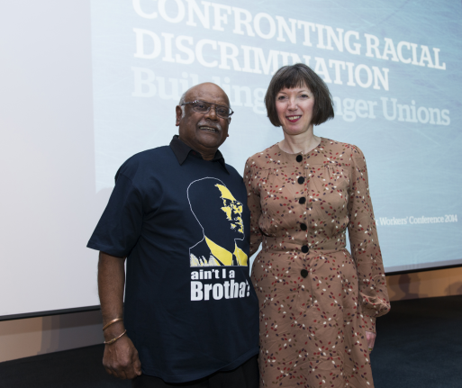
Jim with Francis O’Grady, TUC General Secretary – April 2014

The TUC Silver Badge commemorates 49 years of active membership. Jim Thakoordin, vice chair of the UCU Black Members’ Standing Committee just missed the gold badge by less than a year. Jim’s Trades Union Council has agreed to put him forward for a Gold Badge in 2015 as he will have completed 50 years of active involvement in the trade union movement.

Jim started his union activities in London in 1961, age 18, in the T&GW Union as a shop steward and later Branch Chair. He then became active in the UPW union as Branch Secretary and full-time convenor. He was awarded a TUC scholarship to Ruskin College, Oxford, at age 31. He then studied at the Universities of Essex, Warwick and London, whilst maintaining close links with the trade unions and the Labour Party serving as the Secretary of the Luton TUC and a County Councillor.

After leaving university and becoming a college lecturer, he was appointed a full-time London Regional Officer Education and public Relations Officer for the GMB union in 1978. Jim worked with other unions and the TUC to produce national training manuals, designed and deliver national courses for trade union activists, negotiators and union officials on a wide range of courses, organised by both the TUC and individual unions. Jim combined his duties as a County and Borough Councillor for over 20 years, with his trade union duties for the GMB and the TUC. He served on many union and TUC regional and national committees. Jim stood for Parliament as a Labour Candidate in 1983 and was instrumental in the setting up of the Black Trade Union Solidarity Movement in 1979 and later the Labour Party Black Section. He promoted solidarity between Black workers and the setting up of Black workers structures within the unions and the TUC during the 1970’s and 1980’s. Jim and his colleagues organised the first Annual Black Workers Conferences, starting in 1983, before the TUC took over the BW Conferences in 1993. Jim edited the GMB Newspaper – “Candid”.

Before leaving the GMB Jim published his first book – “Racism within Trade Unions” and a further 11 publications since. After leaving the GMB, he joined NALGO and became a member of the National Black Members Executive Committee. Jim worked in three London Boroughs and as Head of Equality and Diversity for the Local Government Management Board for England and Wales.

Jim left Unison and joined the NATFHE union and became a member of the NEC in 1999. He continued his involvement when NATFHE and the AUT merged to form the UCU and remained on the NEC until he had to have a year off in 2013. He was elected back to the UCU NEC in 2014. For many years Jim was the UCU National Black Members Chair or Vice Chair and has always been a powerful and passionate speaker at UCU and labour movement conferences. Jim was involved in unions when he was a child labourer on a sugar plantation in colonial British Guyana. The trade union and Labour movement has been his life since a teenager. Jim has addressed meetings and conference in America, Europe and the Caribbean.

Even those who disagree with Jim would often express admiration for his fifty plus years of honest, passionate, strategic and sometimes controversial interventions within the Labour movement. Despite celebrating his 70th birthday and his 50th wedding anniversary in 2013, Jim is still active on several TUC and UCU committees, as well as being a Branch Secretary, President of the Bedfordshire and Buckinghamshire TUC’s, Trustee of several Charities and public bodies including the NHS, Law Centre and campaigning groups. Jim is passionate about fighting for justice, fairness, equality democracy and freedom for all workers in Britain and abroad. Jim and his wife Doreen, a retired Deputy High School Head Teacher) still have time for his two grown up children and 4 grandchildren and writing his books. His 13th book “All Equal, All Different – The story of my life” (500 pages) will be available in June 2014.

6. First Muslim President of the TUC

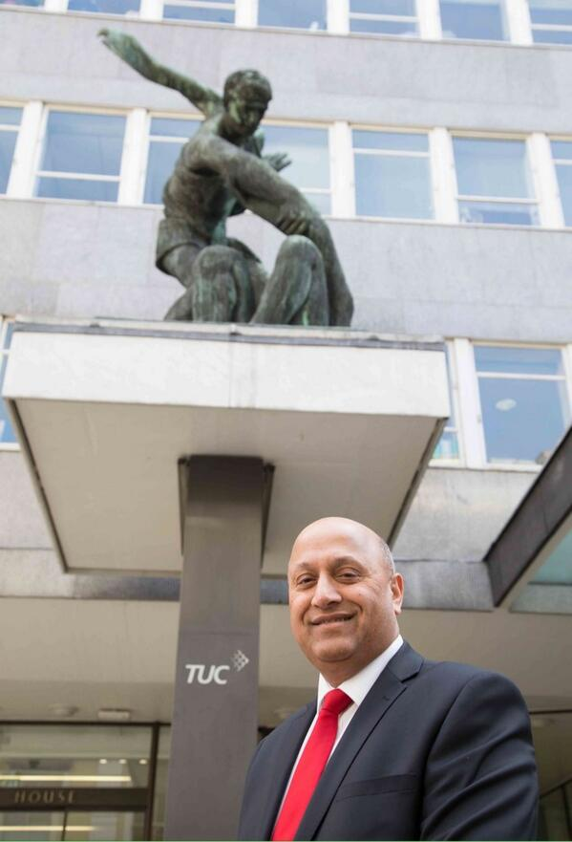
Mohammad Taj, a bus driver from Bradford and the TUC's first Muslim President has been elected as the next TUC President. Taj - who is a member of Unite - was elected by the TUC General Council on the final morning of the 145th Congress.

Taj has worked in public transport since 1974 when he started working for Bradford City Transport as a bus conductor. He first got involved with the Transport and General Workers Union - now part of Unite - when he began to investigate complaints that Asian workers had to
pay a bribe to corrupt union officials and managers before they could get work on the buses.

As a result of his work into unjust practices throughout the company, there was a court case and several people went to prison. In 1982 Taj was elected as the T&G's shop steward at the company, and ten years later became a worker director for the whole of West Yorkshire and sat on the company board.

In the late 1980s unions were beginning to look at how they might do more to better represent workers from black and Asian communities, and Taj was elected chair of the T&G's national black, Asian and ethnic minorities committee which sat on the executive council of the union. Taj has been on the TUC's General Council since 2001. In 1995 following the riots in Bradford - which erupted following long-running tensions between the police and local Asian youths - Taj served as part of the commission set up to look into the underlying causes of the violence. A year later Taj went back to being a bus driver and once again worked on many of the routes serving the towns and cities in West Yorkshire.

He is now based in Unite's branch office of First in Bradford office and is responsible for looking after the interests of the 650 employees who work as cleaners, engineers, clerical staff and drivers. Commenting on his election as TUC President, Taj, said: 'I am proud to have come from lay membership level and be the first Muslim and the first Asian President of the TUC. 'During my year as President I'm keen to reach out to trade unionists in the Arab world - in places like Tunisia, Egypt and Iraq - where people are living and working in extremely dangerous and unstable situations, and help them build, strong, independent and democratic unions’.

'Protecting the NHS and campaigning against government policies - which have seen the increasing involvement of the private sector, and where more and more profit is being put before patient care - will also be one of my priorities’. I'm keen during my presidential year to highlight the distress being felt by families across the country as people struggle to cope with the fallout from the living standards crisis. As we see the first tentative signs of economic recovery, we must ensure that ordinary people too can share in the rewards that growth will eventually bring.' Taj, 61, is married to Naseem with two children and two grandchildren. Taj often refers to Jim Thakoordin who have been friends for decades as his half Brother, because they have often been taken for each other. Best wishes from the UCU for your year as President brother Taj.

7. University students will be repaying loans into their 50’s


Government has been urged to rethink fees and loans system after study finds average student will graduate more than £44,000 in debt.

The majority of undergraduates now at university will be paying off their student loans well into their 40s and 50s, with three-quarters of them unable to clear the debt before it is written off after 30 years, according to a recent publication.

The report by the Institute for Fiscal Studies and the Sutton Trust estimates that the average student will leave university more than £44,000 in debt.

A middle-earning graduate will still owe about £39,000 at today's prices by the age of 40, and will still owe about £32,000 by 50.

"For many professionals, such as teachers, this will mean having to find up to £2,500 extra a year to service loans at a time when their children are still at school and family and mortgage costs are at their most pressing," said Conor Ryan, the Sutton Trust's director of research.

"We believe that the government needs to look again at fees, loans and teaching grants to get a fairer balance."

In cash terms, the researchers estimate that graduates will now repay a total of £66,897 on average, equating in real terms to £35,446 on average in 2014 prices. Claire Crawford of the University of Warwick, one of the report's authors, said a perverse effect of the repayment scheme was that graduates who do less well in the labour market will end up paying back less than before, while middle and high earners will pay back much more.

"The new higher education finance system will leave graduates with much more debt than before. But the effects of the changes will be quite different for different people and at different parts of their lives," she said. Although large numbers will repay more than they borrowed, most will not return their loan in full, the study says.

"We estimate 73% will have some debt written off at the end of the repayment period, compared with 32% under the old system. The average amount written off will be substantial – about £30,000."

The report follows forecasts that 45% of the £10bn in loans made each year will have to be written off. The Department for Business, Innovation and Skills defended the system and said more students from disadvantaged backgrounds were going to university. "Most students will not pay up front to study. There are more loans, grants and bursaries for those from poorer families. Our universities are now well funded for the long term," a spokeswoman said. The figures showed that the number of new part-time undergraduates fell by 93,000 between 2010-11 and 2012-13, while there were 23,000 fewer part-time postgraduate entrants. The figures also showed a 22% fall in the number of undergraduates studying modern foreign languages between 2010 and 2012.

8. Disability and Ethnicity – A Trade Union Issue

There are over 10.5 million people within working age; 16-64 in the UK. Over half of them are unemployed and are living in poverty. There are no detailed breakdown statistics on specific adult ethnic groups on disability, but all indications support the fact that BME are twice as likely to be unemployed, living in poverty, experiencing poor health and lacking access to essential resources. Disabled BME people suffer from double discrimination due to prejudice, stereotyping and discrimination associated with their race and disability.

Pakistanis and Bangladeshis have the highest rates of disability in the UK because of substantially higher unemployment, lower incomes, higher poverty, poorer housing and health and living in deprived urban areas. As a member of the DMSC I have raised the profile of disabled BME members within the committee and across trade unions. I have tried to monitor the work unions are doing on ethnicity and disability but have had almost no response, which indicates that it is not a subject that has been fully addressed by the trade union movement as a whole, despite the following statistics:

- Over 8 million people or, 20% of the working age population have a disability within the Disability Discrimination Act, 1995 and 2000 (DDA)
- The unemployment rate for disabled people exceeds 50% and is much higher for BME
- Only 7% of students in higher education are disabled
- 1.4 million people currently unemployed are disabled
- Only 17% of people were born with disabilities, the majority become disabled after age 16
- Working class people with low, or no incomes, with low qualifications are most likely to become disabled and 1.5 million people in the UK have a learning disability
- About 2 million people have significant sight loss
- Most disabled BME suffers from additional stress, mental health and other illnesses brought about by their disability and lack of resources
- There are over 1.4 million disabled looking for work and are constantly facing rejection
- Disabled workers are 3 times more likely to lose their job due to problems with health, transport, housing, and lack of support. They earn much less, and 55% have no savings

These are some of the problems disabled people have to face in their daily lives. The trade union movement cannot stand back, it must put itself in the forefront of the struggle for equality and rights of disabled people. There is much work to be done by the UCU and TUC with limited resources, but each individual union must take up the issues by translating resolutions, policies and procedures at the workplace, in education and training and within the wider community.

We need to live by our motto “An injury to one is an injury to all” and “Unity is our strength.” Action speaks louder than words

The following recommendations for unions and activists have been tabled and discussed at the UCU DMSC who will be looking to undertake further work on disability and ethnicity:

- Tackle disability discrimination at work through collective bargaining
- Promote the policies of the UCU and TUC on Disability at work. Use the UCU and TUC material and training resources to support the DDA
- Recruit more disabled people to the union and work with them to build self-organised networks
- Review your branch and regional as well as the DMSC commitment to disabled people and the DDA
- Listen to disabled people, organise joint events, do not treat disability as a lesser issue than race or gender for example. Disability transcends all groups
- Make contacts with organisations nationally and locally with groups campaigning on disabilities. Invite disabled speakers to your meetings
- Donate funds to strengthen the campaigns on disability and share information
- Carry out a disability within your union at local and national levels on staffing of paid and lay officers as well as services for disabled people
- Make disabled networks more that a talking shop. Ensure disabled people are involved at every level within your union and community.

9. White students get better degrees

According to recent research, white students get better degrees than minority peers with same entry grades. This raises concerns that English universities are failing to adequately support black and Asian undergraduates. White university students at English universities receive significantly higher degree grades than their peers from minority ethnic backgrounds with the same entry qualifications, research from the Higher Education Funding Council for England has revealed.

The report found that 72% of white students who have grades BBB at A-level went on to gain a first or upper second-class degree, compared with only 56% of Asian students and 53% of black students. The figures – from the most comprehensive study of its kind – raise concerns that universities in England are failing to support black and Asian undergraduates during their student career, despite improved efforts to recruit them.
Hefce's research also showed gaps in degree classes between students from wealthy and poorer areas, and confirmed previous research showing state school pupils outperform those from independent schools with identical A-level results.

"This is important new research. People will focus above all on the gaps between state and independent school pupils. But that would be a shame as there are much bigger gaps by ethnic background," said Nick Hillman, director of the Higher Education Policy Institute and a former special adviser to the universities minister, David Willetts.

"Universities need to think very carefully about how they can best support their students with different ethnic backgrounds, as many are underperforming against their classmates."
The Hefce study tracked the progress of 130,000 students in England who entered fulltime study in 2007 until graduation in 2011, and compared their final degree result with A-level grades gained at school. White students with three B grades at A-level were more likely to be awarded a 2:1 or first-class honours degree than students from ethnic backgrounds with the same A-levels. A similar gap remained between students with somewhat higher and lower grades, such as AAB and CCC, although there was fluctuation at the very top and bottom rungs of A-level results, involving very small numbers of students.

It is a national shame that black students and students from low participation backgrounds are appearing to do worse in degree outcomes than other students even when they get the same grades at A level. A recent NUS study found 16% of black respondents said they had experienced racism at their institution, and many linked those experiences with a drop in confidence and motivation, reporting that they felt marginalised and socially excluded.

Nicola Dandridge, chief executive of Universities UK, said: "It is clear that the gap in attainment between black and minority ethnic students and white students has been a cause for concern for some years." If you look at those who gain BBC grades at A level, 65% of those from state schools go on to get a first or upper second, compared to 53% from independent schools," said Mark Gittoes, Hefce's research director. There was better news for universities from the Higher Education Statistics Agency, showing that state schools pupils made up 89.3% of young British university entrants in 2012 – the highest rate ever – and an uptick in entry by those from disadvantaged backgrounds.

"I am pleased to see rising proportions of people from disadvantaged backgrounds in higher education, both young and mature. This means we're moving closer to a student body that reflects the wider population rather than just those who were born into a particular social group," said Les Ebdon, director of the Office for Fair Access.

10. Congress 2014

UCU Black Members’ Standing Committee is holding a fringe meeting at Congress 2014. See details below.

Mental Health in the Black Community
on
Thursday 29 May
13:00 - 14:00
at
Exchange 4 and 5

Chair: Jim Thakoordin, Vice Chair of
UCU Black Members’ Standing Committee

Expanding on the good work of the Equality Unit around mental health, BMSC will be holding a fringe event highlighting mental health issues within the black community.

The event will be of interest to all UCU members as we will be exploring how such issues impact on staff and students and look at ways of enhancing our commitment in this area.

Guest Speakers:

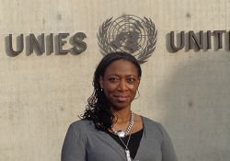  Matilda MacAttram: Matilda MacAttram is founder and director of Black Mental Health UK (BMH UK), a human rights campaigns group established in 2006 to raise awareness and address the stigma associated with mental illness within the UK’s African Caribbean communities. | 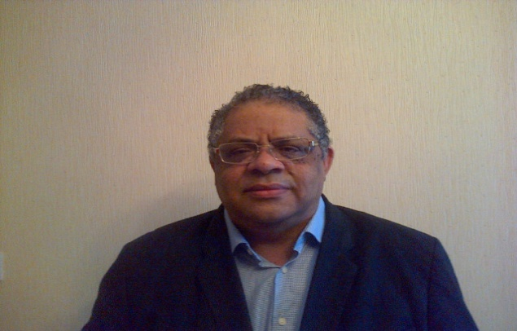  Davidson Chademana: R.G.N.; .R.M.N.; R.C.N.T.; R.N.T.; B.A.; B.Sc.; M.Ed., (Hons) Lecturer in Nursing University of Dundee, Union Activist since 1974 Currently, Vice - Chair STUC BWC and Member of UCU Black Members’ Standing Committee

Training
for
new
black
activists

Course
Dates 2014

Tues 10 June
Tues 17 June
Tues 8 July

This three-day course is for *black members who want to get more involved in UCU. Come and meet like-minded black members who want to make a difference at work.
2014

This course IS for you if:

- you are new to activism in UCU
- you want to get more involved in your union and are looking at the
best ways of doing this
- you self-identify as black.
Course
Dates 2014

Tues 10 June Tues 17 June Tues 8 July
This course is NOT for you if:

- you have already undertaken a UCU reps training course or its equivalent
- you are a member of the branch committee or executive
- you are not new to activism.

You will have the opportunity to meet other activists like yourself and members of the UCU
Black Members’ Standing Committee.

Guest lecturer: Wilf Sullivan (TUC Race Equality Officer)

The course is free to UCU members and all reasonable expenses will be met
*In UCU the word black is used in a political sense to describe people who self-identify as being from a visible minority (more usually from an Asian or African heritage) with a shared experience or understanding of discrimination.



