
December  2014

Contents

The pressure is on…it’s time for a change
- Holocaust Memorial Day 2015: Keep the memory alive
- UAF National Conference
- Stand up to racism: UN Anti-Racism Day

1. The pressure is on… it’s time for a change

With a little over five months left to go to the general election, all political parties have begun to ramp up their campaigns to get your vote, with the biggest issue of immigration topping the list. Reports in the media tells us stories of how migrants have ‘ruined’ the UK by driving down wages and ‘robbing jobs’ from British workers, over populating schools and housing to reducing access to healthcare services. More recently, migration was the reason for delays on the M4!
Sadly, this type of rhetoric is making headway in some quarters as has been seen by the gains so far being made by UKIP and negative scaremongering tactics employed by some newspapers is positively helping the cause of the far-right. Readers only see the headlines and some fail to look deeper under the surface of these stories to see that they bare no truth to the reality of the situation. The only purpose they serve is to incite hatred and fear.

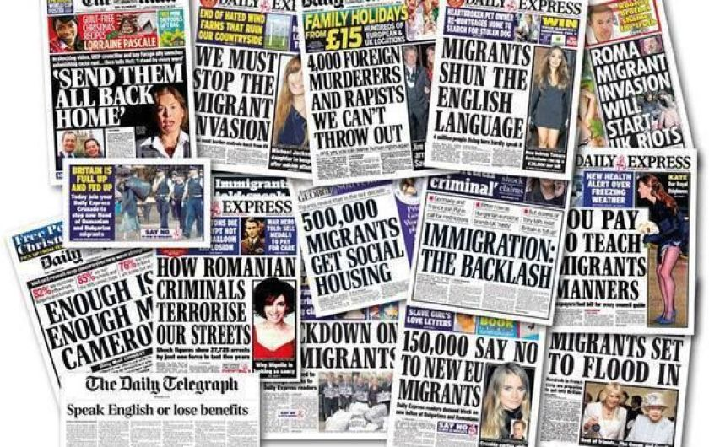

Parties such as UKIP are continuing to gain support by using the narratives last heard in the 1960’s and 70’s as was seen recently with the ‘UKIP Calypso’ song by ex BBC DJ Mike Reid. One thing is for certain, with an increase in anti-immigrant rhetoric comes hate. In a report from the Mayor’s Office for Policing and Crime that looked at hate crime reduction strategy for London, hate crimes motivated by racism, religion and homophobia have significantly increased in London over the past year, including:

- Anti-Semitic Hate Crime: As many as 95 per cent of hate crimes were anti-Semitic in nature following the conflict in Gaza.

- Anti-Muslim Hate Crime: Following the murder of soldier Lee Rigby in Woolwich, south-east London last year, the report also reveals a spike in anti-Muslim incidents.

- Homophobic Hate Crime: In June 2014 a record 175 cases of homophobic crime were reported to the Metropolitan police, while hate crime aimed at transgender people has risen from 58 to 108 cases, a rise of 86.2 per cent.
- Disability Hate Crime: An increase in incidents against disabled people are up by 12.5%

The full report can be downloaded here.

The situation will only continue to get worse if we fail to challenge those who seek to divide and bring fear into our communities. Branches and local associations can help challenge the myths perpetuated in the media, by politicians and others while campaigning for equality rights, especially in the run up to the general election and beyond.

At the ‘Politics of hate’ workshop held at UCU’s Annual Equality Conference in November, Weyman Bennett, joint secretary of Unite against fascism said “... as we fast approach the general election what will become evident is that the election will focus on racism and austerity”.

- You can help challenge the rhetoric by reading our pamphlet ‘Why immigration is good for all of us’. Contact our Campaigns Team for a hard copy at (campaigns@ucu.org.uk) or download it here.

- Speak out and educate against the racist rhetoric of UKIP and other far right groups that aims to spread division and hate in our communities.

- Defend equality policies in the workplace.

- Organise, demonstrate and support events such as Stand up to racism – UN Anti-Racism Day, March 22 2015. Contact www.standuptoracism.org.uk for further information.

2. Holocaust Memorial Day 2015: Keep the memory alive
Liberation

January 2015 marks seventy years since the liberation of Auschwitz, the largest camp established by the Germans that included a concentration camp, killing centre and forced-labour camps.
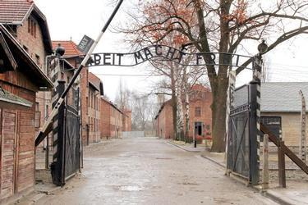
Entrance to Auschwitz-Birkenau

In keeping with the theme for 2015 of ‘Keep the memory alive’, we are encouraging our branches/local associations to use the two films produced on the Holocaust and the Kindertransport. You can access both films and supporting material at http://www.ucu.org.uk/hmd2014.

If you are stuck for ideas, you can display the Holocaust wall chart at your college or university! We would love to hear from you if you are organising an event - tell us how it went and we will share this with the wider membership.

On Holocaust Memorial Day itself, the BBC will be screening Shoah, Claude Lanzmann’s acclaimed 10-hour documentary. Programmes will be aired on both BBC1 and BBC2 – see TV listings nearer to the day.

Bosnian Genocide
Against the backdrop of the civil war, Bosnian Serb forces descended on the Bosnian Muslim ‘safe haven’ of Srebrenica. Around 8,000 men and boys were murdered – the single largest mass murder in Europe since 1945.

In July 2015, we will also see the 20th anniversary of the Bosnian genocide and have produced a short publication in commemoration. You can also download a copy from the above link.

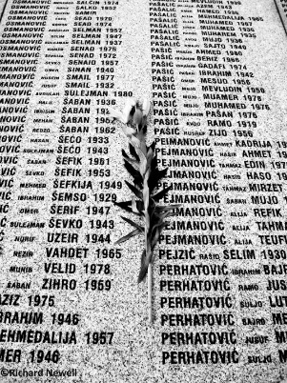 Memorial at Potočari, Srebrenica

3. UAF National Conference

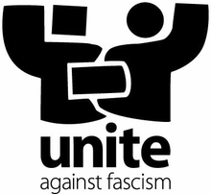
When: Saturday 21 Feb 2014
Time: 9.30 – 4pm
Where: TUC Congress House, Great Russell St, London
Nearest tube: Tottenham Court Road
Click here to Register now

This year far right and fascist groups made advances across Europe. The whipping up of racism against immigrants, black communities, increased homophobia, Islamophobia and Antisemitism has been its cutting edge. The racism of UKIP has been mainstreamed and looks set to worsen with major parties launching a war to outbid each other on attacking immigrant rights. The recent cuts to search and rescue operations for refugees in the Mediterranean epitomise how chilling this agenda has become. The revelations of spying on families of those murdered in racist attacks correlates with the injustice felt around the world following the deaths at the hands of the police of Mike Brown, Tamir Rice, Eric Garner and other black people in the US.

UAF played a leading role in electorally defeating Nick Griffin in his MEP seat this year but we cannot be complacent. The far right violent EDL continue to target the Muslim community and are mobilising around the country. This conference is a timely opportunity to discuss the way forward for challenging racism and fascism, bringing together the trade unions, faith and black communities, anti-racist and anti-fascist activists, LGBT representatives, students and young people for this major anti-racist and anti-fascist annual conference.

Speakers announced:
Diane Abbott MP  Emily Thornberry MP  Ken Livingstone  Shahrar Ali, Deputy Leader Green Party  Billy Hayes, General Secretary CWU  Lutfur Rahman, Mayor of Tower Hamlets  Dr Shuja Shafi, Secretary General MCB  Mark Serwotka, General Secretary PCS  Sabby Dhalu and Weyman Bennett, Joint National Secretaries, Unite Against Fascism

Register early to avoid disappointment!

4. UN Anti-Racism Day

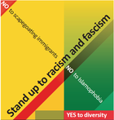
National Demonstration: Stand up to racism and fascism

When: Saturday 21 March 2015
Time: 12 noon
Where: Central London - March followed by rally in Trafalgar Square

#M21

In spring 2014, 10,000 people marched in central London for UN Anti-Racism day - a vibrant mass demonstration celebrating Britain's diversity and challenging the toxic agenda on immigration which dominates the mainstream media and political landscape.

Far right and fascist organisations are gaining support across Europe including in Britain. Scapegoating immigrants for the fall in living standards, economic problems and austerity has provided the cutting edge for the growth of the far-right, racism and fascism.

Across the globe the promotion of fear and hatred of Muslims and Islam is continuing, creating a climate of Islamophobia that is directly leading to violent attacks on Muslim people and mosques, and other communities such as Sikh and Hindu people. Anti-Semitic attacks have also coincided with a growth in support for fascism. African and Caribbean communities continue to experience racism as seen with the killing of Michael Brown, Tamir Rice, Eric Garner and other black people in the US.

UN Anti-Racism day commemorates the anniversary of the Sharpeville massacre in Apartheid South Africa. It was part of a series of demonstrations across Europe and around the world. Many organisations will be coming together again on 21 March 2015 to reject racism, Islamophobia and anti-Semitism; to celebrate diversity and make migrants welcome, to demonstrate our confidence in a future free of scapegoating, racism and hatred, and to remember Nelson Mandela and cherish the idea for a free and democratic society in which all persons live together in harmony and equal opportunities.

We will inform you in the new year of possible activities that branch / local associations can take (if you are unable to attend the event in London) leading up to March 21.

For more information visit www.uaf.org.uk and www.standuptoracism.org.uk

No to scapegoating immigrants’
No to Islamophobia
No to anti-Semitism
YES to Diversity

