
February  2015

Contents
1. Countdown to Election 2015
2. Voter Registration Campaign
3. Holocaust Memorial Day
4. News round-up from our affiliates
5. Anti-fascist resources
6. Events

Countdown to Election 2015

The countdown has begun as all political parties have started the race for your vote!

The political landscape is not as clear cut as we would hope for Commentators tell us that we are heading toward a hung parliament but we must, if anything not let complacency take over, because that could lead to further gains from political parties seeking to divide our communities with their politics of hate.

UCU is currently producing a further pamphlet that will look at the impact of immigration in our sectors. We will notify you when this will be available. In the forthcoming weeks we will share pre-election activities from our affiliates Hope not Hate and Unite against Fascism
In the last newsletter, we informed you the newly launched pamphlet ‘Why immigration is good for all of us’.

You can help challenge the rhetoric by reading our pamphlet ‘Why immigration is good for all of us’.

Contact our Campaigns Team for a hard copy at (campaigns@ucu.org.uk) or download it here

There will be a joint equality fringe meeting at Congress 2015, organised by the Equality Committee and Equality Standing Committees. The topic for discussion will be ‘Resisting the politics of hate’. We will let you know in the following weeks speakers who will address this event.

Voter Registration Campaign

UCU has joined up with the National Union of Students and the Bite the Ballot Campaign to register students to vote between now and the registration deadline of 20 April 2015. For further information visit http://bitetheballot.co.uk/

3. Holocaust Memorial Day 2015

UCU commemorated Holocaust Memorial Day by launching the revised anti-Semitism leaflet here as well as promoting our two films on the Holocaust and Kindertransport. July 2015 will see the 20th anniversary of the Bosnian genocide – visit here to see all our materials for commemorating Holocaust Memorial Day.

We are also pleased to announce that the Holocaust Memorial Day Trust have been given permission to host our two films on their website.

4. News round-up from our affiliates

2015 HOPE not hate campaign - Get involved

2015 is set to see HOPE not hate’s largest, most organised and highly targeted electoral effort to date. It will be made up of hundreds of localised campaigns, with tailored leaflets being distributed to different houses in our key target areas.

And our campaign needs to be this big. While UKIP is not the BNP and Nigel Farage is certainly not Nick Griffin, its increasingly anti-immigrant and anti-Muslim rhetoric, ability to drag the whole political debate to the right and its acceptance of, and seeming indifference towards, casual racism makes it even more pernicious and dangerous.

Worse still, UKIP could hold the balance of power in the next Parliament.

If you don't want to see this happen then sign up to get involved. Last year we saw off the BNP and now, with your help, we can defeat UKIP.

Further information http://www.hopenothate.org.uk/

UAF Report
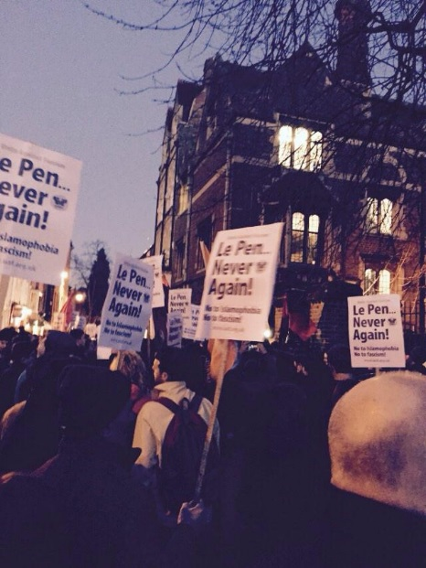 Hundreds out to say No to Le Pen at the Oxford Union
Hundreds say no to Le Pen in Oxford! Never Again!

Around 400 protesters protested last Thursday evening against the Oxford Union invitation to Marine Le Pen.

Opposition had been registered by many local community groups, councillors and students; a petition against the visit gathered 700 signatures in four days. The invitation came weeks after Le Pen called for the surveillance of Mosques and the reintroduction of the death penalty.

Le Front National have ruthlessly exploited the wave of Islamophobia that was unleashed following the horrific shootings in France last month.

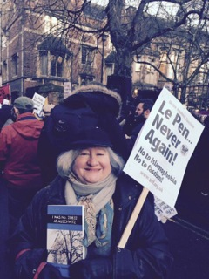
Collete Levi, ‘Hidden Child’ refugee from Nazi occupied France said: “Coming only a week after the Holocaust Memorial events in Britain to commemorate the 70th anniversary of the liberation of Auschwitz, this invitation to the leader of an extreme right wing party is surely a mark of great disrespect to the 6 million victims of the Holocaust and their families, as well as an unnecessarily provocative act at a time of great political sensitivity in Europe.”

Michele Paule Councillor for Rose Hill and Iffley said: “Oxford has a proud history of standing up to fascist bullies who aim to spread fear and division in our city. Residents, students, trades unions, workers and Councillors came together to see off Oswald Moseley when he wanted to speak here in the 1930s. We need to show we are on the right side of history again, not just as a gesture but as a commitment to fairness, equality and just being decent people”.

Collete Levi at No to Le Pen demonstration

Further information http://uaf.org.uk/

5. UCU anti-fascist resource pack

As part of a resource pack for teaching and general campaigning on anti-fascism we will include the issue of immigration including a) the invaluable contribution of migrants and refugees to society, particularly in education, research and the labour movement b) the importance of internationalism for education and research c) the value of academic and cultural exchanges and cultural diversity d) emigration from UK in particular the impact on overseas students / staff.

If you would like to contribute to this project, please email Chris Nicholas (cnicholas@ucu.org.uk) or Sharon Russell (srussell@ucu.org.uk) for further details.

6. Events
NATIONAL CONFERENCE:
Unite against racism and fascism
Saturday 21 February 2015
9.30-4.00pm, TUC Congress House,
Great Russell St, London
Nearest tube: Tottenham Court Road • Registration £12 / £6 concs

The far right EDL continue to target the Muslim community and are mobilising around the country. This conference is a timely opportunity to discuss the way forward for challenging racism and fascism bringing together the trade unions, faith and black communities, anti-racist and anti-fascist activists, LGBT representatives, students and young people for this major anti-racist and anti-fascist annual conference.

The conference will consist of a number of workshops covering the following themes:

From Britain to the USA – how do we combat police institutional racism?  Stand up to UKIP: how do we stop UKIP?  Le Pen, Golden Dawn & Jobbik, the rise of Euro fascism – a danger of the 1930s repeating?  Austerity & economic decline – no to scapegoating immigrants  Stand up to Racism: building the UN Anti-Racism Day demo 21 March 2015  Opposing Islamophobia, the EDL and fascist street movements  Celebrate Diversity – Love Music Hate Racism

Confirmed speakers: Diane Abbott MP ; Janet Alder Justice for Christopher Alder Campaign  Azad Ali Head of community development and engagement MEND  Shahrar Ali Deputy Leader Green Party  Christine Bucholz Die Linke member of the German Parliament  Mick Burke Economist  Jo Cardwell Convenor, Stand Up To UKIP  Petros Constantinou KEERFA, Greek anti-fascist campaign & Athens councillor  Sam Fairbairn Secretary, The People's Assembly Against Austerity  Gerry Gable Editor Searchlight  Lindsey German Convenor Stop the War Coalition  Billy Hayes General Secretary CWU  Lee Jasper Black Activists Rising Against Cuts 
Mohammed Kozbar VP Muslim Association of Britain & Chair, Finsbury Park Mosque 
Ken Livingstone  Lutfur Rahman Mayor of Tower Hamlets  Marcia Rigg Sean Rigg Justice and Change Campaign  Mark Serwotka General Secretary PCS  Dr Shuja Shafi Secretary General, Muslim Council of Britain  Emily Thornberry MP  Simon Woolley Director, Operation Black Vote  Sabby Dhalu and Weyman Bennett Joint National Secretaries, UAF

Collete Levi, one of the 'Hidden Children' from Nazi occupied France will be speaking at the Conference.
UCU will pay the registration fee for six UCU members to attend this event. Places will be allocated on a first come first served basis. You will be required to write a brief report on the event and the workshop you attend. We are unable to pay travel expenses.

If you would like to attend this event, please send your full details to srussell@ucu.org.uk

Stand up to Racism: UN Anti-Racism Day

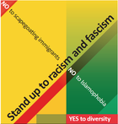
Organised by the TUC and Unite against fascism, a day of action will be held on Saturday 21 March 2015 to coincide with marking the International Day for the Elimination of Racial Discrimination.

This event is supported by UCU, TUC and other unions and coincides and with marking the International Day for the Elimination of Racial Discrimination.

UN Anti-Racism Day Demonstration
Saturday 21 March 2015
Assemble 12noon
March followed by rally in Trafalgar Square, Central London
CHECKLIST
UN ANTI-RACISM DAY
Help to show your support by:

✓ | Distributing leaflets*
✓ | Circulating the e-flyer *
 | Display the poster*
✓ | Upload the flyer to your branch / LA website
✓ | Organise a contingent to attend the event
✓ | Pass the model motion supporting the event*
✓ | Send a message of support to Stand up to Racism
✓ | Make a financial contribution toward the event

* Available from Stand up to Racism www.standuptoracism.org.uk

For further details contact Stand up to Racism at:
Follow @AntiRacismDay
www.standuptoracism.org.uk
info@standuptoracism.org
#M21

No to scapegoating immigrants’

No to Islamophobia

No to anti-Semitism

YES to Diversity

