
Election Countdown 2  March 2015

UN Anti-Racism Day 2015
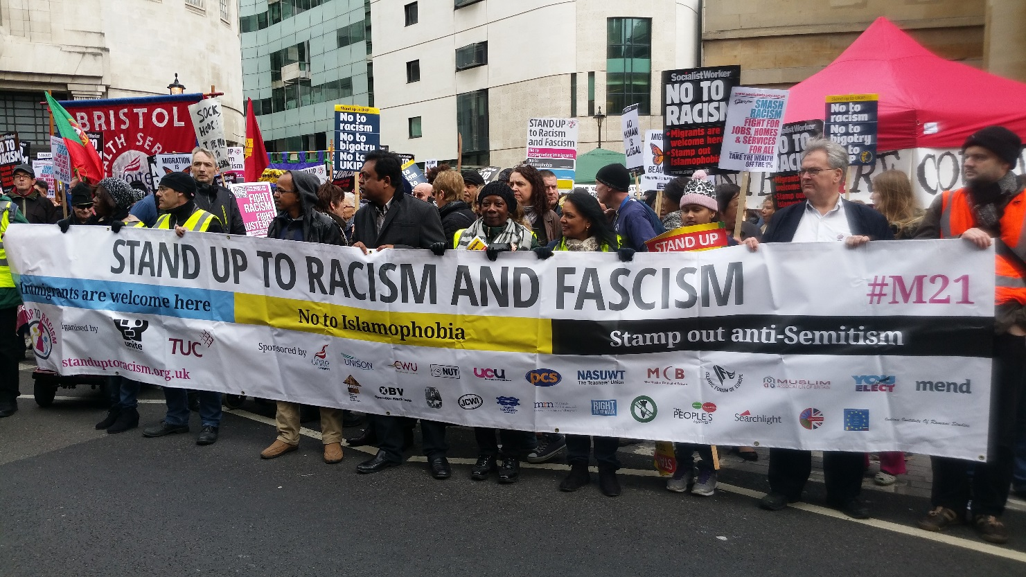
Photo: Sharon Russell

As part of the UN International Day for the Elimination of Racial Discrimination, people from all walks of life took action in cities around the world. The day commemorated the anniversary of the Sharpeville massacre during apartheid South Africa.

15,000 people marched across Britain in demonstrations held in London, Glasgow and Cardiff to say no to racism, Islamophobia, Anti-Semitism and Fascism. The demos saw a vibrant, diverse crowd from all walks of life including parliamentarian, trade unionist, student activists, NHS and other public sector workers, football supporters and LGBT groups, in what was the biggest anti-racist demonstration of the year! Tens of thousands marched worldwide in solidarity and unity, to say no to racism, Islamophobia, Anti-Semitism and Fascism. See end for pictures taken on the day.

We would like to say THANK YOU to UCU members’ who helped to make this day a great success!

Attack on the Aharas Torah Synagogue

Following a very successful day in London and across Britain to say no to Islamophobia, racism, anti-Semitism and fascism, comes the news of a violent and terrifying unprovoked attack at the Ahavas Torah Synagogue in Haringey, North London.

Although some of the comments made from the intruders were of an anti-Semitic nature, the incident was not being treated by the Police as anti-Semitic rather it being anti-social. UCU condemns all forms of anti-Semitism and is committed to challenging anti-Semitism at work and within the wider community. Click here to download UCU’s revised leaflet on Challenging anti-Semitism.

Reject racist & Islamophobic Pegida UK – Saturday 4 April London

The far right Islamophobic Pegida UK[1] aim to recreate the hatred of their allies elsewhere in Europe where thousands have targeted the Muslim community for attack. A planned Pegida march in Scotland fell into disarray when only four people turned up in support outside the Scottish Parliament.

Now, Pegida UK are planning a London demonstration on Saturday April 4. Following the thousands who supported UN Anti-Racism day, UAF are calling for all anti-fascists to mount a counter-demonstration rejecting Pegida’s hateful division. Click here for further details.

Talking about Migration

The TUC has developed new resources for use by members and reps on the issue of migration. The resources consist of:

- Briefing for activists
- PowerPoint presentation

The PowerPoint shows the results of polling commissioned into attitudes around migration and labour market concerns. This has been developed for unions to use in their branches to develop ways to promote messages on migration based on solidarity and workers’ rights. The presentation also has a set of speaker notes to assist members and reps. Please contact Tanya Warlock (twarlock@tuc.org.uk) in the TU EU and International Relations Department to obtain a copy.

Click here to download the resources.

UN Anti-Racism Day 2015 in Pictures

Getting ready…

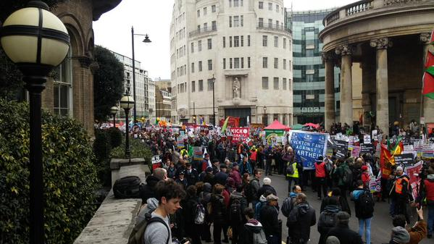
Photo: Stand up to Racism

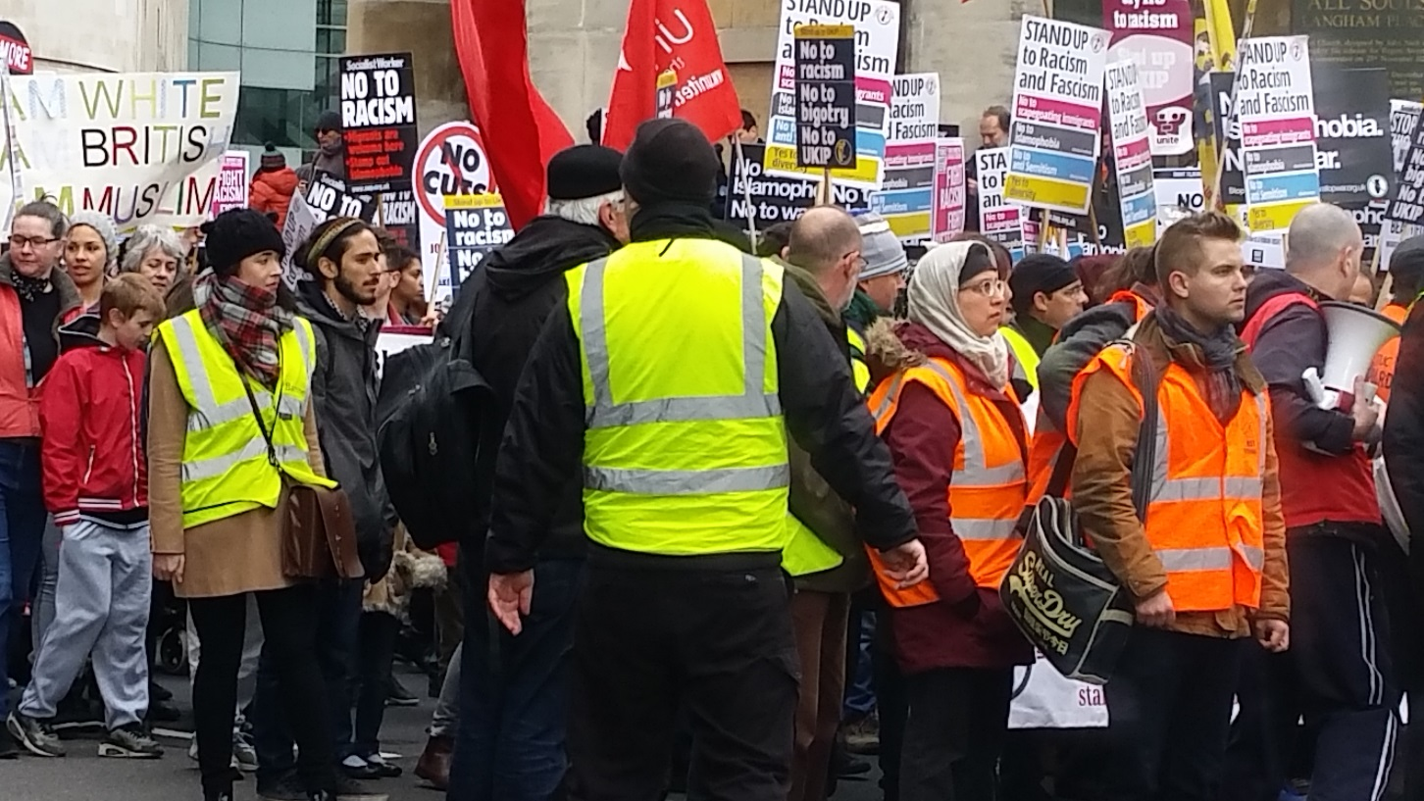
Photo: Sharon Russell

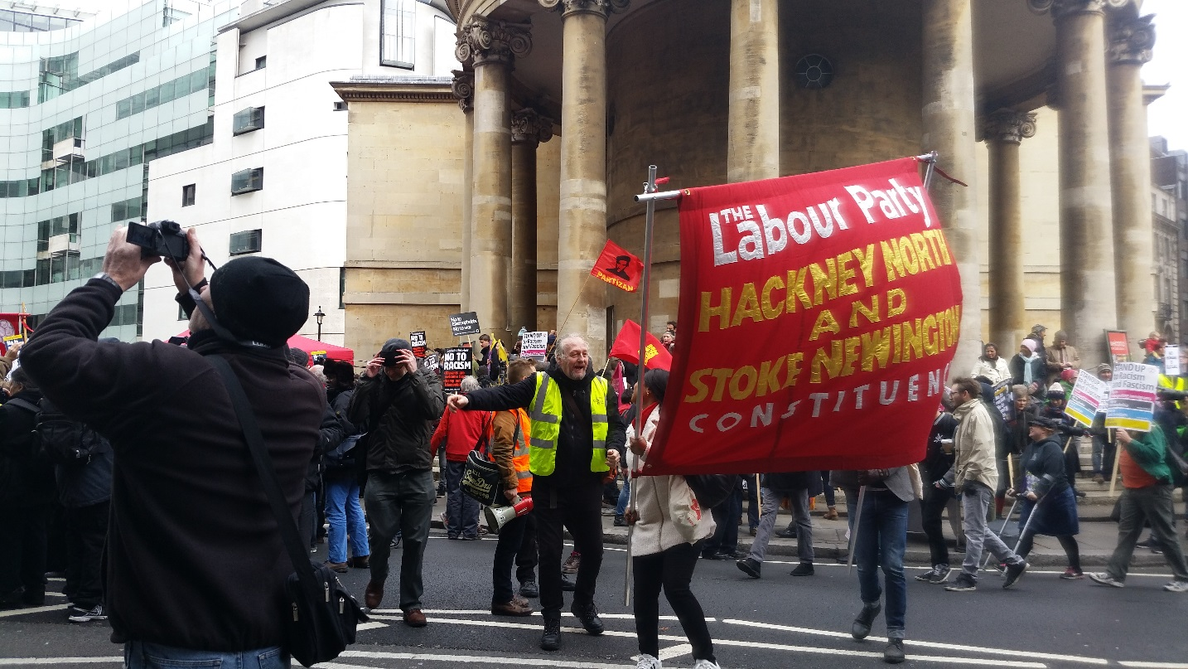
Photo: Sharon Russell

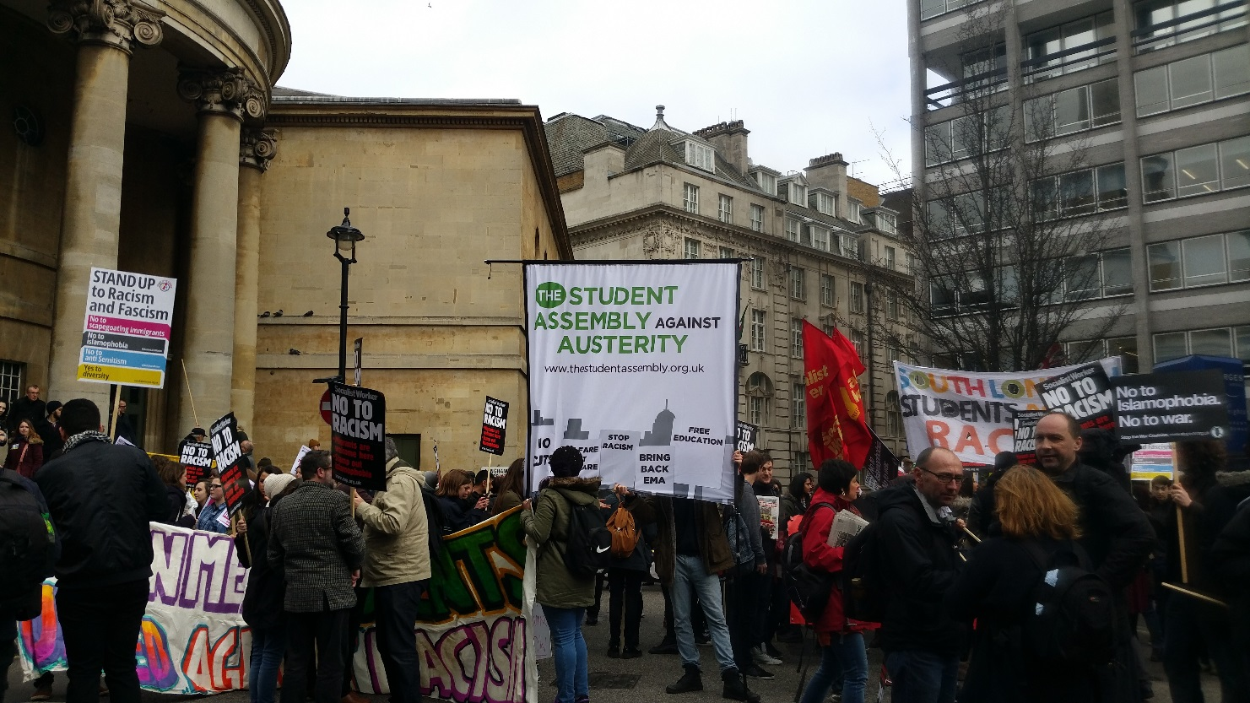
Photo: Sharon Russell

The March…

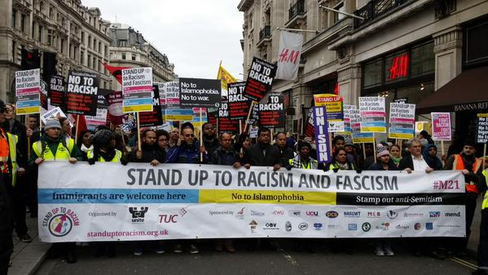
Photo: Stand up to Racism

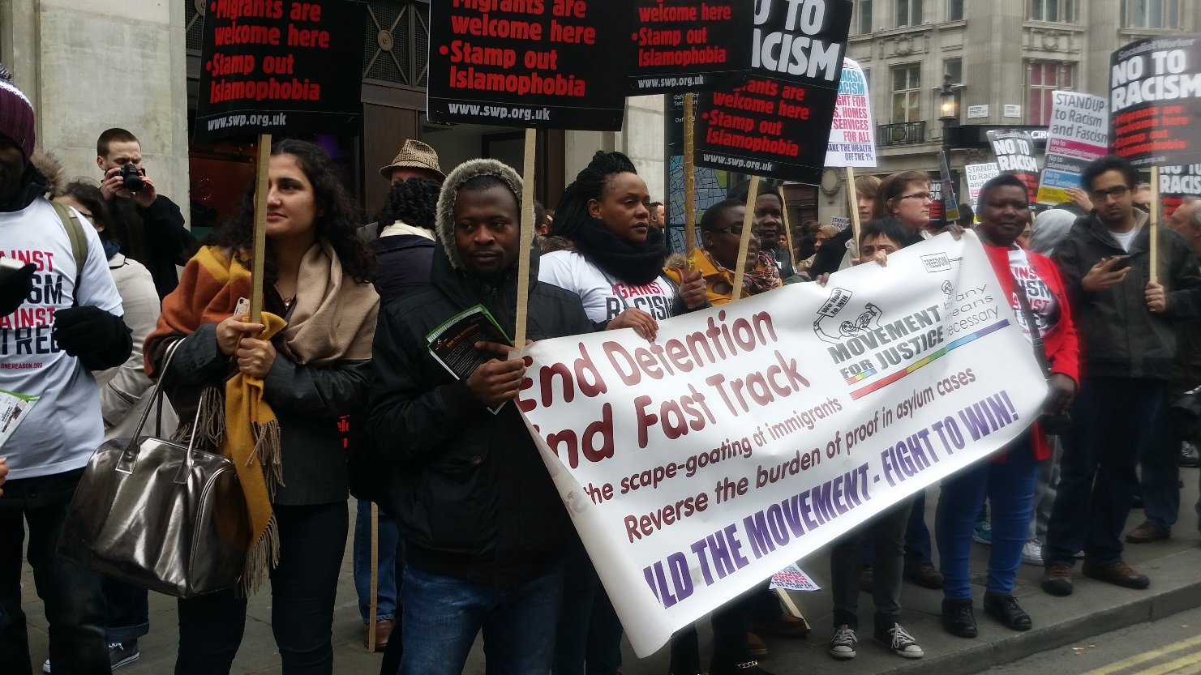
Photo: Sharon Russell

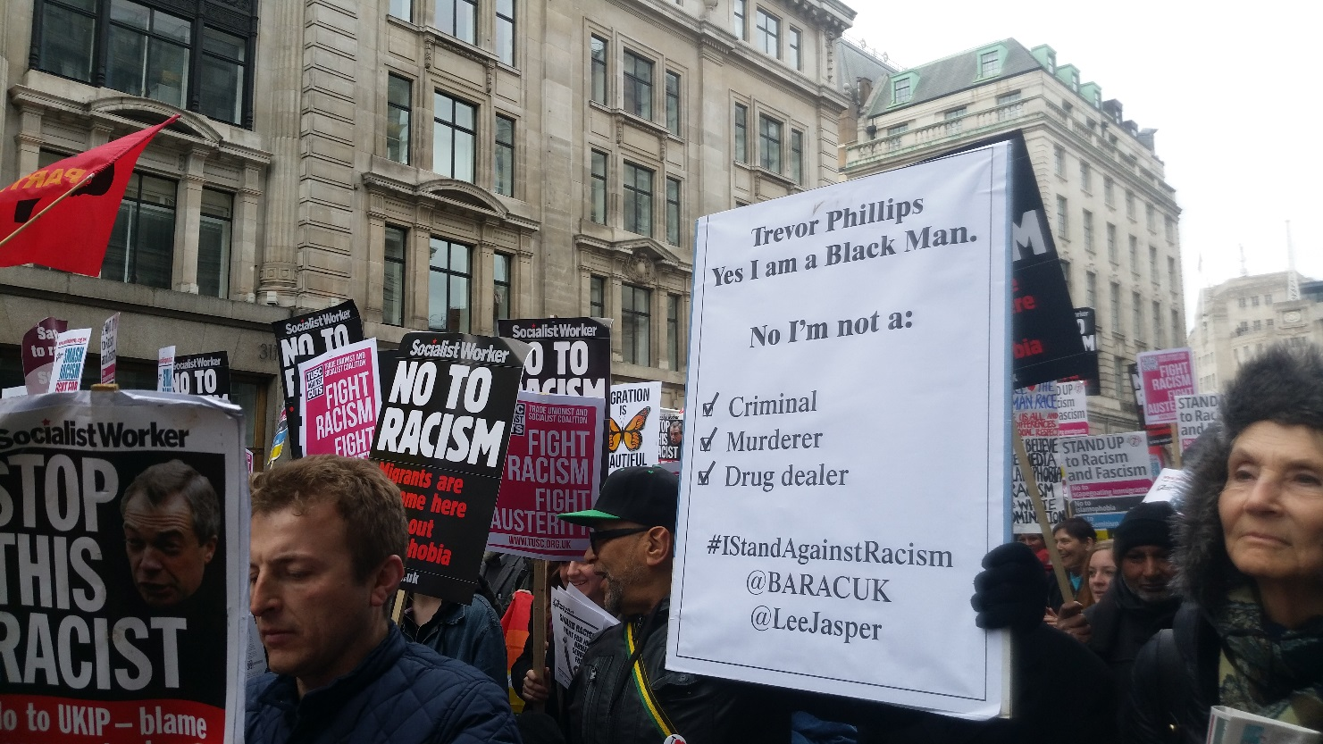
Photo: Sharon Russell

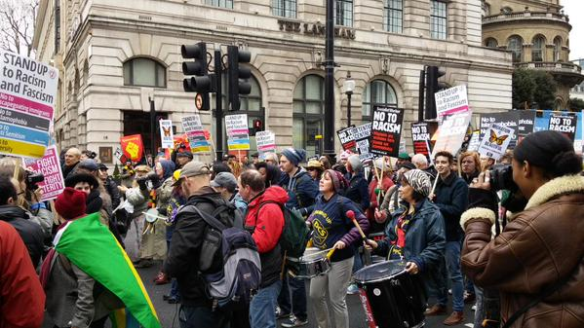
Photo: Stand up to Racism

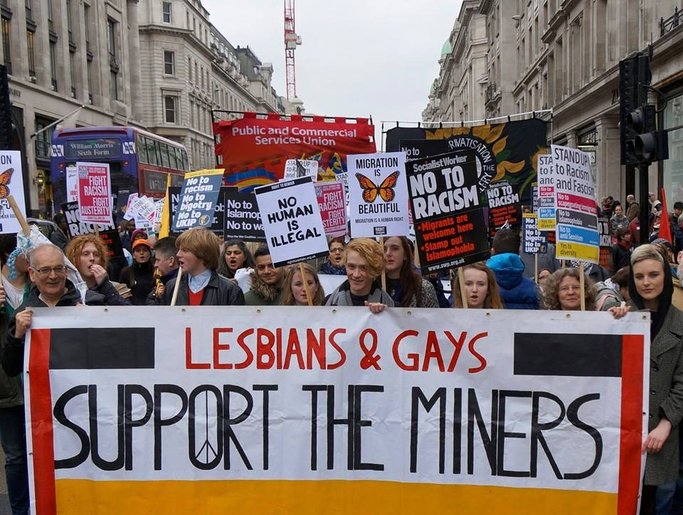Photo: LGSM, Geoff Dexter
The Rally and Speakers

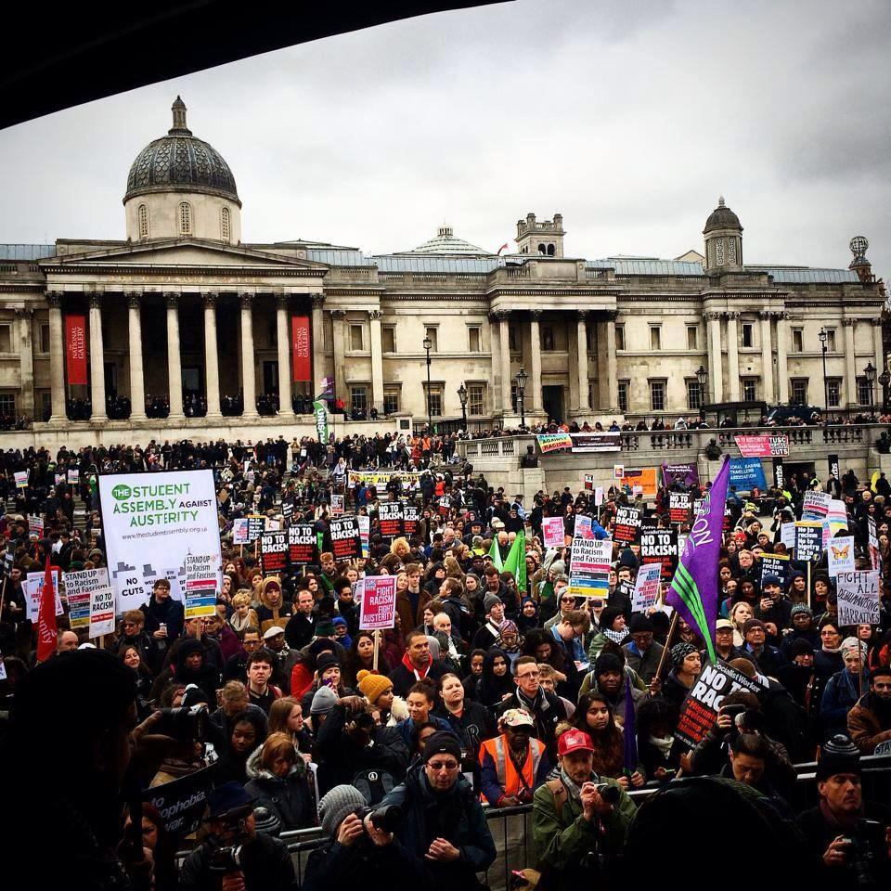
Photo: Stand up to Racism

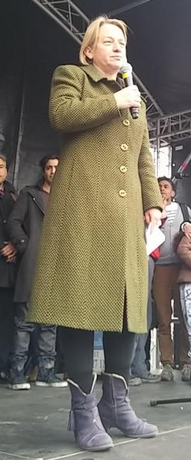
Natalie Bennett, MP
Leader of the Green Party
Photo: Stand up to Racism
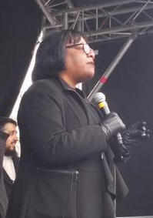
Diane Abbott, MP
Photo: Stand up to Racism

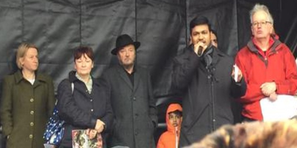

Talha Ahmad MCB National Council, Christine Blower NUT General Secretary, Natalie Bennett Green Party Leader, George Galloway MP and Steve Hart UAF Chair were among the speakers
Photo: Stand up to Racism



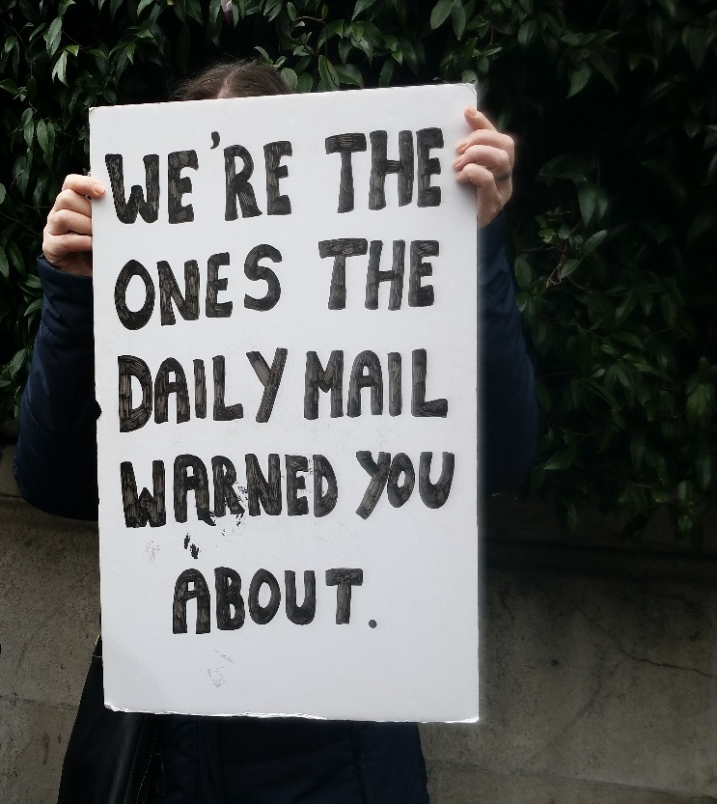

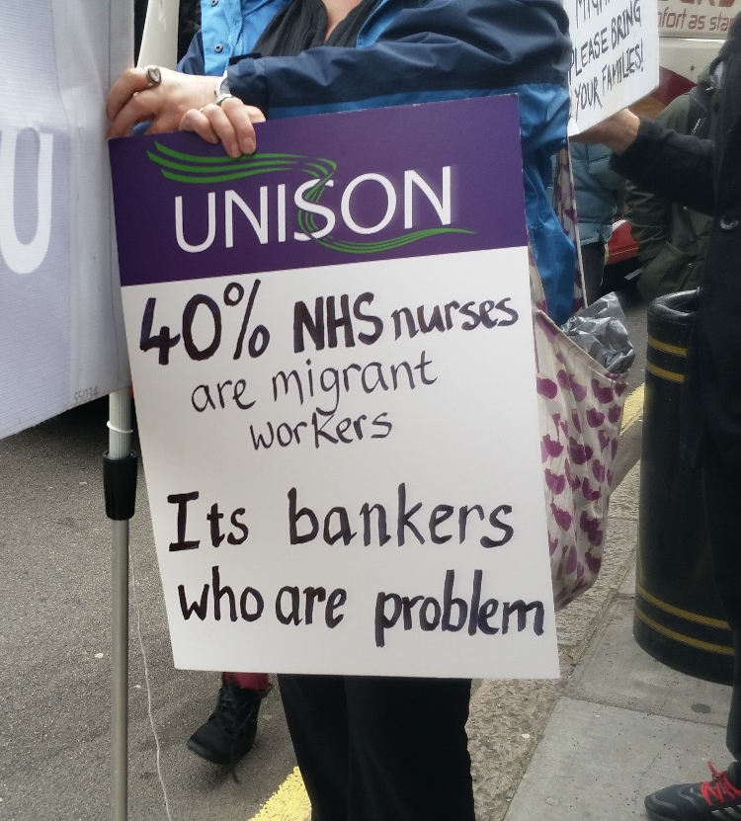

Photos: Sharon Russell
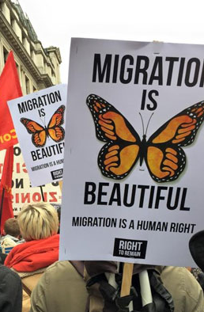
Photo: Stand up to Racism

[ 1] Pegida is a German right-wing anti-Islam political organisation calling for a restructuring of immigration rules particularly for Muslims. It is against what it considers the Islamisation of the Western world.

