
Election Countdown 4  May 2015

Contents
- ‘I am an immigrant’ poster campaign
- 22nd Anniversary of the murder of Stephen Lawrence
- Race and religious hate crime increase on the railways
- Remembering the Cambodian genocide
- General Election lobbying toolkit website

- ‘I am an immigrant’ poster campaign

Movement Against Xenophobia (part of the Joint Council for the Welfare of Immigrants) successfully launched their ‘I am an immigrant’ poster campaign on Monday 13 April at the TUC.

The poster campaign features immigrants representing a wide range of professions and how they contribute to society. The aim of the campaign is to counteract the anti-immigrant rhetoric found in some parts of the media and in political debate. The posters are displayed at 550 train stations across the UK and in 400 London underground stations and on billboards around the country. The campaign was also launched in Wales.

There is still time to join the campaign. This is a fantastic campaign to be a part of and there is still time to join. Visit http://www.iamanimmigrant.net/ for further information.

- 22nd Anniversary of the murder of Stephen Lawrence

Stephen Lawrence was born on 13th September 1974 in South East London. His parents are Neville and Doreen Lawrence and he has two younger siblings, Stuart and Georgina. As a young child, Stephen showed an interest in art: he loved to draw and paint. Stephen was a keen learner; he was good at most subjects at school, but he was best at art and maths.

As well as his interest in design, Stephen was an entrepreneur – at 16, he set up a small business with his best friend designing and selling T-shirts, caps, jackets and book covers of well-known bands, rappers and political figures such as Malcolm X. He even worked as a film extra alongside actor Denzel Washington in the film For Queen and Country.

Stephen decided to use his skills in art design and maths to aim for a university place studying architecture. Following his GCSE exams, his family found him work experience with Arthur Timothy’s architecture practice.

Tragically, at the age of 18 on 22nd April 1993, Stephen was murdered in an unprovoked racist attack. He didn’t know his killers and his killers didn’t know him. To this date, only two of the five perpetrators have been put in prison for his murder.

In his memory and to inspire and help young people just like him, his family set up the Stephen Lawrence Charitable Trust.
Since 2000, the Trust has helped many young people realise their ambitions to become architects by supporting them with bursaries and mentoring support.

In 2008, the Stephen Lawrence Centre was opened in Deptford, South East London, giving thousands more young people an opportunity to nurture and use their creativity.

TUC Stephen Lawrence Fundraising Appeal: Support the legacy of Stephen Lawrence by donating to the TUC Stephen Lawrence Fundraising Appeal Donate Online at www.justgiving.com/TUCslct or Text TUCS99 followed by the £ symbol, then the amount to 70070.

- Race and religious hate crime on the increase

Figures obtained by the Press Association showed that there was an increase in the reporting of suspected hate crimes taking place on the railways during 2014 – see table. It shows that the incident that took place in February on the Paris Metro by football fans is not an isolated event and is borne from the current climate where scapegoating and prejudice towards migrants have become the norm.
Year | Total number of racial / religious incidents
2012 | 1351
2013 | 1364
2014 | 1468

If you are witness or victim of a hate crime on public transport REPORT IT! Contact the British Transport Police at 0800 40 50 40 / text to 61016. Or, alternatively, report the crime on-line via the True Vision website here

- Remembering the Cambodian genocide

On 17th April 1975, Khmer Rouge forces entered the capital city, Phnom Penh and defeated the ruling Lon Nol army. This marked the beginning of the Cambodian genocide.

The Khmer Rouge imposed an extremist programme to reconstruct Cambodia on the communist model of Mao’s China creating a ‘Year Zero’. Everyone was forced to work in labour camps and no one was spared.

The Khmer Rouge targeted ethnic minority groups and 8,000 Christians were murdered. All political and civil rights were abolished. Children were taken from their parents and placed in separate forced labour camps. Factories, schools and universities were shut down, so were hospitals. Lawyers, doctors, teachers, engineers, scientists and professional people in any field were murdered, together with their extended families. Religion was banned, so were music and radio sets. It was possible for people to be shot simply for knowing a foreign language, wearing glasses, laughing, or crying. One Khmer Rouge slogan ran ‘To spare you is no profit, to destroy you is no loss.’

Civilian deaths in this period, from execution, disease, exhaustion and starvation, have been estimated at well over two million. You can read more about the Cambodian genocide here. Source: Holocaust Memorial Day Trust

- The race is on…

UCU General Election 2015: lobbying toolkit website
As we approach the general election in May 2015, UCU is providing members with a range of materials to help you engage with local candidates on issues relating to post-school education. These include UCU’s main policy 'asks', summaries of each party's stance on key education and employment issues, template letters for writing to candidates and details about voter registration – the website is live here.

HOPE not hate election campaign
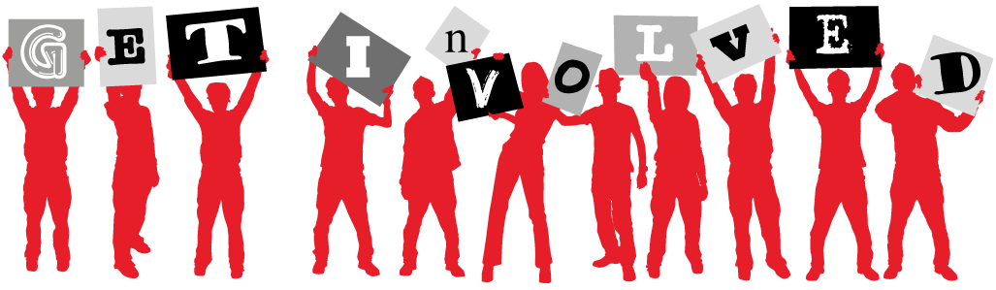
2015 is set to see HOPE not hate’s largest, most organised and highly targeted electoral effort to date. It will be made up of hundreds of localised campaigns, with tailored leaflets being distributed to different houses in our key target areas.

And our campaign needs to be this big. While UKIP is not the BNP and Nigel Farage is certainly not Nick Griffin, its increasingly anti-immigrant and anti-Muslim rhetoric, ability to drag the whole political debate to the right and its acceptance of, and seeming indifference towards, casual racism makes it even more pernicious and dangerous.

Worse still, UKIP could hold the balance of power in the next Parliament.

If you don't want to see this happen then sign up to get involved. Last year we saw off the BNP and now, with your help, we can defeat UKIP. To get involved with the campaign, contact http://action.hopenothate.org.uk/page/s/get-involved-2015

Migrant Rights Network – Our Vote
Migrant Rights Network have launched their Our Vote website calling for an honest approach to the debate around immigration. You can view their short film and find out more about the campaign at www.our-vote.org/

Missed our Q&A Session last week with Weyman Bennett? Read it here

