
Congress Issue  May 2015

Contents
- Our challenge after the general election
- Congress Equality Fringe: Resisting the politics of hate – why immigration is good for all of us
- Congress motions up for debate
- Equality Q&A Session: Weyman Bennett
- News and events

- Our challenge after the general election

After weeks of campaigning, the votes have been cast and verified and we now enter a period of five years leadership under a majority conservative government. An election that despite all the polls, did not foresee Messrs Clegg, Farage* and Miliband resign from public office on the same day.

Some may be disheartened, however, we must take some credit for working hard to ensure that Nigel Farage did not get elected to the South Thanet seat on a ticket of anti-immigration – we must not however remain complacent - UKIP received 12.6% share of the votes in this year’s election having received 3,881,099 votes, still means that we should be vigilant and must continue to oppose anti-immigrant rhetoric and scaremongering.

With a majority Conservative government, they now have the green light to implement fully the changes they were unable to do implement during the last five years. Following the election, our immediate challenges include:

- Austerity - The Government plans to slash benefits by £12bn

- The Human Rights Act 1988 - The Government plans to abolish the Human Rights Act, which guarantees the right to life, liberty, a private life and a fair trial, and replace it with a new British Bill of rights – Article 14 if the Convention.

- Privacy - A Bill that would give the government more surveillance powers - known as the Snoopers’ Charter - is now back on the agenda, according to Theresa May. It is thought the legislation would force British internet service providers to retain large amounts of data about their customers which would be available to the government and security services.

UCU along with others in the trade union movement will campaign against any attack not only for our members but for the most vulnerable in society.

2. Congress Equality Fringe: Resisting the politics of hate – why immigration is good for all of us

The politics of hate is creating a society which is becoming hostile to different equality groups and creating a climate of fear for many.
This includes the current immigration debate which is poisonous, racist and negative and makes our voice for social justice and equality so important. This year, our fringe event will look at ‘Resisting the politics of hate – why immigration is good for all of us’.

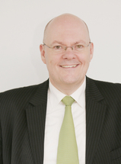
We are pleased to have John Wilkes, Chief Executive of the Scottish Refugee Council address our event. John has been in post since 2008 and has a background in equalities and human rights. He was formerly Director of the Equal Opportunities Commission in Scotland and Scottish Director of Carers UK and held other chief executive roles in the Scottish voluntary sector on issues of HIV and AIDS.

The fringe will be chaired by Mary Jennings, Chair of the Equality Committee and will hear contributions from representatives from all four Equality Standing Committees.

The fringe will discuss what we can do as UCU in this post-election period to develop a positive inclusive agenda for all.

 | ⬅ | Copies of UCU’s latest publications on immigration:  ‘Why immigration is good for all of us’ and;  ‘Impact of UK immigration policies on students and staff in further and higher education’  Will be available for delegates attending this fringe and also available from the Equality and Participation stall. | ➔

The fringe will be held in Boisdale 1 on Sunday 24 May between 1pm and 2pm.

- Congress motions up for debate

A number of motions will be debated at this year’s congress addressing the issue of racism in the workplace, challenging racism within our sectors and the impact of UKIP. These submissions show that our members are not only continuing to challenge and address racism in wider society but also at local level.

With the support of UCU activists, we will be producing a resource pack that counteracts the xenophobic rhetoric being played out that continues to scapegoat immigrants and black communities that we have seen through the election period and will no doubt continue after. Please contact Chris Nicholas (cnicholas@ucu.org.uk) or Sharon Russell (srussell@ucu.org.uk) for further information.

- Equality Q&A Session: Weyman Bennett

The Equality Q&A Sessions focus on an issue of UCU equality campaigning and/or interest arising from existing or new policy. We will cover all equality strands for example looking at topics such as action against violence against women, disability hate crime, racism / xenophobia or challenging homophobia and transphobia for example.

Following the successful UN Anti-Racism Day where 15,000 people marched across Britain to say no to racism, Islamophobia, anti-Semitism and fascism.

We talk to Weyman Bennett, Joint Secretary of Unite against Fascism about the acceptable face of racism, the rise of the far right in Europe, the forthcoming general election and his hopes and fears for a future free from racism and hatred.

United Nations International Day for the Elimination of Racial Discrimination

UN Anti-Racism Day commemorates the victims of the Sharpeville Massacre in 1960 when 69 peaceful demonstrators against apartheid were killed by the South African police force.

- Why do you think UKIP received electoral success at the European elections held last May and have continued to receive public support?

Weyman Bennett: “With the emergence of UKIP, Britain now has a racist, Populist Party influencing political debate, as do a number of countries across Europe. But what kind of political force is UKIP? Understanding its nature is vital if we are to successfully challenge it.

Populist parties claim to look at the interests of the population, not just the establishment or the elite. UKIP combines anti-immigrant racism with a populist pitch that claims to represent the anger of the ordinary “man in the street” against a corrupt political elite.

It presents itself as an anti-establishment outsider and not part of the discredited political game. In doing so UKIP looks to hide its own ties to parts of the establishment. The party is led by former City trader Nigel Farage and backed by a clutch of multimillionaires like Paul Sykes and Stuart Wheeler.

The core of its leadership and millionaire backers are hard neoliberals who support free market policies.

Farage presents UKIP as an empty vessel that can attract people from all classes who can project their hopes and fears onto it. So in the recent election campaign Farage was careful to avoid any discussion of UKIP’s economic policies.”

- Do you think that the success of the Front National in France could see further gains of the right (BNP/UKIP) in the UK?

WB: “The glue that keeps its cross-class alliance together is racism. UKIP seeks to turn bitterness at the crises that threatens to tear people’s lives apart into blaming immigrants and foreigners.

It redirects people’s anger away from the powerful towards scapegoating the oppressed and powerless. It draws on the relentless attacks on asylum seekers, immigrants and Muslims pushed by mainstream parties. UKIP is the ugly child of the establishment.”

“Racist populist parties include UKIP, the Danish People’s Party and Geert Wilders’ Freedom Party in the Netherlands. They are different to fascist parties such as the British National Party (BNP), the French Front National (FN) or Golden Dawn in Greece.”

- Why have far right groups across Europe gained so much traction?

WB: “The latest gains for the fascist Front National (FN) come against a backdrop of years of attacks on Muslims without real opposition.

Ten years ago this month a law was passed banning religious signs in schools. It was a racist and sexist law against girls wearing a hijab.

The argument from the political establishment was that school is a sacred place from which politics and religion must be excluded. In the context of the “war against terror” and of a denial of colonial crimes, France was launching a crusade against any expression of oppressed minorities.

The Front National (FN) beginning 25% of the vote in the European elections represents the biggest vote for a fascist party. Marine Le Pen’s father (Jean-Marie Le Pen, the party’s first leader) had called the Holocaust a small detail in history, further demonstrated the party’s foundation as being deeply racist and anti-Semitic coming from the collaboration with the Nazis in the Second World War.

The party has remodelled itself as an anti-immigrant and racist party particularly against Muslims. It (FN) is the biggest single threat in Western Europe to a party formally coming to power with a presidential candidate. The development in the last local elections in which the party gained 26% of the vote is another step forward in widening the Front National – it is urgent that we recognise this danger and oppose it.

The Front National sister organisation is the British National Party (BNP) which was formerly led by Nick Griffin. Unite against fascism and other anti-fascists opposed and removed the BNP as a serious organisation. Marine Le Pen gives hope to every racist and nazi in Europe if she was to formally come into office seeking alliances in the hope to coalesce the far right around herself.

Organisations which have been weakened like the English Defence League (EDL) and the British National Party still pose a serious difficulty for the anti-fascist movement. That is why it was great to see so many thousands take to the streets in France on 21 March in opposing racism, fascism, anti-Semitism and Islamophobia.”

- We seem to be stepping back into time with people like DJ Mike Reed and his calypso song, football supporters with their racist and anti-Semitic chanting, UKIP councillors and their racist outbursts to the public racially abusing of people travelling on public transport etc. What do you think needs to be done to prevent this type of xenophobic behaviour?

WB: “Not that it has ever gone away, but we are seeing racism raise its ugly head again. The rise of Islamophobia has meant that other racisms have come to the forefront.

We see Chelsea supporters pushing a Black man off the train and claim it was because of overcrowding and the ex-policeman justifying such disgraceful behaviour. It is the politics of anti-immigration racism fuelled by austerity that blames immigrants rather than blaming the banking system and the people that perpetrate the levels of inequality we now see. Unfortunately, mainstream political parties have failed to condemn this instead of trying to copy the rhetoric coming out of people like Farage.”

- To what extent do you think austerity has played in the rise of the right?

WB: “Oscar Wilde once said “We are all in the gutter, but some of us are looking at the stars”.

“Since the 2007 banking crisis, there has been severe cuts in public services and in people’s living standards are falling by up to 10% meanwhile those at the top of our society has doubled their wealth.

‘Divide and rule’ was a phrase coined by Emperor Tiberius but it is fitting for our society today – either you blame your neighbour for the cutting”

- We now have a greater understanding of the impact of institutional racism since the Stephen Lawrence Inquiry but has anything really changed to give Black people more confidence in public institutions?

WB: “50 years have passed since peaceful protestors took to the streets in Selma, Alabama demanding their civil rights and just over 22 years in the fight for justice following the racist murder of Stephen Lawrence. The challenge against institutional racism is being planted by a refusal of senior policymakers to assert that racism still continues to exist. In fact, people and Trevor Philips have gone further by blaming minority communities and pandering to stereotypes.

Great steps were taken to put in place the findings of the Macpherson report following the Stephen Lawrence Inquiry, but in practice, the high rates of dismissal of Black and Asian staff from employment is also a continuation of the same form of prejudice which dominated institutions. In fact, with the application of Prevent turning every Police Officer into an Immigration Officer, we see further examples of entrenchment of racism taking place.

Many Black people are facing greater levels of discrimination from institutions than ever before whereas we may argue that racism is not at the same level as it was in 1950s but that there still remains an attempt to formally turn the clock back and refuse to accept that we live in a multicultural society.”

- How can UCU members work effectively to oppose and expose racist and xenophobic statements?

WB: “UCU has been at the forefront of fighting racism and discrimination, producing materials to counter the narrative of Government and to oppose the racism of UKIP.

UCU participated with the 12,000 strong demonstrations in central London against racism. In every college in every university we have to oppose the politics of scapegoating international students and particularly Muslim students who are particularly targeted.

We have to maintain our equality departments and support the work they do in giving confidence to members to confront racist abuse when they see it and uncover discrimination that exists. The union is to be commended in its opposition against Islamophobia, anti-Semitism and racism.”

- What are three key priorities for the anti-fascist movement as we head toward this year’s general election?

WB: “Three key priorities for the anti-fascist movement is to:

- Maintain and continue to build Unite against fascism so that we can stop organisations such as Britain First and Pegida as we did in Newcastle

- We must stop the UK Independence Party from peddling their racism and anti-discrimination

- We have to have a positive message and encourage everyone to celebrate multicultural Britain and to stop mainstream parties blaming immigrants for the crisis.”

- What are your hopes and fears for a future free from racism and hatred?

WB: “My biggest fear is that there are four forums of far right fascist organisation building across eastern and Western Europe. There are groups like Golden Dawn, Jobbik and Euro Fascist such as Le Pen who may not have the same paramilitary structure, share the same ideology. Racist populist organisations like UKIP dominate the political agenda and finally, the English Defence League who continue to threaten all communities.

My hopes live in the fact that we confronted and broke the back of the English National Front in the 1970s and again with the British National Party throughout the 1990s until we successfully removed them from office in 2010.

My hope lies in the multicultural, multi-racial, anti-racist, anti-fascist organisations that have challenged these people but there is no room for complacency. We all have a duty to fight against all forms of bigotry and discrimination because in a period of crisis, they can only come to power in order to repeat the genocides and Holocaust that we so much wished should never happen again.

My slogan still remains “Black and White Unite, Fight and Never Again!”

- News

The European Network Aganst Racism (ENAR) has published a set of shadow reports on incidents of crimes motivated by racism which took place in the 26 EU member states in the period 2013-14.

The report found that a total of 47,210 racist crimes were reported in the countries covered. However, its states the belief that this is only the tip of the iceberg, since EU Member do not properly record and report racially motivated crimes.

Principal findings include:

- Black and Asian ethnic minorities, Roma, Jews and Muslims – or those perceived as such – are the main targets of racist crime and perpetrators.
- In Italy, 57% of bias motivated crimes relate to race or ethnicity.
- In Greece, over 200 racially motivated incidents targeting people with an Asian background were recorded.
- In Sweden, 980 crimes with an Afro phobic motive were recorded.
- In most EU countries, cases of violence, abuse or incitement to violence against Roma were reported.

It also found evidence of hate crimes motivated by anti-Semitic and Islamaphobic sentiment. These include:

- A rise in anti-Semitic crimes in Bulgaria, Denmark, Germany, Hungary, the Netherlands and Sweden. In Germany, 1,275 crimes with an anti-Semitic motivation were recorded.
- Islamophobic crimes have risen in France, England and Wales.
- In Sweden, police reports of crimes with an Islamophobic motive increased by 69% from 2009 to 2013.
- In the United Kingdom, 74% of incidents reported to the organisation Tell MAMA were online.

To read the a summary of the report, the full report, and view a video presenting its findings, go this the ENAR website

The People's Assembly Against Austerity is calling a major national demonstration & festival on Saturday 20 to send a clear message to the Tory government; we demand an alternative to austerity and to policies that only benefit those at the top.

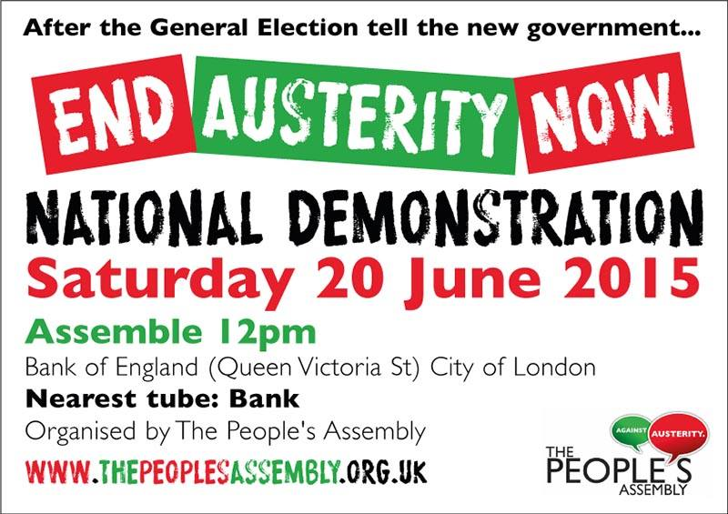

I AM AN IMMIGRANT
The full set of posters are displayed at UCU Offices, Carlow Street

