

Academic Freedom: the case for legal protection

Joint statement between AUTS and EIS on the Further and Higher Education (Scotland) Bill

AUT Scotland and EIS believe that the legislative protection of academic freedom should be extended to cover all higher education institutions and further education colleges in Scotland and believe it is an anomaly that it presently only applies to pre-1992 universities.

According to the Times Higher Education Supplement, the Principals’ body Universities Scotland also supports academic freedom
‘...the principle of academic freedom is one we clearly more than fully support. ...academics should have freedom of expression’

Academic freedom is defined in the Education Reform Act 1988, Section 202 (2).
to ensure that academic staff have freedom within the law to question and test received wisdom, and to put forward new ideas and controversial or unpopular opinions, without placing themselves in jeopardy of losing their jobs or privileges they may have at their institutions;

Institutions that did not have university status in 1988 may in practice respect the individual academic freedom of their staff but this is not guaranteed or underpinned by legislation and is not necessarily covered in their contracts. As institutional autonomy is to be extended, then academic freedom should be extended in a similar way. However, this would not mean that academics have carte blanche to use university resources. It is also important to understand that academic freedom does not allow unlawful activity under the guise of academic publication. The concept is freedom ‘within the law’. But it does offer protection to academics from political, economic and social pressures, which could otherwise restrict scholarly work.

We believe that the extension of academic freedom can be achieved through a simple amendment to the Further and Higher Education (Scotland) Bill.

Borrowing the relevant wording from the Education Reform Act 1988, it would be feasible to extend the principle of academic freedom to embrace all universities and FE colleges, by adding to Section 7 (2) (c) a new subsection: ‘procedures to ensure that academic staff employed by the body have freedom within the law to question and test received wisdom, and to put forward new ideas and controversial or unpopular opinions, without placing themselves in jeopardy of losing their jobs or privileges they may have at the body’
The new funding council will then be obliged to ensure that there are suitable procedures and arrangements for all matters covered in the list in Section 7 of the bill for every fundable body.

This avoids the complicated use of commissioners in the Education Reform Act 1988 while allowing each institution some leeway to apply academic freedom in the most suitable way, subject only to the broad overview of the funding council

As the new funding council would only have to ensure that institutions had procedures in place for academic freedom we do not believe that is an onerous task. Similar work will be required to ensure that institutions meet their obligations in many other areas covered in the list in section 7. Indeed the funding councils already have this role for quality assurance, finances, governance and management. The funding council can, as usual, consult stakeholders to avoid a heavy-handed approach to securing assurance that suitable procedures are in place.

We do not believe that the executive has justified the assertion that they cannot amend the bill and we are extremely concerned that their reasoning is due to having received a small number of representations. This is hardly open and inclusive consultation. The statement from the Minister that individual freedom is primarily a matter between the institutions and their employees fails to appreciate the strong historical case for legal protection of academic freedom in the wider interest of society.

The bill itself has sections on the ombudsman, fees levels etc that are not directly related to the merger of the funding councils and are included simply because of a convenient legislative opportunity. If this opportunity is missed then it may be many years before another legislative vehicle comes along.

For these reasons we believe academic freedom should be included in this bill.

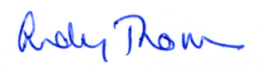 | 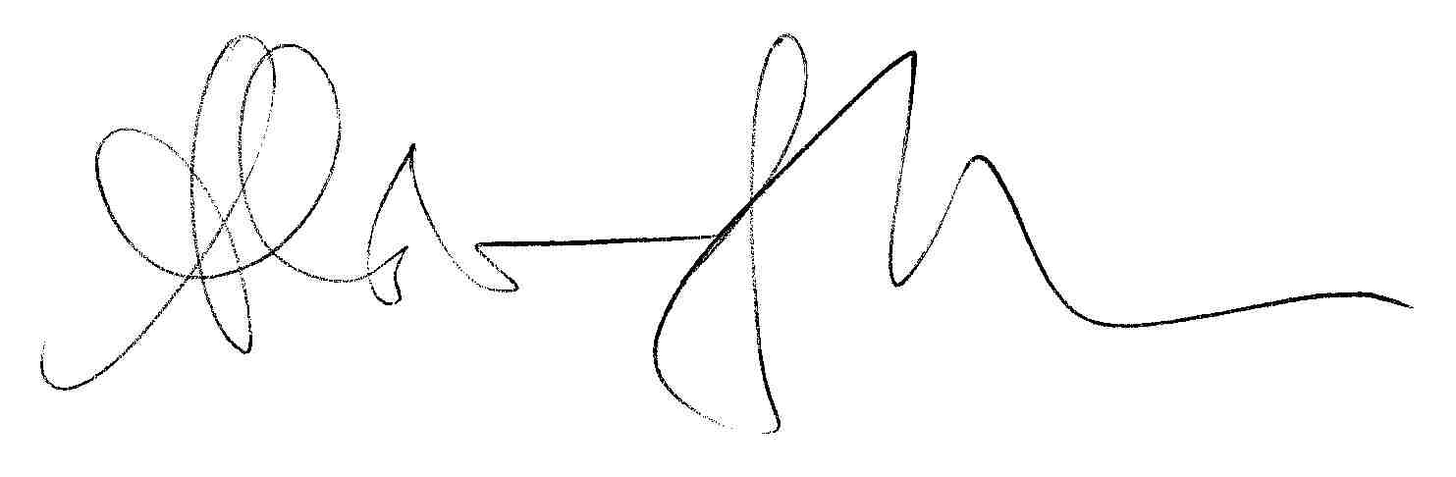
Andy Thomson  President  EIS-ULA | Alastair G Hunter  President  AUT Scotland

