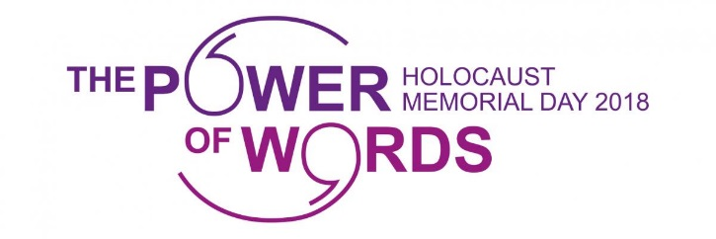
Holocaust Memorial Day 2018
Event planning information sheet

- Order copies of the following – all UCU materials are available at
https://www.ucu.org.uk/hmd

    - UCU Holocaust Memorial Day wall chart: The UCU Holocaust Memorial Day wallchart has been brought up to date and includes new sections about the recent fight against fascist organisations like the BNP and EDL. This resource can be used in your institution to educate against the dangers of anti-Semitism, fascism and racial discrimination.

    - Testimonials: UCU publications detailing the testimonials of survivors (the Holocaust, Rwanda and Bosnian genocide). These testimonials, gives the reader an insight into how the Holocaust and subsequent genocides have impacted lives.

    - UCU leaflet on anti-Semitism: UCU is committed to challenging anti-Semitism at work and within the union. UCU wants all its members to be treated equally at work, to participate fully in the union and to have the protection of UCU when it is needed.

2. Show one (or both) of our films – available online via the UCU website at https//www.ucu.org.uk/hmd, they are:

- The Holocaust: This film features UCU members who speak movingly about the impact of the Holocaust on their families and themselves. It won joint first prize for the TUC Communications Award in 2013.
- Journeys to Safety: Memories of the Kindertransport: Our second film featured three kinder children (Lord Dubs, Ruth Barnett and John Fieldsend) speaking about the impact leaving their families had on
them via the Kindertransport route.

3. Create a display using the above materials to raise awareness about the Holocaust and subsequent genocides.

4. In addition to UCU resources, you can also contact the Holocaust Memorial Day Trust for further resources including their information sheet for
colleges and universities and their guide exploring LGBT themes related to
HMD at http://hmd.org.uk/page/get-involved.

5. Contact the Holocaust Memorial Day Trust to register for their workshop to assist you with planning your event. These workshop sessions are free but registration is essential. Contact http://hmd.org.uk/page/workshops for further details.

6. The Holocaust Memorial Day Trust can provide a list of speakers available to address your event. Visit http://www.hmd.org.uk/page/survivor-speakers or email enquiries@hmd.org.uk. You might want to consider working with sister campus unions and student groups.

