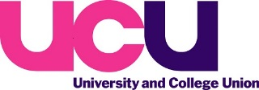

Day of Action Against Workforce Racism
28 February 2018

Theme: Decolonising Education

In 2017, UCU Congress passed the following motion:

Decolonise kyriarchal education by resourcing collaboration to Liberate The Curriculum
Black Members Standing Committee

Congress notes that:

- Kyriarchy, as defined by Elisabeth Schüssler Fiorenza, is 'a complex pyramidal system of intersecting multiplicative social structures of superordination and subordination, of ruling and oppression'.

- In supposedly "post"-colonial education, the legacy of the British Empire is colonial kyriarchy: perspectives from the peak of this colonial pyramid are promoted, as if they set a universal standard.

- This structural propping-up of these minority perspectives unjustly determines what:
- research is funded,
- curricula are taught, and
- assessments are made, in recruiting, retaining, and progressing both students and staff.

Congress further notes that:

- 'Liberate The Curriculum' aims to empower students with tools to decolonise kyriarchal education.

- It does this by amplifying local decolonial campaigns—such as 'Why Is My Curriculum White?', 'Rhodes Must Fall', 'Decolonising SOAS'— spreading their good practice nationally.

Congress resolves to resource local branches to work strategically with (decolonial groups within) local student unions to 'Liberate The Curriculum'.
“Arguably, the narrowness of our curricula – at all levels of education – has fuelled the current political status quo, where a crude understanding of ‘us’ and ‘them’, built on a sepia-tinged nostalgia for a past that never was, is inspiring grand acts of national self-harm…, the question is simple. Do we want to educate young people so that they understand the full range of experiences and perspectives that have contributed to world history? If our answer to that is yes, then we, at least in principle, support repeatedly reassessing who is read and studied and questioning what experiences and perspectives are left out. If our answer is no, then, in principle, we support limiting the exposure of the next and subsequent generations to the realities of the world they occupy.”

Malachi McIntosh, Cambridge research fellow and expert on 20th and 21st century Caribbean literature, https://www.theguardian.com/education/2017/oct/26/grand-acts-of-national-self-harm-academics-on-decolonising-education
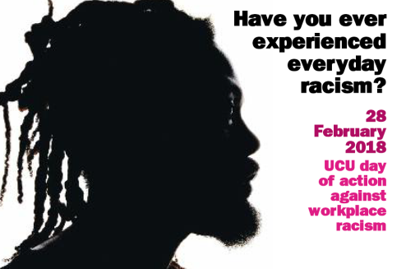

Decolonising Education
Getting the branch involved

The Day of Action against Workplace Racism is the opportunity for your branch to highlight its opposition to racism in the workplace. The theme of this year’s Day of Action is ‘Decolonising Education’.

Branches are encouraged to host meetings of all members to discuss issues and approaches to the decolonising agenda and how best to engage with colleagues and your institution. As per UCU policy branches are also encouraged to work strategically with their local student union.

Below are some resources your branch may want to use to stimulate discussion amongst members and students.

Why Is My Curriculum White? (Film)
- https://www.youtube.com/watch?v=Dscx4h2l-Pk

Dismantling The Master’s House
- http://www.dtmh.ucl.ac.uk/

Decolonising SOAS
- https://soasunion.org/campaigns/decolonisingsoas/

National Union of Students: Liberate My Degree
- https://rmfoxford.wordpress.com/about/

National Union of Students: Liberate Education
- https://www.nusconnect.org.uk/resources/liberatemydegree-starting-the-conversations-on-your-campus

National Union of Students: Liberate the Curriculum
- https://www.nusconnect.org.uk/campaigns/liber8-education/liberate-the-curriculum

National Union of Students: Why Is My Curriculum White?
- https://www.nus.org.uk/en/news/why-is-my-curriculum-white/

