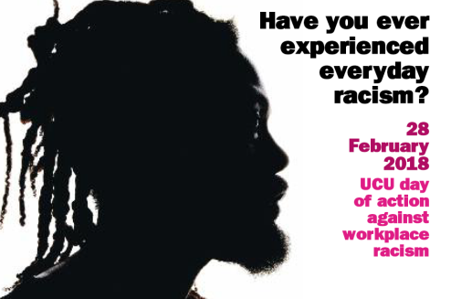
DECOLONISING

EDUCATION

28/02/18


www.ucu.org.uk

DAY OF ACTION AGAINST WORKPLACE RACISM
DECOLONISING EDUCATION
28/02/18

The Day of Action Against Workplace Racism is the opportunity for your branch to highlight its opposition to racism in the workplace. Branches are encouraged to host meetings of all members to discuss issues and approaches to the decolonising agenda and how best to engage with colleagues and your institution. As per UCU policy branches are also encouraged to work strategically with their local student union. Please let us know what you branch is planning so we can share it with other branches.

Diagnostic

Does your workplace suffer from irresolvable tensions arising from imperial histories?
Are the valuable aspects of learning being lost to short-term market demands?
Do you find yourself trapped between an imperial (not so) past and a corporatist present?

If yes, then this handy diagnostic is for you.

HISTORY

- Has your organisation benefited from Britain’s imperial history? This might include endowments, land, individuals of value, named chairs. Is this history acknowledged?

FUNDING

- Does your organisation pursue sponsorship, funding or partnership from private and corporate sources? For what purposes?

- Does your organisation operate any ethical checks on potential funders and partners?

- Do ethical checks include assessment of imperial ties, profits from slavery, human rights abuses, and ecological impact?

REPRESENTATION

- Does your organisation recruit students from local communities?

- Is your student body reflective of the local community, in terms of class, disability, gender identity, race, sexual orientation

- Is the staff body diverse at all levels? Are any group of staff over-represented at some levels (including non-disabled white heterosexual men)?

- Who is represented on your governing body?

- Does the governing body reflect the local community? Do members represent corporate or political interests?

- Are there ethical checks on potential and sitting members of the governing body?

CURRICULUM

- How do you review the curriculum in your organisation?

- Does the current curriculum include consideration and acknowledgement of Britain’s imperial history?
- Of the experience and contribution of BME communities?
- Of the experience and contribution of disabled people?
- Of the contributions of all genders?
- Of the experience of LGBT+ people?

- Are there mechanisms to enable these matters to be included in the curriculum in future?

